Employee Awards Nomination Form
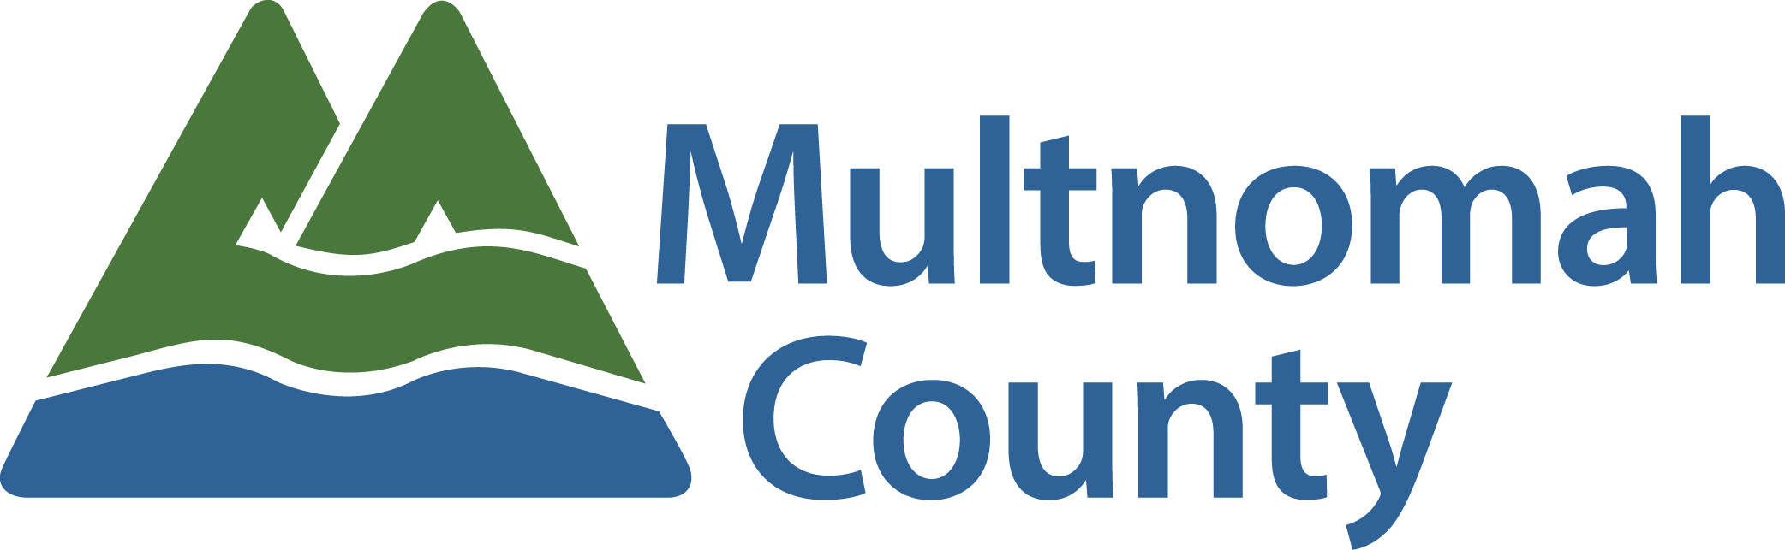
Sustainability Award

Sustainability is often framed exclusively in terms of environmental impact or use of natural resources. At Multnomah County, we have a broader definition of sustainability, one that includes social and economic factors alongside environmental impact.

To salute employees and teams who apply creative thinking to address the root causes of environmental, social, or economic inequities that lead to disproportionate impacts on the most vulnerable communities within Multnomah County, and if left unaddressed, will increase the need for our safety net services.

Employee or Team Being Nominated:
Your Name:
Your Email Address:
Your Phone #:

The following criteria will be used to select the Sustainability Award recipient:
Implementation of a new approach, project or program for delivering core services that targets the root causes of environmental, social, or economic. This can include new, more efficient and more inclusive processes that support the delivery of core County services e.g. purchasing, IT, fleet services, etc. The work should have been done (or the major project completed) between March 1, 2017 and the time the nomination is written.

Please give examples of how this person or team applied creative thinking to address the root causes of environmental, social or economic inequities. (5 points)

Please give examples of how the different or new approach to providing services to the public or other employees has led to more efficient and inclusive processes. (5 points)

Please give examples of how this program or project has positively impacted Multnomah County employees and/or the people we serve. (5 points)

Please provide additional information regarding this employee or team and how you feel this employee or team inspired pride in the work of Multnomah County. (5 points)

Please be as detailed and specific as possible about the nominee. The information provided will be the sole factor determining the committee’s ranking of nominees.

PLEASE READ BEFORE YOU SUBMIT YOUR NOMINATION:

Every description field above is scored on a 0-5 point system and scored as indicated below. Any field left blank or incomplete will be scored with a 0 or a 1. All scores are then totaled and nominees are ranked based on those totals.

0 = Not Covered
1 = Unclear: Not clearly defined; not explicit.
2 = Noteworthy: worthy of notice or attention
3 = Significant: having or expressing a meaning; important; of consequence.
4 = Distinguished: made conspicuous by excellence;
5 = Extraordinary: exceptional in character, amount, extent, degree, etc…; remarkable; uncommon, rare, phenomenal, special

Submission instructions:
- Save file to your network folder
- Attach completed saved form in to an email to Employee.recognition@multco.us

