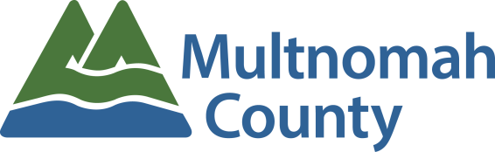
Employee Awards Nomination Form
Diversity & Cultural Competency Award

To recognize employees and teams who promote inclusiveness and champion diversity in the community or within the organization.

Employee or Team Being Nominated:
Your Name:
Your Email Address:
Your Phone #:

The following criteria will be used to select the Diversity & Cultural Competency Award recipient:
The award may go to employees who demonstrate excellence in creating or advancing projects, policies or programs that model the county’s core values related to diversity and cultural competency, which could include engaging diverse communities and partners in successful service outcomes or working internally to help provide culturally competent services. The work should have been done (or the major project completed) between March 1, 2017 and the time the nomination is written.

Please give examples of how the person or team promoted inclusiveness in the community or within the organization. (5 points)

Please give examples of how the person or team championed diversity in the community or within the organization. (5 points)

Please provide additional information regarding how this employee or team inspired pride in the work of Multnomah County. (5 points)

Please be as detailed and specific as possible about the nominee. The information provided will be the sole factor determining the committee’s ranking of nominees.

PLEASE READ BEFORE YOU SUBMIT YOUR NOMINATION:

Every description field above is scored on a 0-5 point system and scored as indicated below. Any field left blank or incomplete will be scored with a 0 or a 1. All scores are then totaled and nominees are ranked based on those totals.

0 = Not Covered
1 = Unclear: Not clearly defined; not explicit.
2 = Noteworthy: worthy of notice or attention
3 = Significant: having or expressing a meaning; important; of consequence.
4 = Distinguished: made conspicuous by excellence;
5 = Extraordinary: exceptional in character, amount, extent, degree, etc…; remarkable; uncommon, rare, phenomenal, special

Submission instructions:
- Save file to your network folder
- Attach completed saved form in to an email to Employee.recognition@multco.us

