2017-2020 Area Plan; Year 3 Update
Multnomah County Aging, Disability, & Veterans Services Division
Rebecca Miller
Year 3 Updates - Robyn Johnson

Year 3 Update
February 15, 2019
MULTNOMAH COUNTY
AGING, DISABILITY, & VETERANS SERVICES DIVISION
2017-2020 AREA PLAN

Table of Contents
A-1: Introduction 4
A-2: Mission, Vision, & Values 4
A-3: Planning and Review Process 6
A-4: Prioritization of Discretionary Funding 9
Section B: Planning and Service Area Profile 11
B-1: Population Profile 11
Table 1: Population Profile 13
B-2: Target Populations 19
B-3: AAA Services and Administration 20
B-4: Non-AAA Services, Service Gaps and Partnerships to Ensure Availability of Services Not Provided by the AAA 27
Section C: Focus Areas, Goals and Objectives 30
C- 1: Information & Assistance Services and Aging & Disability Resource Connection (ADRC) 30
C-2: Nutrition Services 40
C-3: Health Promotion (OAA Title IIID) 48
C-4: Family Caregivers 54
C-5: Elder Rights and Legal Assistance (OAA Titles VII & IIIB) 62
C-6: Older Native Americans (OAA Titles VI & IIIB) 72
C- 7: Health System Transformation 77
C-8: Behavioral Health 85
C- 9: Veterans 97
C-10 Transportation Coordination and Access 103
Section D: OAA/OPI Services and Method of Service Delivery 107
D-1: Administration of Oregon Project Independence (OPI) 107
D-2 Services Provided to OAA and/or OPI Clients 112
Appendices 113
Appendix A: Organizational Chart 113
Appendix B: Advisory Council(s) and Governing Body 114
Senior Advisory Council (SAC) 114
Disability Services Advisory Council (DSAC) 116
Multicultural Action Committee 117
Governing Body – Multnomah Board of County Commissioners 118
Appendix C: Public Process 119
Community Listening Session Schedule 119
Appendix D: Final Updates on Accomplishments from 2013-2016 Area Plan 122
Appendix E: Emergency Preparedness Plan(s) 136
DCHS: ADVSD Continuity Plan Summary 136
Severe Weather SOP 136
Appendix F: List of Designated Focal Points 137
Appendix G: OPI Policies and Procedures 138
OPI Expansion and MPI Services Guidelines 143
Client Rights and Grievance Procedure 144
Appendix H: Partner Memorandums of Understanding 145
Appendix I: Statement of Assurances and Verification of Intent 146
Attachment C: Service Matrix and Delivery Method 149
Attachment D: Congregate Nutrition Sites 168
Attachment E: Adult Protective Services Screening Protocol 169
Attachment F: OPI In-Home Fee Schedule 176

Section A: Area Agency Planning and Priorities

A-1: Introduction
Multnomah County Aging, Disability, and Veterans Services Division (ADVSD) is the designated Area Agency on Aging for the County and a division of the County’s Human Services Department, which also includes Developmental Disabilities and Youth and Family Services. ADVSD provides services to low-income seniors and people with disabilities at five District Centers, ten Enhancing Equity providers, and five Medicaid Long Term Services and Supports offices throughout the County. In addition, Adult Protective Services, Adult Care Home Licensing, and Public Guardian/Conservator programs offer targeted assistance to those who are most vulnerable and at risk. ADVSD offers clients seamless entry to services to ensure that they receive appropriate help regardless of where they enter the system, and to further that aim, three of the five District Centers are co-located with Medicaid offices and all Medicaid sites serve both older adults and people with disabilities.
ADVSD’s primary goal is to help elders and adults with disabilities live as independently as possible and provides a range of services—some directly and others under contract with community agencies—to achieve that end. Complete lists of key services can be found in Section B-3, AAA Service and Administration and Section D-2 Services Provided to OAA and/or Oregon Project Independence Clients.
ADVSD has three Advisory Councils—Aging Services Advisory Council, the Disability Services Advisory Council, and Multicultural Action Committee—that make recommendations on important issues affecting seniors and people with disabilities and advocate for legislation and initiatives.
For questions or comments, please call (503) 988-3646 or areaplan@multco.us.

A-2: Mission, Vision, & Values

ADVSD’s mission is to:
Promote independence, dignity and choice in the lives of older adults, people with disabilities and veterans.
This mission springs from a vision that all older adults, people with disabilities and veterans thrive in diverse and supportive communities and that ADVSD will be a leader and catalyst in developing, promoting, and implementing options for these choices.
ADVSD’s mission and vision are founded on the following organizational values:

- Put People First
- Act with Integrity
- Promote Equity, Empowerment and Inclusion
- Collaborate
- Pursue Excellence
- Accept Personal Responsibility
- Foster Creativity and Innovation
- Act as Change Agents
- Bring Our Best Selves to Work

We provide services directly and in concert with multiple community-based partners. We leverage the strengths of these non-profit organizations to provide coverage across the county and to provide culturally responsive and culturally specific services. We coordinate activities that have regional impacts with neighboring counties, cities within Multnomah County, and with sister agencies across the state. We strive to provide trauma-informed and person-centered services. We embrace innovation and learn from our peers across the nation and in communities across the globe. We are actively breaking silos within our program areas, across the Department of County Human Services, and between Multnomah County Departments to better utilize technology, to change the dominant culture to promote social justice, and to create a future that empowers all of our aging residents to enjoy their lives with dignity, choice, and independence. Some of our partners include:

- African American Health Coalition  - Asian Health and Service Center  - Asian Pacific American Senior Center  - Ecumenical Ministries of Oregon  - El Program Hispano Católico  - Elders in Action  - Friendly House  - Hollywood Senior Center  - Immigrant and Refugee Community Organization  - Impact NW  - Independent Living Resources | - Latino Network  - Meals on Wheels People  - Metropolitan Family Services  - Native American Rehabilitation Center  - Native American Youth and Family Center  - Neighborhood House  - SAGE Metro Portland  - Store to Door  - Q Center  - Urban League of Portland  - YWCA  - 211

A-3: Planning and Review Process

Scope of Need
ADVSD is continually gathering information about the needs of older adults and people with disabilities and tracking success in meeting those needs, using both quantitative and qualitative methods. We consistently find that as people age, there is a compounding effect on marginalized communities that contributes to disparities in health, income, safety, and connection to resources. We are necessarily focusing on the needs of marginalized communities and the strengths we can leverage to create equitable and culturally specific and culturally responsive programs and services. A few of the issues facing people in our community:
- Older adults, people with disabilities, and low-income minorities are being displaced by rising housing costs at a disproportionate rate.
- People with disabilities were more than twice as likely to live in poverty as people without disabilities and it is estimated that twelve percent of people who are homeless in Multnomah County are veterans.
- There is a lack of affordable and reliable transportation, which is a critical component to receiving quality health care, preventing abuse and social isolation, having access to nutritious foods, and connecting to other community-based services.
- People aging with HIV and AIDS Long-Term Survivors are more likely to experience social isolation, depression, and substance use disorders.
- Racial, ethnic, and cultural minority elders are less likely to access services or have awareness of resources available.
- People experiencing chronic conditions or disability want more health education and support specific to their needs.
- Language is a barrier for non-English speakers navigating health, transportation, and other systems; many rely on community-based organizations or other informal networks of support to fill their needs.
- More information and outreach is needed to and for people who are deaf-blind.
- LGBT older adults feel a lack of safety in their homes, at senior centers, and in other places throughout the community.
- Immigrants and refugees rely heavily on staff to organize and provide transportation to community-based organizations that serve them.

Community Listening Sessions
An equity lens was applied throughout the community engagement and area plan development process. In January 2016, we convened a group of 20 AAA advisory council members and stakeholders to approve our draft community engagement plan. In small groups they discussed the types and format of data and information that should be provided to consumers during the process; methods for outreach and specific populations to reach; ways to incorporate the feedback received; removing possible barriers to inclusion in the process, and ways for advisory council members to meaningfully engage throughout the process.
In April - June 2016, ADVSD conducted 18 public listening sessions in locations across the county. The methods used during the sessions were vetted by our knowledge of the equity lens and as the process went on we adjusted our methods according to what we observed and what participants expressed was successful or unsuccessful.
Attendees were asked three questions about nine focus areas that were developed using the State Area Plan guidance, the Multnomah County and Portland Age-Friendly Action Plan domains, and other Department-wide issues of interest. The nine focus areas were: Behavioral Health; Caregiver Respite, Support and Education; Case Management and Options Counseling; Emergency Services and Gap Programs; Healthy Aging; Nutrition Services; Outreach, Information, and Referral; Safety and Abuse Prevention; and Transportation Coordination and Resources. Participants were asked the following questions, in relation to each of the above listed focus areas:
1) What is important to you?
2) What is working well?
3) What do you need more of?

The listening sessions drew 474 people and solicited 2,348 comments. Some 68 percent of attendees were non-English speakers and 89 percent were from non-mainstream groups, including the LGBT community. Participant comments were coded using an inductive, qualitative process and results are available in an interactive web-based file that can be found at www.multco.us/ads. Additional outreach is being made to Multnomah County Library Books by Mail delivery program participants.

Advisory Council members and staff worked together on July 21, 2016 to review the listening session data and further refine and develop draft area plan goals and objectives.

ADVSD Community Services RFPQ Workgroups
In May 2015, ADVSD Community Services convened a Request for Programmatic Qualifications (RFPQ) planning workgroup, in preparation for releasing an RFPQ for OAA funded services beginning in 2018. This workgroup helped establish five foundational assumptions for OAA funded services: 1) Maintain a regional and culturally specific approach to service delivery; 2) Maintain the major service areas; 3) Maintain commitment to funding culturally specific services; 4) Be participant-centered and participant-directed; and 5) Build on recent service system changes.
The RFPQ workgroup also provided recommendations that led to the formation of an Equity and Allocations Workgroup and a Contractor Feedback Workgroup to examine resource allocation and system structure; access and service integration; service gaps and program review; and ADVSD system and program outcomes. The Equity and Allocations Workgroup studied key demographic and service data and will provide guidance related to the RFPQ process and funding allocations for culturally specific and culturally responsive service providers.
The Contractor Feedback Workgroup focused largely on internal operations that can improve our customer service to contractors and quality of programming offered to consumers via those contracts.

Multnomah County Culturally Specific Workgroup
In the spring of 2015, Multnomah County’s Culturally Specific Workgroup was convened to review best practices, solicit local and national advice and create a common, county-wide definition of culturally specific and culturally responsive services that follows applicable state and federal laws. ADVSD will be using the technical guidance created by this Workgroup for programs procuring culturally specific services.

Other Resources Used
Recommendations provided in the 2010 report issued by the Coalition of Communities of Color entitled “Communities of Color in Multnomah County: An Unsettling Profile,” have helped shape the Area Plan community engagement process and have reinforced strategic efforts to address disparities. Several other resources have been useful for planning purposes and developing the 2017-2020 Area Plan. Some of these include an ADVSD-directed Community Services Consumer Satisfaction survey and subsequent workgroup recommendations developed in October 2015; a County-Wide Age-Friendly Multnomah County Employee Survey report completed in September 2015 and most recently, results from the Healthy Columbia Willamette Collaborative Needs Assessment.

Public Comment
Two public hearings were held by the Senior Advisory Council in August 2016, one in Gresham and one in downtown Portland. These were advertised in local newspapers, in community calendars, and distributed via web calendars and email lists. Participants in area plan listening sessions were also invited to attend. The meetings were recorded and posted at www.multco.us/ads. We provided ASL interpretation, amplified sound and closed loop system, and language interpretation upon request. Public comment was invited via email, postal mail, voice recording in any language, and at the public hearings.

A-4: Prioritization of Discretionary Funding

ADVSD will direct our District Center partners to place newly referred individuals on a waitlist and prioritize services to the highest need whenever funding limitations require it. The process for each of these separately funded programs is listed below.
Oregon Project Independence (OPI) in home services and support:
  - OPI Risk Assessment Tool (RAT- 287j form) is completed and clients most at risk for nursing facility placement are prioritized. The risk of self-neglect and abuse or neglect by others are also considered in priority ranking.
  - Options Counseling is provided to individuals not prioritized for Oregon Project Independence.
- Transportation assistance:
  - Individuals on the waitlist who receive case management services will have their transportation risk and need assessed to determine prioritization.
  - Individuals without a case manager will be given information and assistance about other resources in the community for transportation.
- Family Caregiver Support Program:
  - The family caregiver is placed on a waiting list and offered Options Counseling and referred to other programs such as support groups, education, training and respite options such as Adult Day Services.

ADVSD is currently reviewing the funding formula applied for programming through our RFP process. As we change and update our funding formula and program model we are applying the equity and empowerment lens and involving community engagement opportunities, including conversations with communities of color and the LGBT community to inform our decision.
In all cases we strive to prioritize services for those at highest risk and those in most need, utilizing assessment tools and census/demographic data to guide our decisions. We also prioritize funding for programs and services that are evidence-based or that are proven to have a positive impact on the community being served, again, applying an equity and empowerment lens and being informed by communities of color.
As of January 2018, ADVSD has entered into new five year contracts for community based services such as evidence-based health promotion, nutrition, options counseling, case management, information & referral, focal point, and recreation as outlined in Attachment C. Funds were distributed between districts using the same formula as the previous contract cycle, however allocations between the regional and culturally specific providers changed from a 10% culturally specific and 90% regional allocation to 38% culturally specific and 62% regional allocation.

Section B: Planning and Service Area Profile

B-1: Population Profile
The large baby boom generation coupled with historical increases in longevity have resulted in tremendous growth in the 60+ population in recent years. The Census Bureau, through the 2014 American Community Survey has estimated the county 60+ population at over 140,000, a growth of 21% over 2010 figures. This cohort now represents 18%, or nearly 1-in-5 of the county’s residents. In our county, considerable concentrations of older adults are located in Mid and East County, areas with a greater supply of affordable housing and retirement communities. Map 1 shows the county’s 60+ population by census tract, using American Community Survey’s 2014 5-Year estimates.
Since 2010, we’ve seen the population of those aged 60-74 years old grow an astonishing 29.4%. We have also seen a 5.9% growth of our 85+ population, a cohort often in great need of supports and services. According to 2014 figures, this population measures at 13,285 individuals or 9.5% of those aged 60 years or greater. Map 2 shows the county’s 85+ population by census tract, using American Community Survey’s 2014 5-Year estimates. Somewhat like the County’s 60+ population, those aged 85 or greater are more concentrated in the Mid district.
In Multnomah County we are seeing a more ethnically and racially diverse aging population. It is estimated that for 2014, minorities made up 17% of the aging population, compared with 16% in 2010. Minority elders make up a greater proportion of those aged 65 or greater in the Mid and N/NE regions. Multnomah County minority populations are not homogenous and racial/ethnic groups tend to be clustered more in certain regions. For example, Black/African-Americans, while making up about 22% of minorities in Multnomah County, made up roughly half of those living in our N/NE region. Our elder Asian population makes up two-thirds of our minority population in both Mid and SE regions. Map 3 shows the dispersion of our aging minority populations.
Of those that are aged 60 years or greater, 8% report limited English proficiency, defined as either not speaking English at all, or speaking English less than very well. Nearly 5% of people in Multnomah County, aged 60+ are linguistically isolated, which means that no one in their household over the age of 14 speaks only English, or speaks English “very well”. Reaching these populations with mass marketing techniques prove to be a challenge and underscore the need to provide inclusive services that provide materials in languages other than English. Approximately 14% of our county residents aged 60+ were born outside of the US. Multiple tribes constitute Multnomah County’s Native American elders, those in federally recognized and recorded tribes represent less than 1% of Multnomah County’s 60+ population and 4% of its minority 60+ residents.
Poverty data are shown for the 60+ age group in Table 1. Almost fourteen percent (14%) of the 60+ population lives below the Federal Poverty Level (FPL) which in 2014 was $19,790 for a family of three. Because the cost of living in Multnomah County is higher than the guidelines suggest, many programs have established eligibility thresholds based on earning less than 185% of the FPL ($36,611 for a family of 3), and often have even higher thresholds. Over 3-in-10 people over the age of 60 have earnings less than this threshold, Map 4 shows poverty prevalence throughout the county for those aged 65+. Concentrations of poverty for the older population exist primarily in Mid and East County, with dispersed but sizeable pockets in the N/NE and West (Downtown) district area as well. These areas continue to experience individuals with lower income moving into or retaining housing in these areas due in part to housing availability, and subsidized living options.
Almost 65,000 individuals aged 18 to 64 years report having a disability, the Census Bureau no longer publishes 1-Year estimates by Census Tract, so Table 1 shows the distribution of this population based on 5-Year estimates. As our population ages and more people live longer, the number of people with disabilities also grows. Of those that are aged 60+ in Multnomah County, nearly 30% report having a disability.

Table 1: Population Profile
All estimates are based on populations 60+ unless otherwise noted. Estimates based on Census Bureau American Community Survey Data (2014, 1-Year) and/or Minnesota Population Center, University of Minnesota, 2014 Integrated Public Use Microdata Series (IPUMS). Multnomah County estimates are derived by using IPUMS proportional data and applying that to Census Bureau 60+ population estimates.
Characteristic | Population Estimate | Percent of 60+ Population
Total | 140,097 | 100%
Below 185% FPL | 40,240∗ | 7.6%
Minority | 22,352 | 16.9%
Below 185% FPL minority | 9,089* | 7.3%
Person with disability | 48,445 | 35.2%
Limited English Prof. | 11,199* | 8.6%
American Indian or Alaska Native | 700 | 0.5%
Black / African-American | 6,585 | 4.7%
Asian / Pacific Islander | 9,106 | 6.5%
Other Race | 1,261 | 0.9%
Two or More Races | 2,382 | 1.7%
Hispanic | 4,903 | 3.5%

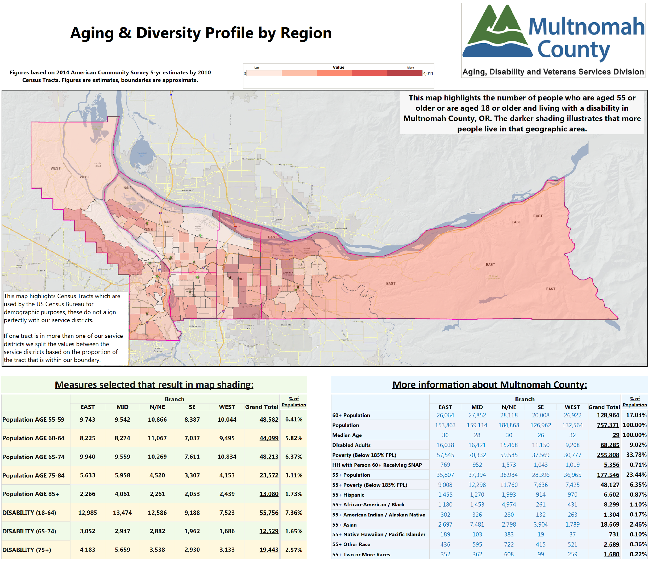
Map SEQ Map \* ARABIC 1
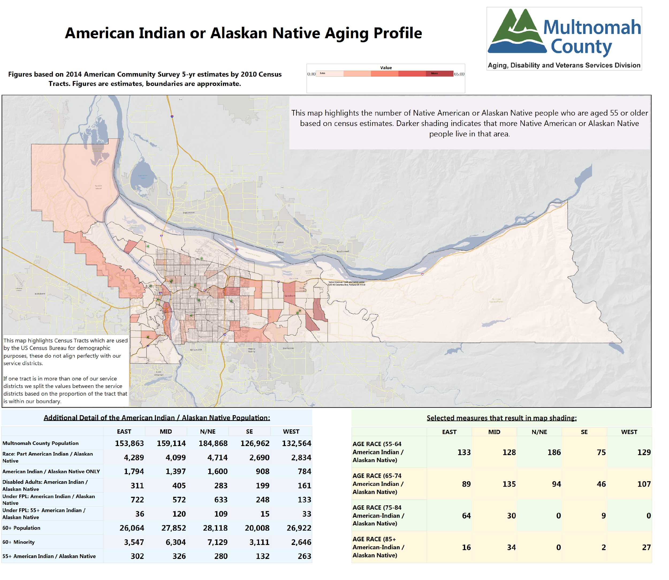
Map SEQ Map \* ARABIC 2
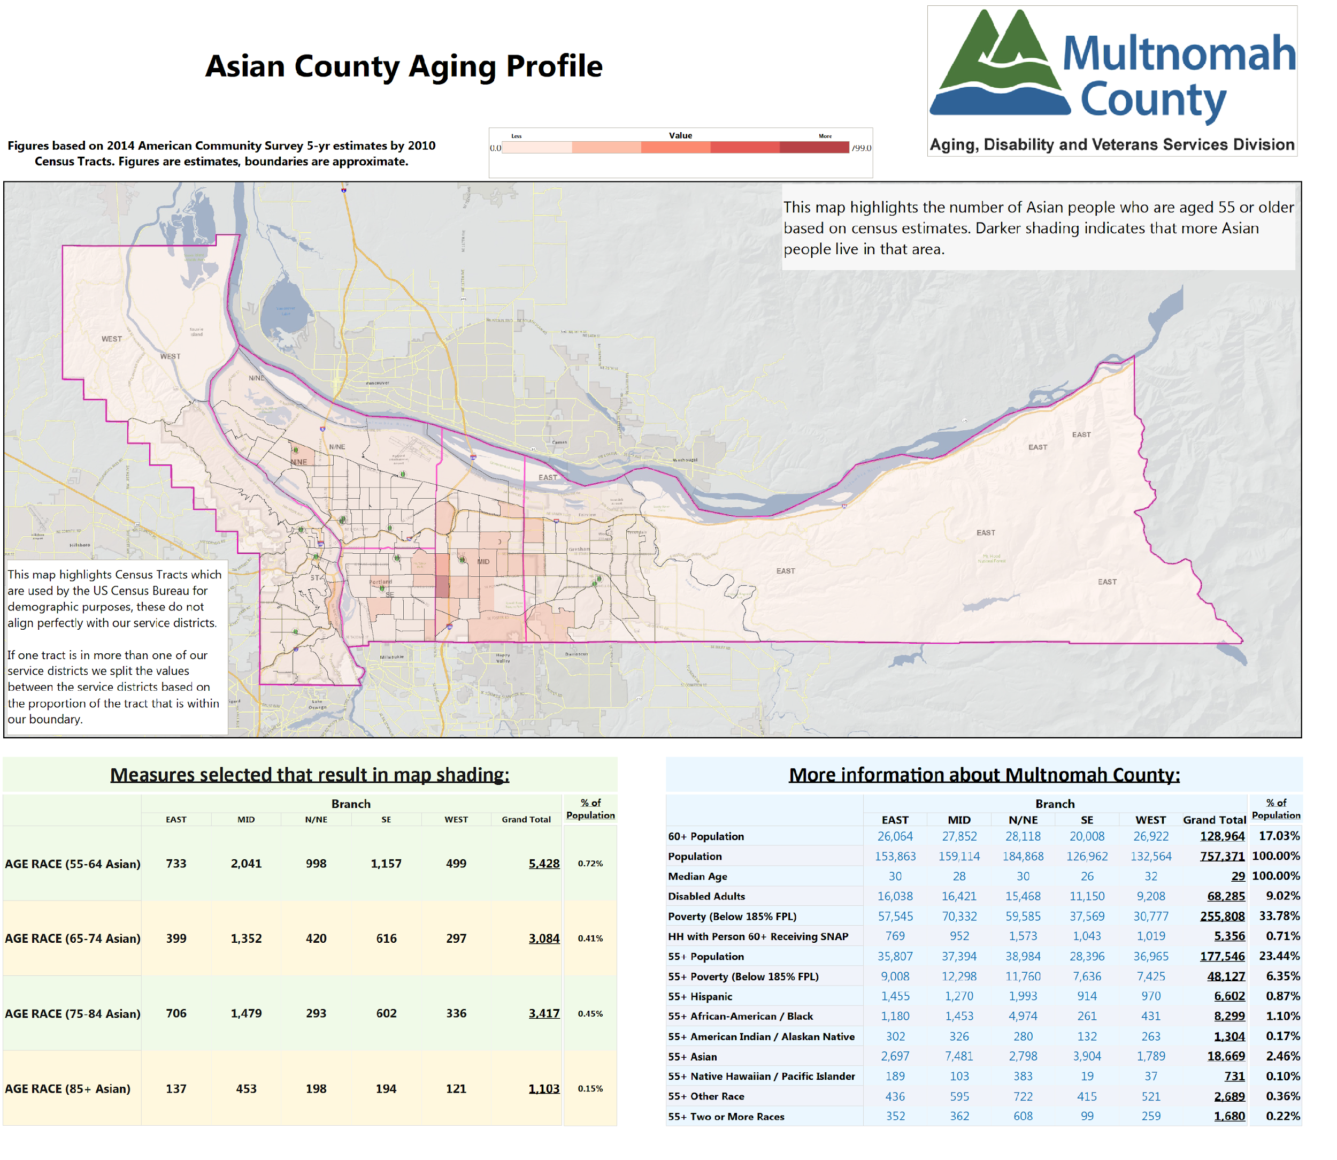
Map SEQ Map \* ARABIC 3

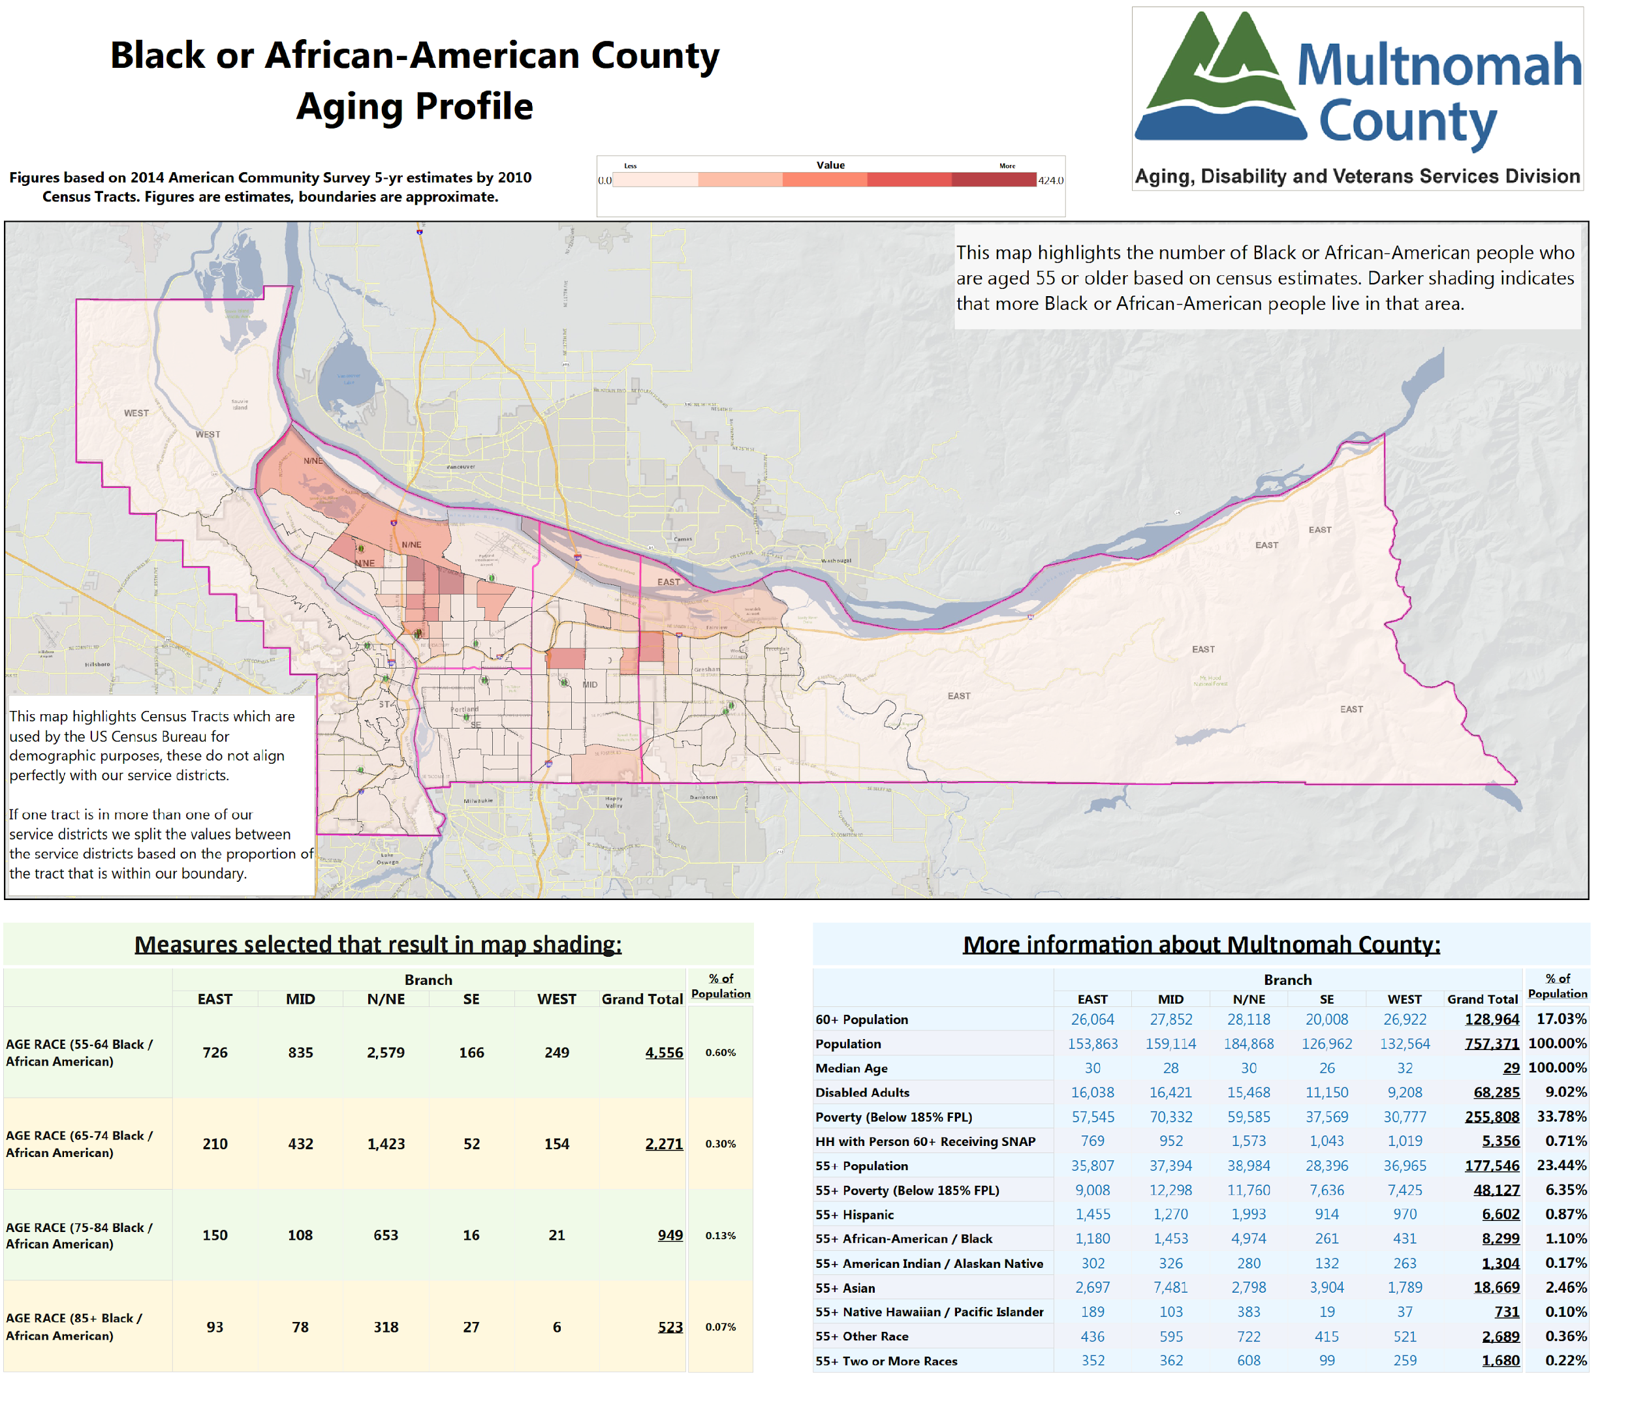
Map SEQ Map \* ARABIC 4
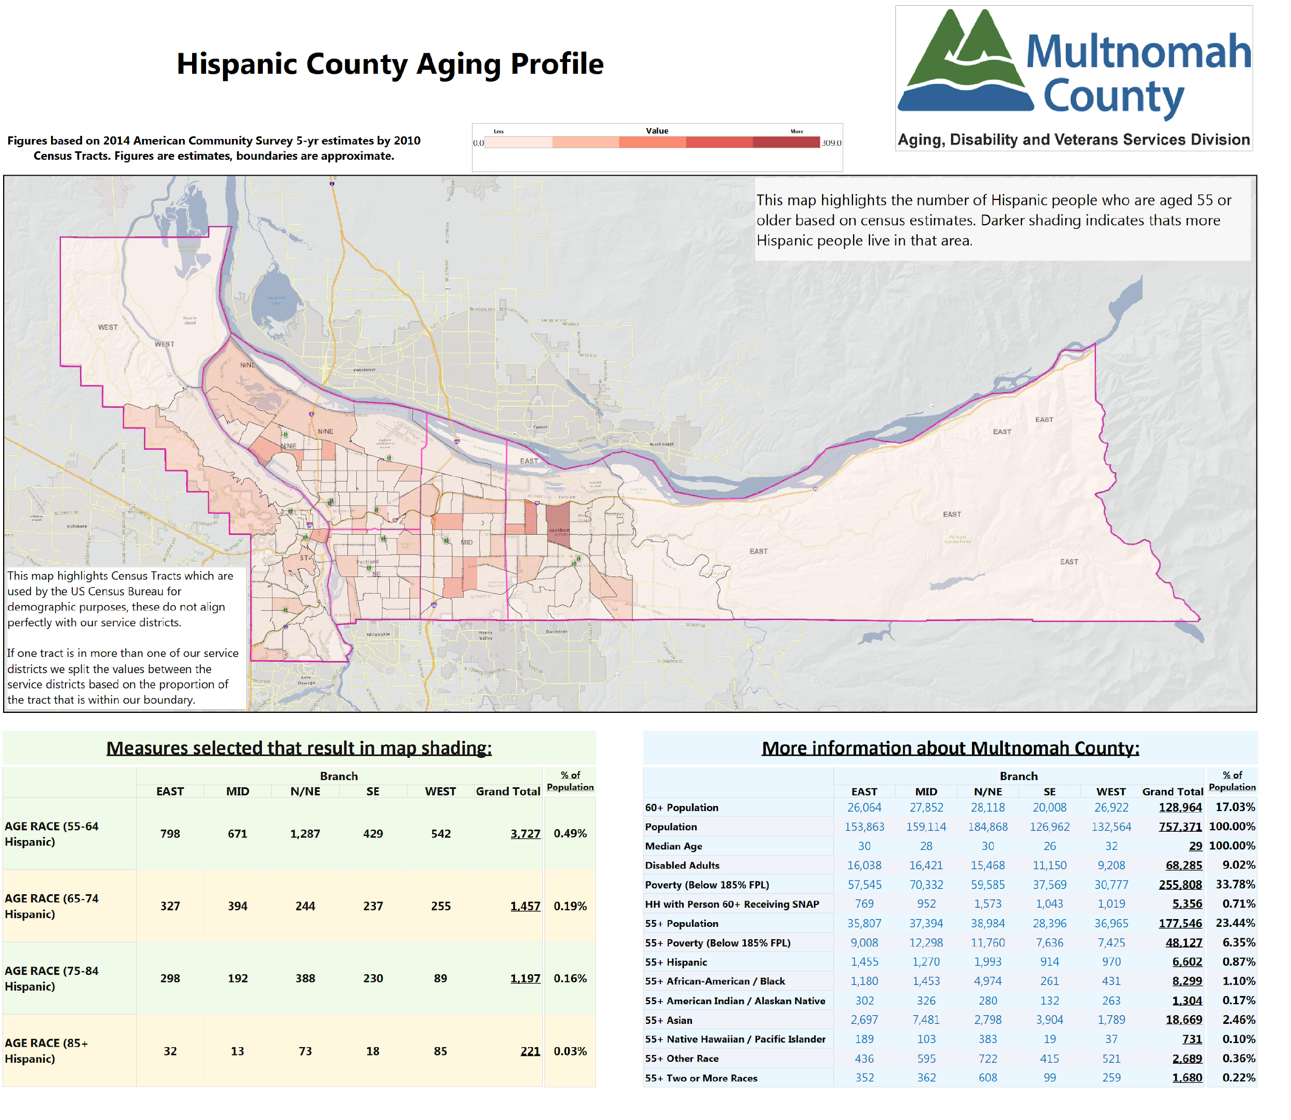
Map SEQ Map \* ARABIC 5

B-2: Target Populations

During the past four years, ADVSD has devoted considerable attention to improving services for older adults with the greatest economic and social needs as well focusing on equity issues impacting communities of color and communities from diverse ethnic and cultural backgrounds. During the 2013-2016 Area Plan, we began contracting with nine (9) providers to offer a range of services to racial, ethnic, and sexual minority elders. These five-year contracts, titled Enhancing Equity for Racial, Ethnic, and Sexual Minority Elders, have funded services such as options counseling, evidence-based health promotion, recreation, volunteer services, caregiver access assistance, and congregate meals, and target six underserved populations—Asian; African American; Hispanic; Native American; Immigrant and Refugee; and Lesbian, Gay, Bisexual, and Transgender elders. We are continuing with this service delivery model and plan to further diversify how our funding is allocated to community partner agencies to be more reflective of the community and the needs of racial, cultural, ethnic and sexual minority elders. We are redesigning our service model and funding formula which will result in a dramatic shift in how funds are allocated to culturally responsive and culturally specific providers.
Culturally responsive services are those that have been adapted to be respectful of, and relevant to, the beliefs, practices, culture and linguistic needs of diverse client populations and communities whose members identify as having particular cultural or linguistic affiliations by virtue of their place of birth, ancestry or ethnic origin, religion, preferred language or language spoken at home. Cultural responsiveness describes the capacity to respond to the issues of diverse communities. It thus requires knowledge and capacity at different levels of intervention: systemic, organizational, professional, and individual.
Organizations providing culturally specific services demonstrate commitment to safety and belonging through advocacy; design of services from the norms and worldviews of the community; reflect core cultural constructs of the culturally specific community; understand and incorporate shared history; create rich support networks; engage all aspects of community; and address power relationships. These services are provided for specific communities of color, immigrant, or refugee populations based on their particular needs.
Lastly, ADVSD will conduct outreach to underserved populations and employ measures to promote equity in its operations. Making inroads with isolated and disenfranchised people, such as deaf-blind people, residents without citizenship status who are isolated by fear of retribution, people who are isolated by language, and people who have been disenfranchised by institutions such as Native American veterans, LGBT veterans, and people aging with HIV. Individualized counseling for Medicare and Medicaid beneficiaries to prevent healthcare fraud, for example, will target Hispanic and urban Native American elders. ADVSD will continue to utilize the Equity and Empowerment Lens—a tool that is used to make equity the foundation of planning, decision-making, and service delivery.

B-3: AAA Services and Administration

Information in this section serves, in part, as narrative accompaniment to Attachment C - described further in Section D-Services Provided to OAA and/or OPI clients.

Advocacy: Focuses on monitoring, evaluating, and, where appropriate, commenting on all policies, programs, hearings, levies, and community actions that affect older adults. Activities include representing the interests of older persons; consulting with and supporting 04ad, the statewide AAA advocacy organization; and coordinating efforts to promote new or expanded benefits and opportunities for older adults.

Adult Day Care/Adult Day Health: Personal care for dependent elders in a supervised, protective, and congregate setting during some portion of a day. Services offered in conjunction with adult day care/adult day health typically include social and recreational activities, training, counseling, and services such as rehabilitation, medications assistance and home health aide services for adult day health.

Caregiver Access Assistance: A service that assists caregivers in obtaining access to available services and resources in their communities. To the maximum extent possible, it ensures that the individuals receive the services needed by establishing adequate follow-up procedures.

Caregiver Cash and Counseling: Services provided or paid for through allowance, vouchers, or cash to clients so that they can obtain the supportive services they want.

Case Management:
Case Management provides access to an array of service options to assure appropriate levels of service and to maximize coordination in the service delivery system. Case management must include four general components: access, assessment, service implementation, and monitoring.
Case Management for Elders is a comprehensive service provided to individuals age 60 and over who is experiencing complex or multiple problems that affect the individual’s ability to remain independent. Additionally, Case Management for Family Caregivers is a comprehensive service provided to family caregivers who are caring for
Persons age 60 and over, or for individuals who are grandparents 55 years of age or older who is a relative caregiver of a child. The definition of Family Caregiver has been broadened to include friends, neighbors and domestic partners who care for someone age 60 or older.

Cash and Counseling: Services provided or paid for through allowance, vouchers, or cash to clients so that they can obtain the supportive services they need.

Chore: A service for eligible OPI clients that provides assistance such as heavy housework, yard work, sidewalk maintenance, and bed bug treatment preparation. (AoA Title III/VII Reporting Requirements Appendix – www.aoa.gov) Note: Chore services are provided on an intermittent basis.

Chronic Disease Management, Prevention, and Education: Programs such as the evidence-based Living Well with Chronic Conditions (Stanford’s Chronic Disease Self-Management) program, weight management, and tobacco cessation programs that prevent and help manage the effects of chronic disease, including osteoporosis, hypertension, obesity, diabetes, chronic pain, HIV, and cardiovascular disease. (http://patienteducation.stanford.edu/programs/)
- Living Well with Chronic Conditions and Diabetes Prevention Program (DPP) will be provided to Chinese, Korean, and Vietnamese elders using translated materials, and to African American elders through two agencies with a specific focus on the African American population under ADVSD’s Enhancing Equity contracts.
- Tomando Control de Salud will be provided to Hispanic elders under ADVSD’s Enhancing Equity contracts.
- Positive Self-Management Program for HIV (PSMP) is offered in partnership with Multnomah County Health Department and will be an option for Enhancing Equity contractors in the future. The Positive Self-Management Program is a workshop for people with HIV given two and a half hours, once a week, for six weeks, in community settings, Workshops are facilitated by two trained leaders, one or both of whom are non-health professionals with HIV.
- Chronic Pain Self-Management Program will be added to the suite of programs in the 2017-2020 planning cycle.

Congregate Meal: A meal provided to a qualified individual in a congregate or group setting that meets all of the requirements of the Older Americans Act and state/local laws.
- Five meal sites provide culturally-specific cuisine to Asian, Hispanic, Slavic, and Native American elders, four of which are funded under ADVSD’s Enhancing Equity contracts.

Elder Abuse Awareness: Public education and outreach for individuals, including caregivers, professionals, and paraprofessionals on the identification, prevention, and treatment of elder abuse, neglect and exploitation of older individuals, with particular focus on prevention and enhancement of self determination and autonomy.

Financial Assistance: Limited financial assistance for clients with low-income, aiding them in maintaining their health and/or housing. Services may include prescription, medical, dental, vision care or other health care needs not covered under other programs; and, the cost of utilities such as heat, electricity, water/sewer service or basic telephone service.

Guardianship/Conservatorship: Performing legal and financial transactions on behalf of a client based upon a legal transfer of responsibility (e.g., as part of protective services when appointed by court order) including establishing the guardianship/conservatorship.

Homemaker: Assistance such as preparing meals, shopping for personal items, managing money, using the telephone or doing light housework.

Home-Delivered Meals: A meal provided to a qualified individual in his/her residence that meets all of the requirements of the Older Americans Act and state and local laws. (Note: The spouse of the older person, regardless of age or condition, may receive a home-delivered meal if, according to criteria determined by the area agency, receipt of the meal is in the best interest of the homebound older person.)

Information & Assistance: Provides individuals with a) information about services available in the community; b) links individuals to services and opportunities that are available in the community; and (c) to the maximum extent practicable, establishes adequate follow-up procedures.

Information for Caregivers: A service for caregivers that provides the public and individuals with information about resources and services available to individuals in their communities. These activities are directed to large audiences of current or potential caregivers and include disseminating publications, conducting media campaigns, etc.

Interpreting/Translation: Provides assistance to clients with limited English speaking ability to access needed services. Provide assistance to accommodate the communication needs of people with disabilities.

Legal Assistance: Legal advice or representation provided by an attorney to older individuals with economic or social needs, including counseling or other appropriate assistance by a paralegal or law student acting under the direct supervision of an attorney, or counseling or representation by a non-lawyer where permitted by law. Priority legal assistance issues include income, health care, long term care, nutrition, housing, utilities, protective services, defense of guardianship, abuse, neglect, and age discrimination. Legal services may also include assistance to older individuals who provide unpaid care to an adult child with disabilities and counsel to assist with permanency planning for the child. Assistance with will preparation is not a priority service except when a will is part of a strategy to address an OAA-prioritized legal issue. Support public in accessing legal resources that fall outside of this scope via the ADRC Helpline.

Nutrition Education: A program to promote better health by providing accurate and culturally responsive and culturally specific nutrition, physical fitness, or health (as it relates to nutrition) information and instruction to participants, caregivers, or participants and caregivers in a group or individual setting overseen by a dietician or individual of comparable expertise.

Options Counseling: Counseling that supports informed long term care decision making through assistance provided at five district senior centers to individuals and families to help them understand their strengths, needs, preferences and unique situations and translates this knowledge into possible support strategies, plans and tactics based on the choices available in the community. Additionally, Asian, African American Native American; Lesbian, Gay, Bisexual, Transgender (LGBT), Immigrant and Refugee’ and Hispanic elders may receive Options Counseling by ADVSD’s Enhancing Equity providers.

Personal Care: In-home services provided to maintain, strengthen, or restore an individual's functioning in their own home when an individual is dependent in one or more Activities of Daily Living (ADL), or when an individual requires assistance for ADL needs. Assistance can be provided either by a contracted agency or by a Homecare Worker paid in accordance with the collectively bargained rate.

Physical Activity and Falls Prevention: Programs for older adults that provide physical fitness, group exercise, and dance-movement therapy, including programs for multi-generational participation that are provided through local educational institutions or community-based organizations. Programs that include a focus on strength, balance, and flexibility exercise to promote physical activity and/or prevent falls; that are based on best practices; and that have been shown to be safe and effective with older populations are highly recommended.
- Racial, cultural, and ethnic minority elders will participate in Tai Chi: Moving for Better Balance; Walk with Ease, or Arthritis Foundation Exercise Program under ADVSD’s Enhancing Equity contracts

Public Outreach/Education: Services or activities targeted to provide information to groups of current or potential clients and/or to aging network partners and other community partners regarding available services for the elderly. Examples of this type of service would be participation in a community senior fair, publications, conferences, other mass media campaigns, presentations at local senior centers where information on OAA services is shared, etc.

Recreation: Activities that promote socialization, such as sports, performing arts, games, and crafts, either as a spectator or as a participant.
- Asian, Native American, LGBT, Immigrant and Refugee, and Hispanic elders will be provided culturally-specific and other recreation activities under ADVSD’s Enhancing Equity contracts.

Senior Center Assistance: Financial support for use in the general operation costs (i.e., administrative expense) of a senior center.

Transportation: Assist older adult consumers and others acting on behalf of older adults with transportation scheduling and coordination. This includes bus passes and tickets, cab rides, and door-to-door rides through contracts with local transportation providers for ADVSD clients to access services that help them maintain their independence in the community for as long as possible. This service includes activities such as
- screening for eligibility for transportation services,
- assessing transportation needs,
- verification of eligibility for transportation,
- assisting in the completion of forms and applications for transportation,
- advocacy on behalf of older adults requesting transportation services,
- scheduling and coordinating rides with transportation providers, and
- the distribution of bus passes and tickets.
Clients needing transportation will be prioritized according to the following ADVSD criteria:
- Medical trips (doctors, therapists, hospital, test, or health-related treatment) for non-Medicaid clients;
- Congregate nutrition; and
- Multiple supportive services (i.e. Multicultural Centers, Senior Centers, etc.).

Volunteer Recruitment: Identifying, training, and assigning an individual to a volunteer position.

Volunteer Services: Uncompensated supportive services to AAAs, nutrition sites, and other ADVSD contracted partners. Examples of volunteer activities may be, but are not limited to, meal site management, Board and Advisory Council positions, home-delivered meal deliveries, office work, support group facilitation, etc.

As of October 2016, OPI funded services and Transportation are being affected by budget constraints.

B-4: Non-AAA Services, Service Gaps and Partnerships to Ensure Availability of Services Not Provided by the AAA

The services listed below complement those provided by ADVSD, and information about them is available at the ADRC website, www.adrcoforegon.org, or by calling ADVSD’s Helpline at 503-988-3646. Providers noted can also be contacted directly.
Service | Contact
Alzheimer’s Resources | ADVSD collaborates with the Oregon Chapter of the Alzheimer’s Association and several other partners on the STAR-C project, a grant-funded evidence-based intervention aimed at reducing caregiver stress among those caring for older adults with Alzheimer’s disease or related dementias. Family Caregiver Support Program staff collaborates with the Alzheimer’s Association on targeted community outreach events. The Multnomah County and Portland Age-Friendly Advisory Council are also integrating Dementia Friendly Community best practices into planning efforts.
Transportation Resources & Services | Paratransit Service: Helpline staff, contracted District Senior Center staff, and Enhancing Equity contractors provide referrals to Tri-Met Lift, which assesses consumers’ functional eligibility for services. District Senior Center staff may assist consumers with Lift applications. Non-Emergent Medical Transportation (NEMT) and its more limited companion service--Non-Medical Community Transportation services for waivered long term care recipients are key benefits for members of the Oregon Health Plan (OHP). NEMT assists older adults as well as adults with disabilities to go to and from routine or scheduled OHP-covered medical services. Community Transportation assists frail older adults and adults with disabilities who qualify for long term services and supports (LTSS) to go grocery shopping, to conduct personal business, and to participate in community activities that are part of their person-centered long term care service plan authorized by their case manager. Ride Connection provides older adults and people with disabilities with information and access to all transportation options in the region, travel training, door-to-door transportation for any reason, and other mobility enhancing services.
Disability Services Programs | ADVSD partners with Independent Living Resources (ILR) on grant-funded projects, and Helpline, District Senior Center, and Enhancing Equity contractor staff refer people with disabilities to ILR, and other disability services providers as their needs dictate. ADVSD has recently joined the Deaf-Blind Services Task Force to bring more attention and services to people who are aging with combined vision and hearing loss.
Employment Services | ADVSD is a host site for the Title V Senior Community Service Employment Program, providing limited part-time employment to eligible individuals, and Helpline staff refers consumers to community Work Source providers other employment services in the county.
Energy Assistance | Low-income energy assistance is provided by the county’s community action agencies, which include several ADVSD contracted partners—El Programa Hispano Católico, Human Solutions, Impact NW, Immigrant & Refugee Community Organization (IRCO), NAYA Family Center, and Self-Enhancement, Inc.(SEI). Helpline Supervisor meets annually with community action agency staff to distribute energy assistance information to the aging and disability network.
Food Access, Pantries, and Gleaners | Helpline staff, contracted District Senior Center staff, and Enhancing Equity contractor staff provide referrals to food pantries and gleaners, which are numerous and located throughout the county to provide emergency food boxes to those in need. Several District Senior Centers host senior food box programs. Store to Door delivers and unloads groceries and prescriptions to homebound older adults and people with physical disabilities to parts of Multnomah and Washington Counties. Farmer’s Markets are exploring mobile options and offer neighborhood-based access to fresh produce. SNAP benefits can be used in many, but not all, Farmer’s Markets.
Housing | Helpline staff refers consumers to housing services based on their identified need (e.g. low-income residences, independent senior living, assisted living, etc.). Referrals are made to Home Forward, NW Pilot Project, Northwest Housing Alternatives, and a number of other housing providers.
Information & Referral | Through an agreement with 211Info, ADVSD ensures that seniors and adults with disabilities are referred to the Helpline for assistance.
Mental Health Services | Helpline staff refers consumers to mental health services based on their presenting issue (e.g., depression, anxiety, bereavement, etc.) and available treatment options include outpatient and inpatient counseling, group therapy, home-based mental health, support groups, and peer counseling. Helpline and the County Mental Health Crisis Call Center cross-train and share cross-referral processes. The Older Adult Behavioral Health Initiative offers resources for complex case coordination across mental health, aging, and addictions program areas.

Section C: Focus Areas, Goals and Objectives

C- 1: Information & Assistance Services and Aging & Disability Resource Connection (ADRC)
Profile of the issue
The Aging & Disability Resource Connection (ADRC) is the Front Door for older adults, people with disabilities, veterans, their families and community organizations. This community resource emphasizes coordination among AAAs and aging network organizations to strengthen community resources so that wherever consumers turn for help they receive seamless assistance and a “no wrong door” approach.
The Information and Assistance and ADRC programs are monitored for quality and access and improvements are made continuously. Multnomah County ADRC exceeded state standards for quality assurance in 2015, as reflected in our consumer satisfaction survey results for both quality of service and ease of access. As part of our ongoing regional ADRC Quality Improvement process, survey results are routinely shared with I&R staff across the Metro ADRC and information gathered is used to develop customized training and support for staff. We also use accountability measures to track assistance to the linguistically and culturally diverse community. Although all programs across our system have access to interpreter and translation services and many of our brochures are translated into a number of languages, equitable access remains an area for improvement.
Coordination is a hallmark of the “no wrong door” approach. We have better integrated our Veterans Services Program into the 24/7 ADRC, including direct referrals and tracked client outcomes, better data collection for Veteran status and a system for additional follow-up with Veterans. We piloted a Long Term Care (LTC) Service Screener project with our Branch Offices as a way to reduce wait times. This innovative pilot allows us to screen complex cases using Helpline staff to provide initial assessment and immediate connection to resources to consumers who have needs but do not appear to be eligible for Medicaid. In addition, we continue to work to develop closer ties with 211info and the Multnomah County Mental Health call center to better support the needs of shared clients. In all these examples, more clearly defined roles and responsibilities have helped our team to focus on providing person-centered, streamlined access to information and services.
Problem/need statement
Participants in the Multnomah County listening sessions identified “ease of access” and “connecting to important services” as most important to them within the focus area of Outreach, Information and Referral. Culturally specific communities identified this focus area as more important than primarily English speaking communities did. Culturally specific clients also indicated in higher numbers the need for more of this focus area and were less likely than primarily English-speaking clients to say our services are working well.
Our five regional District Senior Centers and nine Enhancing Equity - culturally specific community partners - require additional support to better address the needs of older adults who face linguistic and cultural barriers and may not know or trust our ADRC and I&A services as they are currently delivered. One clear gap is the lack of funding currently allocated for I&A services to our Enhancing Equity partners who are an invaluable resource for reaching our increasingly diverse population. In 2016, we modified our Quality Assurance process to measure consumer satisfaction specific to District Senior Centers and agencies that serve racial, ethnic, and sexual minority elders.
Multnomah County ADRC works strategically with the Metro ADRC advisory council, the AAA Network and the State Unit on Aging to address the larger issue of sustainable funding for these critical services. We are exploring the provision of services to CCOs and hospitals, fee for service private case management, offering our services through Employee Assistance Programs and developing a proposal for Medicaid match for non-Medicaid functions of the ADRC. By working together, we also hope to increase access to the ADRC for all consumers by making technology improvements especially around multiple languages and for consumers experiencing visual loss and other disabilities. We continue to monitor trends for most requested needs unmet needs and share these reports with stakeholders to inform our work plans and strategies.
Goal: Decrease isolation and barriers to access experienced by physically, emotionally, culturally or linguistically isolated older adults.

Objectives:
- Build capacity to provide inclusive and culturally specific services.
- Utilize a targeted outreach approach that builds on existing relationships, trusted cultural centers, and leverages the strengths of the community.

Goal: ADRC is recognized by the community as a valuable resource for older adults and people with disabilities.
Objectives:
- Utilize a multimodal approach to promote ADRC as front door/coordinated entry to all ADVSD/ Enhancing Equity services
- 85% of ADRC consumers will express satisfaction (excellent or good) with services and activities provided at these community access points.

Focus Area - Information and Assistance Services and Aging & Disability Resource Connection (ADRC)
Goal: Decrease isolation and barriers to access experienced by physically, emotionally, culturally or linguistically isolated older adults.
Measurable Objectives  Build capacity to provide inclusive and culturally specific services. | Key Tasks |  | Lead Position & Entity | Timeframe for 2017-2020  (by Month & Year) |  | Accomplishment or Update
 |  |  |  | Start Date | End Date
 | a | Train HelpLine staff to increase their knowledge of the Public website and become better navigators for the ADRC services | Program Manager | November 2016 | January 2020 | Ongoing efforts include monthly team meetings, attending regional educational conferences, and providing other professional development opportunities to staff
 | b | In-person contact in field sites to help I & R providers access the ADRC database | Program Manager and Community Services Team | July 2018 | June 2019 | Ongoing bi monthly meeting. Provide on-site training at partners’ offices and during other site visits to ADRC locations.
 | c | Understand barriers to accessing services in specific communities | ADRC Outreach focal point, Community Advisory Council, EE / DC contract liaisons | January 2018 | December 2020 | Identified language as a significant barrier. Through support from culturally specific agencies, we provided more printed materials in languages other than English.

Focus Area - Information and Assistance Services and Aging & Disability Resource Connection (ADRC)
Goal: Decrease isolation and barriers to access experienced by physically, emotionally, culturally or linguistically isolated older adults
Measurable Objectives  Utilize a targeted outreach approach that builds on existing relationships, trusted cultural centers, and leverages strength of community. | Key Tasks |  | Lead Position & Entity | Timeframe for 2017-2020  (by Month & Year) |  | Accomplishment or Update
 |  |  |  | Start Date | End Date
 | a | Outreach in culturally responsive manner | ADRC Outreach Coordinator | January 2017 | December 2020 | Ongoing. Worked with Asian Health & Service Center to give an ADRC and Medicare Open Enrollment presentation in Mandarin, Cantonese, Korean, and Vietnamese in 2018 and 2019. 180+ attendees
 | b | Maintain current programs with culturally specific partners (called Enhancing Equity contracts) since they already have relationships w/ community members | Program Manager | on-going | December 2020 | FY 18 - 719 I & A units by culturally specific providers Friendly House, Asian Health & Service Center, and El Programa Hispano Católico.
 | c | Use current data to analyze and report usage | Program Manager, Resource Specialist, Outreach Coordinator, Data Analyst, community partners | March 2017 | June 20-20 | Project to establish baseline data completed in 2018. Able to pull reports to show trends by race, ethnicity, age, disability, and income, thus increasing our ability to show impact of targeted outreach activities.  2019 - Completed Database intergration into the mult co data mart and providing quality assurance reporting to I&R/A staff  Network wide
Focus Area - Information and Assistance Services and Aging & Disability Resource Connection (ADRC)
Goal: ADRC is recognized by the community as a valuable resource for older adults and people with disabilities
Measurable Objectives  Utilize a multimodal approach to promote ADRC as front door/coordinated entry to all ADVSD/ Enhancing Equity services. | Key Tasks |  | Lead Position & Entity | Timeframe for 2017-2020  (by Month & Year) |  | Accomplishment or Update
 |  |  |  | Start Date | End Date
 | a | Create marketing plan, increasing outreach | ADVSD Outreach & Marketing Committee | October 2016 | June 2020 | Ongoing communications and social media outreach with DCHS communications team. Update materials annually. Conducted outreach at 15 community and cultural events.
 | b | Improve ADRC access and increase available languages by working together with the Metro ADRC. | Resource Specialist  Program Manager | January 2018 | December 2020 | Advocated with Metro ADRC to request materials in a variety of languages this was approved in 2018 and funding was allocated to print and deliver more copies
 | c | Empower community based and culturally specific partners to do outreach and produce materials once they become familiar with the work of the ADRC. | ADRC Outreach Coordinator | July 2017 | December 2020 | Partners create own materials and distribute amongst their various language groups. New activities and accompanying promotional materials provided to ADVSD.Facilitating cross partner promotions of events, activities, and trainings through regular network meetings.  Conducted bilingual training specific to Medicare and ADRC to 100 plus participants in Cantonese, Vietnamese, Mandarin, and Korean.
 | d | Improve ADRC search for specific communities or issues | Resource Specialist | January 2017 | December 2020 | Completed work to improve search terms for LGBT and Long-Term Survivors of HIV/AIDS. Future efforts will align with target populations served by culturally specific providers.  In 2018, added comprehensive Medicare related search terms to make it easier for clients to access services.  This provide a more clear route for the public to find Medicare resources.

Focus Area - Information and Assistance Services and Aging & Disability Resource Connection (ADRC)
Goal: ADRC is recognized by the community as a valuable resource for older adults and people with disabilities
Measurable Objectives  85% of ADRC consumers will express satisfaction (excellent or good) with services and activities provided at these community access points. | Key Tasks |  | Lead Position & Entity | Timeframe for 2017-2020  (by Month & Year) |  | Accomplishment or Update
 |  |  |  | Start Date | End Date
 | a | Strengthen existing Quality Improvement (QI) measures to include focus on non-English speakers, and communities of color. | Program Manager and Resource Specialist; Metro ADRC QA Committee | January 2018 | December 2019 | Conducting regular quality improvement activities during bi-monthly meetings withpartners.
 | b | Explore increasing center-based I&A for contracted partners especially Enhancing Equity organizations. | Program Manager, ADVSD Management | February 2017 | June 2017 | Increased funding to culturally specific organizations for contract period 2018-2022. Four culturally specific organization will be providing I & R.
 | c | I&R more integrated between ADRC Helpline and Branch Offices | Community Resources Program Manager | January 2017 | December 2017 | ADRC staff provided training on after-hours alerts and after-hours consultant services to improve 24 hour access.

C-2: Nutrition Services

Profile of the issue:
The purpose of the OAA Nutrition Program is to reduce hunger and food insecurity, promote socialization, and help ensure older adults’ good health and well-being by providing access to nutritious meals and nutrition education that empowers older adults with the information to make better nutritional choices for their health. A healthy daily diet is an important key in helping adults 60 years and older to positively impact their physical and mental health and prevent or delay the onset of disease. The benefits of proper nutrition include increased mental acuity, resistance to illness and disease, higher energy levels, a more robust immune system, and faster recuperation from illness and medical treatments.
Currently, ADVSD contracts with several community agencies to provide congregate meals. The largest provider is Meals on Wheels People (MOWP). They have seven (7) congregate meal sites and four (4) satellite sites in the county. We provide partial funding for five of these locations. These meal sites offer two (2) daily lunch options in the interest of appealing to diverse tastes, and at a few locations, ethnic cuisine is served to attract diners from diverse cultural backgrounds. These meals are considered to be culturally responsive. Full MOWP schedule available here: www.mealsonwheelspeople.org/what-we-do/dining-centers/ and Attachment D includes this schedule as well as culturally specific meals, described below.
ADVSD contracts with five culturally specific agencies to provide culturally specific meals. This change was made in 2012, and has been expanded to better provide person-directed services to meet the needs of culturally specific populations. Asian Health and Service Center, NAYA Family Center, El Programa Hispano Católico, Immigrant and Refugee Community Organization, and Ecumenical Ministries of Oregon provide culturally specific meals for Asian elders Native American elders, Hispanic elders Slavic, Asian, and African elders, and HIV/AIDS Long-Term Survivors over age 50, respectively.
The culturally specific meals are currently being delivered in threeways: 1) Meals are prepared at a MOWP congregate site and transported to culturally specific partner to serve at their site. 2) The use of culturally specific restaurant delivered meals that are served at the culturally specific agency. 3) Providing a prepared culturally specific meal in the culturally specific agency’s commercial kitchen.
Ten of the sixteen congregate meal sites are co-located with either District Senior Centers or Enhancing Equity sites or their staff members to provide a natural link to services such as options counseling, family caregiver, health promotion, OPI, and other vital community-based services. Staff members who work at sites that are not co-located receive Gatekeeper and other training to assure that appropriate and timely referrals to additional services are made.
Each location has a written donation policy that is posted at sign-in and placed next to a clearly marked, locked donation box which is opaque to make donation amount private. Donation box is monitored, donations counted and recorded in standardized process.
ADVSD contracts with Meals on Wheels People to provide home-delivered meals to older adults who cannot attend a meal site because they are frail, have a chronic condition that limits their mobility, or are recuperating from surgery or a hospital stay. Because many homebound older adults have special dietary needs, low sodium, soft food, vegetarian and diabetic meals are available as part of this service. This program also provides social contact, information dissemination, and nutrition education, which is provided quarterly for all congregate meal sites and annually for home-delivered meals, in accordance with Oregon Congregate and Home-Delivered Nutrition Program Standards. Ecumenical Ministries of Oregon began delivering a week’s supply of frozen meals to HIV/AIDS positive Long-Term Survivors who are unable to visit a congregate meal site.

Problem/need statement:
Over 9,000 adults 65 years and older in Multnomah County live below the Federal Poverty Level (FPL) and more than 25 percent of that number are racial and ethnic minority elders. Congregate meal sites and home-delivered meals are vital resources for these older adults, in particular, and for the broader population of people 60 years and older, as well. The poverty rate of racial and ethnic minorities is greater than that of their white counterparts.
Fourteen percent of comments received during the 2016 community listening sessions were about nutrition resources and education. As many comments indicated that nutrition services were working well as those that indicated more resources were needed. People indicated that receiving a variety of culturally appropriate, healthy, and medical or other diet appropriate food was important. In addition to lunch programs available through congregate meal sites, people wanted education about resources or eligibility criteria for other types of nutrition support, such as SNAP, Farmer’s Markets, and transportation or assistance to purchase and manage groceries, and to prepare nutritious meals. Affordability of food and earning a living wage were also mentioned as barriers to nutrition for older adults.
Eating in community, whether it was at a congregate meal site, in an apartment community center, or with family or friends in their home, was cited as important for reducing loneliness and feeling good. Community members asked for more creative support to access healthy foods, such as group travel to Sauvie Island, farmer’s markets, and cooking classes. Some thirty-six people indicated that they get pushed aside at food banks and wanted to have Elder-first policies to ensure they had the same access as faster, more able-bodied people.
The responses from racial, ethnic, and cultural minorities indicate that access to food, culturally specific home-delivered meals, and nutritious culturally specific food to be a gap.
Goal: Older adults will have ready access to healthy food that is affordable and supports a healthy diet.

Objective:
- Provide access to low or no-cost healthy food in a variety of settings to meet the diverse needs of older adults.

Goal: Be a leader in equity around food security.

Objective:
- Programming is targeted to the highest need populations.

Focus Area - Nutrition Services
Goal: Older adults will have ready access to healthy food that is affordable and supports a healthy diet.
Measurable Objectives  Provide access to low or no-cost healthy food in a variety of settings to meet the diverse needs of older adults. | Key Tasks |  | Lead Position & Entity | Timeframe for 2017-2020  (by Month & Year) |  | Accomplishment or Update
 |  |  |  | Start Date | End Date
 | a | Deliver 78,746 meals containing 1/3 of the US RDA to homebound older adults each year | ADVSD Nutrition Services Contract Liaison, Meals on Wheel People (MOWP) | January 2017 | December 2020 | Delivered 365,328 meals to 2,766 people in 2019.
 | b | Serve 30 clients with seven meals a week containing ⅓ of the US RDA to homebound HIV/AIDS Long-Term Survivors over the age of 50 each year | ADVSD Nutrition Services Contract Liaison, Ecumenical Ministries of Oregon | January 2018 | December 2020 | Delivered 6,200 meals to 43 clients since Jun 2018.
 | c | Congregate nutrition sites will serve fresh fruits and vegetables for a minimum of four (4) months each year. | ADVSD Nutrition Services Contract Liaison, MOWP | January 2017 | December 2020 | Completed and ongoing.
 | d | Five congregate nutrition sites will provide 78,243 meals containing 1/3 of the US RDA to older adults who attend the sites regardless of their ability to make a monetary donation | ADVSD Nutrition Services Contract Liaison, MOWP | January 2017 | December 2020 | 161,230 congregate meals provided to 3,735 people by MOWP in 2019.
 | d | Provide culturally-specific congregate meals containing 1/3 of the US RDA to older adults who attend the sites regardless of their ability to make a monetary donation. —Asian Health and Service Center (AHSC) 20,710, NAYA Family Center- 4600(1600 breakfasts & 3000 lunches), El Programa Hispano Católico (EPHC) - 4643, and the Immigrant and Refugee Community Organization (IRCO) – 8,668. | ADVSD Nutrition Services Contract Liaison,  Culturally-specific congregate meal providers | January 2017 | December 2020 | AHSC - 28,845  NAYA - 3,386  EPHC - 4,171  IRCO - 8,782
 | e | Congregate nutrition sites will provide nutrition education a minimum of four (4) times yearly. | ADVSD Nutrition Services Contract Liaison, MOWP | January 2017 | December 2020 | Completed and ongoing
 | f | All recipients of home-delivered meals will receive nutrition education upon enrollment and annually thereafter. | MOWP | January 2017 | December 2020 | Completed and ongoing.
 | g | Increase number of individual nutritional assessments completed annually | ADVSD Nutrition Services Contract Liaison | January 2017 | December 2020 | FY17 – 1,462  FY18 - 2,495

Focus Area - Nutrition Services
Goal: Be a leader in equity around food security.
Measurable Objectives  Programming is targeted to the highest need populations. | Key Tasks |  | Lead Position & Entity | Timeframe for 2017-2020  (by Month & Year) |  | Accomplishment or Update
 |  |  |  | Start Date | End Date
 | a | Provide training to organizations interested in responding to an RFPQ for nutrition services to increase capacity of network to serve culturally specific communities. | ADVSD Nutrition Services Contract Liaison, EE Contractors | January 2017 | April 2017 | Completed and one new agency added serving Long-Term Survivors of HIV/AIDS
 | b | Ensure programming and allocations are reflective and proportional to the population/need served. | ADVSD Community Services Manager | May 2016 | December 2017 | Increased percentage of total nutrition allocation to culturally specific providers from 26% to 38%
 | c | Support culturally specific providers to meet the dietary standard and dietician requirement with innovative ideas like using nutrition students or government dietician resources to help build menus in collaboration with culturally specific restaurants and providers. | ADVSD Nutrition Services Contract Liaison | January 2017 | December 2017 | Technical assistance provided in 2017. Based on feedback from contractors and in order to provide more consistent results, ADVSD will be providing a dietician for culturally specific providers beginning in 2018.
 | d | Work with the State on component meals as a way that culturally specific providers can meet the nutrition criteria with culturally specific restaurants. | ADVSD Nutrition Services Contract Liaison | January 2017 | December 2020 | Hired on call dietitian to work with EE providers for the remainder of their contracts.

C-3: Health Promotion (OAA Title IIID)

Profile of the issue:
According to the Centers for Disease Control and Prevention, it is estimated that chronic diseases are responsible for 7 out of 10 deaths nationally each year. Treatment costs for persons with chronic diseases account for 86% of national healthcare costs. Oregon Health Authority found in 2014 that more than half of Oregon residents have one or more chronic conditions. These numbers are mirrored in Multnomah County, with roughly 50% of the population having one or more chronic condition. Additionally, it should be noted that African Americans, Native Americans and Latinos have the highest rates of Chronic Disease in Multnomah County.

Problem/need statement:
ADVS contracts with nine community partners to provide Evidenced-Based Health Promotion programs in our area. Our District Center partners and our Enhancing Equity partners provide workshops across the county in easy to access community centers. There is a need for additional courses, along with marketing and outreach to educate the public about these valuable workshops and exercise opportunities. Despite the startling statistics that over 50% of Multnomah County residents have one or more chronic conditions, there is encouraging news about the effectiveness of evidenced-based health promotion programs. These programs have the ability to help improve quality of life and reduce healthcare expenditures.
Findings from studies on patient outcomes for Chronic Disease Self Management Courses include: greater self-efficacy, better psychological well-being, greater energy, lower health distress, self-rated health status improvement and decreased depression. Tai Chi for Arthritis has shown benefits that include reduced pain and less falls. The Walk with Ease program helps participants improve arthritis symptoms, and perceived control, balance, strength, and walking pace. These programs can help older adults and people with disabilities have more control and empower them to learn new ways to improve their quality of life.
The availability of these programs has increased over the last several years, but there is still a need to enhance program offerings. Programs specializing in pain management, HIV focused Self-management programs, Diabetes Prevention and additional courses offered in Spanish, have been identified as areas where growth is needed. ADVS continues to work with neighboring AAAs to address both the variety of programs offered, in addition to the accessibility and registration issues. There is also a regional goal to build working relationships with local Healthcare agencies, which will increase offerings and also potentially provide additional funding streams.

Goal: Improve county-wide access to and utilization of services by racial, ethnic, cultural minority and other underserved groups of elders that address the social determinants of health and/or forge links between health systems and community services and work to develop other funding sources to support these activities as current funding sources have bee.

Objectives:
- Maintain access and utilization of culturally and linguistically diverse evidenced-based workshops and activity offerings throughout the region based on fuding availability.
- Older adults and people with disabilities and chronic conditions will learn disease specific information through regional efforts to improve coordination, leverage resources and build capacity of evidence-based health promotion and self-management education programs.
- Participate with and explore opportunities through the Portland and Multnomah County Age-Friendly Health Services, Equity, and Prevention Committee.

Goal: Involvement in health promotion programs will reduce social isolation by providing older adults and people with disabilities support through social networks and direct linkages to community resources offered by our contracted partners.

Objective:
- Participants in evidence-based health promotion programs will have access to ADRC, options counseling, nutrition programs, etc.

SECTION C – 3 Health Promotion
Goal: Improve county-wide access to and utilization of services by racial, ethnic, cultural minority and other underserved groups of elders that addresses the social determinants of health and/or forge links between health systems and community services
Measurable Objectives  Increase access and utilization of culturally and linguistically diverse evidenced-based workshops and activity offerings throughout the region. | Key Tasks |  | Lead Position & Entity | Timeframe for 2017-2020  (by Month & Year) |  | Accomplishment or Update
 |  |  |  | Start Date | End Date
 | a | Increased availability of exercise at EE & DC’s and programs in multiple languages (promotional materials, speakers, cultural inclusivity factors specific to population) | Evidenced-Based Health Promotion Program Coordinator | August 2016 | December 2019 | Increased funding to culturally specific providers beginning Jan 2018. Added falls prevention classes for Latino, Native American, and LGBT community members under new contracts
 | b | Increase availability of CDSMP at EE & DC’s and programs in multiple languages (promotional materials, speakers, cultural inclusivity factors specific to population) | Evidenced-Based Health Promotion Program Coordinator | August 2016 | December 2019 | Increased overall funding to culturally specific providers beginning Jan 2018. Contracting with three culturally responsive and five culturally specific agencies. Added chronic pain management to our suite of offerings and offering more DSMP to two new sites. Expanded to serve LGBT and Asian populations.

Goal: Improve county-wide access to and utilization of services by racial, ethnic, cultural minority and other underserved groups of elders that addresses the social determinants of health and/or forge links between health systems and community services
Measurable Objectives  Older adults and people with disabilities and chronic conditions will learn disease specific information through regional efforts to improve coordination, leverage resources, and build capacity of evidence-based health promotion and self-management education programs. | Key Tasks |  | Lead Position & Entity | Timeframe for 2017-2020  (by Month & Year) |  | Accomplishment or Update
 |  |  |  | Start Date | End Date
 | a | Increase participation through education & linkage with community partners, health plans, hospitals, and primary care clinics | Metro Region Healthy Living Coalition, Evidenced-Based Health Promotion Program Coordinator, LTSS Innovator Agent | August 2016 | December 2020 | Quarterly meetings of Metro Region Healthy Living Coalition established participant-related goals and objectives. Established an annual survey of self-management offerings and leaders.
 | b | Improve coordination, build referral systems and develop sustainable payment structures. | Tri County Joint Aging, Disability and Health Systems Steering Committee Evidenced-Based Health Promotion Program Coordinator | August 2016 | December 2020 | The Regional Coalition is meeting regularly in pursuit of these goals and objectives.
 | c | Expand access to Diabetes self-management education and Diabetes Prevention education among under-served groups across the region. | Tri County Joint Aging, Disability and Health Systems Steering Committee Evidenced-Based Health Promotion Program Coordinator | January 2018 | December 2020

Goal: Improve county-wide access to and utilization of services by racial, ethnic, cultural minority and other underserved groups of elders that addresses the social determinants of health and/or forge links between health systems and community services
Measurable Objectives  Participate with and explore opportunities through the Portland and Multnomah County Age-Friendly Health Services, Equity, and Prevention Committee. | Key Tasks |  | Lead Position & Entity | Timeframe for 2017-2020  (by Month & Year) |  | Accomplishment or Update
 |  |  |  | Start Date | End Date
 | a | Develop relevant and desired age-specific training to Community Health Workers | ADVSD Planning & Development Specialist, Age-Friendly Health Services | August 2016 | December 2017 | Developed trainings for navigating aging network of services, older adult behavioral health, and substance use in older adults
 | b | Strengthen relationships with other community resources, such as public pools, gyms, dance classes, etc. | Evidenced-Based Health Promotion Program Coordinator  & Age-Friendly Health Services, Prevention, and Equity Committee | February 2019 | December 2020 | Reconvening the Age-Friendly Health Services, Equity, & Prevention committee in Spring 2020 with larger stakeholder group to develop plan and determine alignment to Community Powered Change, Multnomah County’s CHIP.

Goal: Involvement in health promotion programs will reduce social isolation by providing older adults and people with disabilities support through social networks and direct linkages to community resources offered by our contracted partners.
Measurable Objectives  Participants in evidence-based health promotion programs will have access to ADRC, options counseling, nutrition programs, etc. | Key Tasks |  | Lead Position & Entity | Timeframe for 2017-2020  (by Month & Year) |  | Accomplishment or Update
 |  |  |  | Start Date | End Date
 | a | Develop a structure to ensure that EBHP participants will receive ADRC cards and overview of available services at the beginning and end of an EBHP series. | Evidenced-Based Health Promotion Program Coordinator and EBHP Contractors | March 2018 | December 2019

C-4: Family Caregivers

Profile of the Issue:
The majority of older adults with long-term care needs rely on family caregivers and other informal caregivers who are often new to the caregiving role. Other family caregivers are non-traditional and sometimes go unrecognized, as is common among people aging with HIV and AIDS Long-Term Survivors. Because of this new and essential role, family caregivers need access to a wide variety of information to help them move forward in their caregiving role from a person-centered/family-centered perspective to meet their specific needs.
According to the Family Caregiver Alliance, minority and low-income caregivers may face additional challenges in meeting their basic needs and being able to afford support services and supplemental paid care. As a result, lower-income caregivers are half as likely to have paid respite type services. Caregiver stress and burden levels can increase, jeopardizing the caregiver’s ability to continue to provide care. In addition, one–third of family caregivers who participate in the Administration for Community Living respite program report that they spend 40 hours per week caring for an older relative; this time commitment certainly can also add to caregiver burden. The Alzheimer’s Association reports that 61% of family caregivers, many of whom are between the ages of 45-64, report high emotional stress, 43% report high physical stress, and their average annual health care costs increased by $550. There are approximately 175,000 estimated unpaid caregivers in Oregon.
54% of residents in licensed care settings have dementia diagnosis (DHS) and the World Health Organization has ranked severe dementia as the disability that creates the greatest impact to daily living. These statistics point to the profound importance of caregivers, the challenges they face, and the need to support them.
Family Caregiver Support Program information services are provided by the ADRC. One-on-One Caregiver Assistance is provided through contracts with District Senior Centers. FCSP funds can pay for counseling, respite, and supplemental services for eligible caregivers, including older relatives raising children. Training is provided by ADVSD staff or through contracts with community based partners.

Problem/need statement:
Participants in the Multnomah County listening session identified culturally specific outreach and training as important to family caregivers. Additionally, they indicated that caregiver respite and education is working well, but that they still need more of caregiver respite and educational training.
- Family Caregivers need access to information and resources that are delivered in person centered, trauma-informed, and culturally relevant formats.
- Family caregivers who have low-incomes are unable to afford support services, including respite care, resulting in higher caregiver stress and burden levels. Slightly more than half of Asian-American caregivers (53%) and four in ten white caregivers (42%) report household incomes of $50,000 or more. Only one-third of African-American caregivers (33%) and 37% of Hispanic caregivers report the same according to Caregiving in the U.S., National Alliance for Caregiving and AARP, 2004.
- People aging with HIV and AIDS Long-Term Survivors have experienced decades of trauma and discrimination, have increased rates of depression, substance use, and chronic illness and often rely on non-traditional caregivers, who may go unrecognized and unsupported.
- Family caregivers, caring for a person with Alzheimer’s or another dementia, experience higher levels of caregiver stress and depression than other family caregivers. Family caregivers caring for a person with Alzheimer’s or another dementia, benefit from Alzheimer’s/dementia specific training to support them in their caregiving role and to decrease caregiver stress and burden.
- Currently, the evidence based caregiver training centered on caregivers caring for people with Alzheimer’s or another dementia have training materials only offered in English.

Goal: Support quality services for family caregivers.

Objective:
- Provide culturally relevant caregiver training

Goal: Promote access to family caregiver services and resources, including respite services, to meet the needs and preferences of family and informal caregivers from diverse cultural backgrounds.

Objective:
- Increase participation by family and informal caregivers that identify in racial, ethnic, and cultural minority groups.

SECTION C - 4 Family Caregivers
Goal: Support quality services for family caregivers
Measurable Objectives  Provide culturally relevant caregiver training | Key Tasks |  | Lead Position & Entity | Timeframe for 2017-2020  (by Month & Year) |  | Accomplishment or Update
 |  |  |  | Start Date | End Date
 | a | Assess training needs for culturally specific family caregivers by working with Enhancing Equity partners, Multnomah County Health Department outreach staff and other community partners. | FCSP Coordinator, ADVSD Research & Evaluation Specialist | August 2016 | July 2017 | Completed
 | b | Research evidence-based and best practices training programs that address the culturally specific training needs identified in year one. Find evidence based family caregiver training in other languages that address the needs identified for culturally specific family caregivers. If evidence based programs are not available, or cost prohibitive, find training considered “best practice”. | FCSP Coordinator | August 2016 | Dec 2018 | Identified an outdated Savvy Caregiver Class in Spanish created by Emory University called “Cuidando con Respeto” that is being used by Alzheimer’s Los Angeles and they report is “evidence-derived”. The LA Alzheimer’s Association just received a 3-year ACL grant to update the Spanish curriculum and report it should be available by 2022. The local Alzheimer’s Association has training about Dementia available in Spanish that is considered “Best Practice” but does not have Spanish speaking trainers.
 | b | Find and train 1-2 culturally diverse trainer(s) to teach an evidence-based or best practice family caregiver training. Recruit trainers from an Enhancing Equity Partner, a Multnomah County Health Dept employee, or other community partner, to teach one culturally specific training for family caregivers. | FCSP Coordinator | July 2017 | July 2018 | Asian Health and Services Center staff person trained in STAR Caregiver Program but was unable to follow through with seeing clients or obtaining certification in the program.
 | c | Find and train a 2nd and 3rd culturally diverse trainer(s) to teach an evidence-based or best practice family caregiver training. Recruit trainers from an Enhancing Equity Partner, a Multnomah County Health Dept employee, or other community partner, to teach one cultural specific training for family caregivers. | FCSP Coordinator | August 2018 | June 2019 | Trained an additional Powerful Tools for Caregiver trainer serving LGBT community. IRCO Senior Services will be awarded a grant to bring caregiver training to Slavic community through a partnership with ADVSD.
 | d | Host quarterly Memory Cafe & Social with goal of reaching 100 unduplicated individuals and their caregivers. | FCSP Coordinator | January 2019 | December 2019 | Hosted 8 Memory Café & Socials in 2018, reaching 75 unduplicated participants. Concerted effort to attract culturally specific populations have had limited success. Considering possible co-location with culturally specific organization to reach new populations.
 | e | Host quarterly Memory Cafe’ on Interstate  Memory Cafe’ on Interstate partnership began focusing on outreach to the African American/Black Community |  | December 2019 | December 2020 | Partnership includes PreSERVE Coalition (grp focusing on African American Brain Health), OHSU Layton Center, the Urban League of Portland, Hollywood Senior Center, Kaiser Permanente and Multnomah County Family

Goal: Promote access to family caregiver services and resources, including respite services, to meet the needs and preferences of family and informal caregivers from diverse cultural backgrounds.
Measurable Objectives  Increase participation by family and informal caregivers that identify in racial, ethnic, and cultural minority groups. | Key Tasks |  | Lead Position & Entity | Timeframe for 2017-2020  (by Month & Year) |  | Accomplishment or Update
 |  |  |  | Start Date | End Date
 | a | Develop culturally specific outreach materials and other methods to serve culturally diverse family caregivers. | FCSP Coordinator | July 2016 | June 2020 | Completed
 | b | Distribute culturally specific outreach materials and conduct other methods of reaching out to culturally specific family caregivers. | FCSP Coordinator | March 2018 | June 2020 | The ADVSD Outreach Coordinator attends a dozen or more cultural and community events annually, distributing FCSP brochures and Caregiver Handbooks in multiple languages and those targeted towards English speakers in the Asian and Pacific Islands and LGBT communities.  Distribute culturally relevant Family Caregiver Handbooks and other materials to community health workers and culturally specific providers.  FCSP grant monies were focused on family-directed services since respite providers speaking languages other than English are difficult to find.
 | c | Hold bilingual outreach event(s) targeting Spanish-speaking family caregivers, Elders, and professionals who serve them, in places identified by the Spanish-speaking community as appropriate. | FCSP Coordinator | July 2017 | December 2019 | Bilingual ADRC Helpline staff and FCSP staff presented to senior group at El Programa Hispano and continue to provide training and education to culturally specific providers about family caregiver programs.  Aging Well Conference had a Spanish track and had a Spanish speaker present “Help is Here” in Spanish covering issues of family caregivers caring for a person with dementia. Help is Here presentation continues to be available in Spanish via Providence Medical Center and FCSP will arrange for this speaker to present at a family caregiver event by 12/31/2019.
 | d | Collaborate with PreSERVE Coalition to promote access to African-American family caregivers. | FCSP Coordinator | July 2016 | June 2020 | No activity in 2018 due to staffing changes at OHSU. Expect this to restart in 2019.
 | e | Develop capacity for meeting the needs of LGBT elders and family and informal caregivers. | FCSP Coordinator & SAGE/Friendly House | January 2017 | December 2019 | Q Center offered a Powerful Tools for Caregivers class for the LGBT community in May/June 2018 and is contracted to teach another class by 6/30/19. A new volunteer from the LGBT community has been trained in Powerful Tools for Caregivers and has been connected with the Q Center to co-lead the class.
 | f | Host two(2) Savvy Caregiver and four (4) Powerful Tools for Caregiver (two in English and two in Spanish). | FCSP Coordinator | January 2017 | December 2019 | One PTC in English and one Savvy class offered Spanish in 2018.
 | g | Provide one-to-one family caregiver information and/or caregiver self-directed care to 350 individuals. | FCSP Coordinator | January 2018 | December 2018 | Served 291 individuals in 2018. Increased amount of respite funds awarded per family caregiver. ADVSD contractors often open up a family caregiver client as an Options Counseling client due to issues of reimbursement of services which lowers the number of clients reported as family caregiver clients.  Served 355 individuals in FY 2017.
 | h | Support the development of age-specific training topics that are desired by community health workers to help them better serve older adults and family caregivers. | Age-Friendly Health Services, Equity, and Prevention Committee - CHW Task group, ADVSD Planner | September 2016 | June 2017 | Two trainings developed and offered for CHW in 2017 and being delivered in 2018 by the Older Adult Behavioral Health Initiative. See Behavioral Health issue area.

C-5: Elder Rights and Legal Assistance (OAA Titles VII & IIIB)

Profile of the issue
Protecting older adults from abuse, neglect, and exploitation is a critical element to helping them remain healthy and engaged in community life, and as the baby boom cohort enters retirement, it is essential that steps be taken to reduce the incidence of elder abuse and to prevent it from increasing apace with the rapidly growing population of older adults. Although the exact scope of the problem is not known because many instances of abuse are not reported, an elder abuse study published in 2013 in The American Journal of Public Health noted that 11 percent of respondents reported being victims of abuse, neglect, or exploitation, and importantly, those surveyed did not include older adults with dementia or those living in institutional settings—groups that are often at the greatest risk of being abused.
In recent years, financial abuse has become increasingly common, accounting for over 40 percent of Oregon’s substantiated cases in 2010, and as several studies have shown women are more likely than men to be victims of this form of abuse. Perpetrators of these crimes include once trusted relatives, friends and acquaintances that gain the confidence of victims, and unscrupulous financial advisers. The consequences can be devastating financially and emotionally for those who have been abused and exploited in this fashion. ADVSD’s Adult Protective Services (APS) is charged with investigating such cases in collaboration with local law enforcement, and benefits from receiving referrals from the agency’s ADRC and Gatekeeper Program, as well as Elders in Action’s Peer Advocates. APS has an established Financial Abuse Specialist Team (FAST) to conduct investigations and prosecute financial abuse cases.
To assist older adults faced with civil (non-criminal) legal issues, ADVSD contracts with the Legal Aid Services of Oregon (LASO), to provide counsel and representation on tenant rights, eligibility for public benefits, and other matters. In addition, LASO maintains a corps of attorneys who volunteer their time to provide 30-minute consultations to county residents who are 60 years and older or spouses of someone 60 years and older, and these clients may be eligible for continuing pro bono legal services if they meet eligibility guidelines.

Problem / Need Statement
Combating abuse will require early detection of potential dangers, as well as education in the form of training for the aging network staff, private and public sector employees who are in contact with older adults (bank and credit union staff, letter carriers, utility company customer service representatives, etc.), and community members is a vital element of reducing elder abuse. ADRC Helpline, District Centers that conduct Information and Referral/Assistance, and Gatekeeper volunteers are instructed, as mandatory reporters, to notify and work with the APS screener for referral. See Attachment E for APS Screening Protocol. Another critical element is to ensure that instances of abuse receive appropriate follow-up and disposition, effective communication and coordination among the many parties that may be involved in a case is essential. Finally, because the cost of legal services is often prohibitive for low-income older adults, ensuring that subsidized consultation and representation is available for those dealing with civil legal issues, is critical in this focus area. Based on feedback received at community listening sessions, it is essential that the area agency is able to respond, in a culturally specific way, to concerns of abuse and neglect. Examples of this need for culturally specific response, as garnered from community listening sessions include:
- LGBT community: lack of safety in community, senior centers, housing, assisted living facilities, etc. Asset transfer information for non-married partners. End of life decision making. Medical decision-making and advance directives.
- Elder abuse within specific cultural communities, particularly some Asian and African Elder communities.
Goal 1:
Ensure that older adults and people with disabilities have access to protection against abuse, financial exploitation, and neglect, with particular attention focused on resources, access, and financial stability.

Objectives:
- Adult Protective Services (APS) will demonstrate effective response to complaints.
- 1,500 Multnomah County Medicare/Medicaid beneficiaries will receive personalized counseling by skilled volunteers, with special attention devoted to increasing the number of Hispanic/Latino and urban American Indian/Alaskan Native beneficiaries.
- Develop a new program to create a scalable Volunteer Benefits Information & Enrollment Center (VBIEC) model that may serve up to 1000 older adults who need additional assistance with applications for various benefit programs, including Medicare Savings programs.

Goal 2: Ensure adequate and equitable access to legal support, peer support, and advocacy for older adults.

Objective:
- An average of 850 older adults will receive civil legal assistance yearly, with an emphasis on developing capacity to serve racial, ethnic, and cultural minority group elders.

Focus Area - Elder Rights and Legal Assistance
Goal: Ensure that older adults and people with disabilities have access to protection against abuse, financial exploitation, and neglect, with particular attention focused on resources, access, and financial stability.
Measurable Objectives  Adult Protective Services (APS) will demonstrate effective response to complaints. | Key Tasks |  | Lead Position & Entity | Timeframe for 2017-2020  (by Month & Year) |  | Accomplishment or Update
 |  |  |  | Start Date | End Date
 | a | Develop protocol across branch offices for consistent and equitable access to services and supports provided through MDT Referrals | ADVSD Adult Protective Services and ADVSD Research & Evaluation | October 2016 | June 2018 | Successfully increased access to consistent and timely data from the MDT database to evaluate available services.  Full implementation of a Data Mart system in 2019 will assist in further timely evaluation of the MDT process.
 | b | Develop a tool that measures referral and connection of people to appropriate services | ADVSD Adult Protective Services and ADVSD Research & Evaluation | June 2018 | June 2019 | A 2016 evaluation led to changes in how program impact is measured for MDT participants; These changes and tracking tools are scheduled for implementation in 2019. This evaluation measures service referrals, service utilization and overall situational improvement for clients through a 19 question tool.
 | c | Implement use of MDT Outcome Tool | ADVSD Adult Protective Services | July 2019 | December 2020
 | d | Serve 12 Hispanic and/or African immigrant community members by staffing new outstation with Ortiz Center an average of 10 hours per month. | ADVSD Adult Protective Services | January 2017 | December 2019 | This method of outreach was discontinued after it proved ineffective. Exploring culturally appropriate ways of speaking of abuse to elicit trust and dialogue in these communities that will help us develop future outreach methods and identify trusted gatekeepers.
 | e | Conduct elder abuse prevention and outreach activities to raise awareness, reduce stigma, and educate potential reporters of abuse | Community Information Specialist | January 2018 | December 2020 | Conducted 31 Gatekeeper trainings and other outreach events that reached 19,298 individuals.

Focus Area - Elder Rights and Legal Assistance
Goal: Ensure that older adults and people with disabilities have access to protection against abuse, financial exploitation, and neglect, with particular attention focused on resources, access, and financial stability.
Measurable Objectives  1,500 Multnomah County Medicare/Medicaid beneficiaries will receive personalized counseling by skilled volunteers, with special attention devoted to increasing the number of Hispanic/Latino, urban American Indian/Alaskan Native and LGBT-identified beneficiaries | Key Tasks |  | Lead Position & Entity | Timeframe for 2017-2020  (by Month & Year) |  | Accomplishment or Update
 |  |  |  | Start Date | End Date
 | a | The demographics of Medicare/Medicaid beneficiaries that receive personalized counseling will reflect the demographics of community. | Community Resource Manager | January 2018 | December 2020 | Working towards this long-term goal through targeted outreach, improved materials, and relationship building
 | b | Double the percentage of individuals from racial, ethnic, and cultural minority groups served. | Community Resource Manager | January 2018 | December 2020 | including Medicare, SHIBA, SMP and OMSC presentations at Asian Health & Service Center (AHSC) in Korean, Vietnamese, Cantonese and Mandarin. Open Enrollment Event at AHSC.
 | c | 17% of new SHIBA and VBIEC volunteers will identify as racial and ethnic minorities. | Community Resource Manager | January 2017 | December 2019 | Design process and tool to track race and ethnicity of volunteers
 | d | Provide program-specific training to identified volunteers, including training to assist with application completion. | Community Resource Manager | January 2017 | December 2020 | 100% have completed and received  ed necessary training
 | e | Provide at least three trainings to 40 volunteers regarding Medicare benefits and access to benefits for transgender beneficiaries annually | Program Specialist | October 2016 | December 2020 | Staff changes mean that as of early 2018, we no longer had the transgender competency in-house. Have trained mid and east county staff to improve access to benefits for marginalized and underserved and continue to provide training as needed.

Focus Area - Elder Rights and Legal Assistance
Goal: Ensure that older adults and people with disabilities have access to protection against abuse, financial exploitation, and neglect, with particular attention focused on resources, access, and financial stability.

Measurable Objectives  Develop a new program to create a scalable Volunteer Benefits Information & Enrollment Center (VBIEC) model that may serve up to 1000 older adults who need additional assistance with applications for various benefit programs, including Medicare Savings programs. | Key Tasks |  | Lead Position & Entity | Timeframe for 2017-2020  (by Month & Year) |  | Accomplishment or Update
 |  |  |  | Start Date | End Date
 | a | Create BEC Model | ADVSD staff | January 2017 | December 2020 | The VBIEC program was cut from the Multnomah County Budget July 1 2019 – due to funding constraints
 | b | Work with provider to launch and bring program to full scale | ADVSD Program Manager, MFS, IRCO | January 2018 | December 2020

Focus Area - Elder Rights and Legal Assistance
Goal: Ensure adequate and equitable access to legal support, peer support, and advocacy for older adults.

Measurable Objectives  An average of 850 older adults will receive civil legal assistance yearly, with an emphasis on developing capacity to serve racial, ethnic, and cultural minority group elders. | Key Tasks |  | Lead Position & Entity | Timeframe for 2017-2020  (by Month & Year) |  | Accomplishment or Update
 |  |  |  | Start Date | End Date
 | a | Reach people aging with HIV and AIDS Long-Term Survivors to provide legal information and services related to health care decision making, protection of assets for the care of unmarried partners, and navigating Federal VA, Ryan White, and other entitlements. | ADVSD Planning & Development Specialist, Regional LGBT Alliance, ADRC Resource Specialist | December 2016 | December 2017 | Increased connections between providers to begin to address this and other needs specific of this community. Added culturally specific home delivered meal services and a new focal point provider that will help increase our connection to the community
 | b | Develop culturally specific abuse awareness, education, and prevention resources. | APS Program Manager | March 2017 | December 2017 | APS and Legal Aid Services of Oregon presented to Multicultural Action Committee the culturally specific providers to better understand and meet the need.
 | c | Volunteer legal professionals will provide free 30 minute consultations to individuals through community-based legal clinics | LASO and Contract Liaison | January 2018 | December 2020 | Served 747 individual clients with 1206 hours of free legal aid in 2018  Served 882 individual clients with 1355 hours of free legal aid in 2017
 | d | Facilitate connection between LASO and one new culturally specific partner to reach underserved older adults | LASO, Contract Liaison, and culturally specific provider | December 2018 | December 2019

C-6: Older Native Americans (OAA Titles VI & IIIB)

Profile of the Issue:
Multnomah County is home to more than 884 Native Americans 60 years and older according to the 2014 U.S. Census American Community Survey 5-yr Estimates—a figure that is likely an undercount, as Native Americans have historically been underrepresented in U.S. Census reports. The area’s urban Native American elders are diverse. One local organization serves Native American people representing more than 380 tribal backgrounds and those in federally recognized and recorded tribes represent less than 1% of Multnomah County’s 60+ population and 4% of its minority 60+ residents. The older Native American community is fairly young, with nearly 50% of Native Americans 55 and older in the younger cohort of ages 55-64.
The lifetime effects of discrimination and biased policies have created disparate impacts to the health of the community. As data from the National Resource Center on Native American Aging and the Coalition of Communities of Color 2011 report, The Native American Community in Multnomah County: An Unsettling Profile, show: Native American elders are more likely than their white counterparts to suffer from chronic diseases, with the prevalence of diabetes being particularly high; one in three live in poverty; and have a shorter life expectancy.
Native American elders are buoyed, despite systemic and cultural bias, by a culture that embraces and honors aging. The relational and communal nature of tribes is a protective factor for many older adults and presents a model for the larger community to embrace and learn from.
ADVSD coordinates with the Native American Rehabilitation Association (NARA) and NAYA Family Center (NAYA) to serve the county’s urban Native American elders, and both agencies will have Enhancing Equity contracts in place over the course of this area plan to provide options counseling, OAA case management, recreation, evidence-based falls prevention, caregiver support, and congregate meals to their clients. NAYA staff participates on the Multicultural Action Committee, an ADVSD advisory body of stakeholders representing racial, ethnic, and cultural minority elder issues to inform policy and programs.

Problem / Need Statement:
Elders attending a community listening in spring 2016 indicated that the health promoting classes and culturally-specific nutrition programs they are receiving through our contracted partners are working well. The community they experience through these programs helps them feel connected and respected. They talked about the challenges they face with transportation, affordable housing, and finding culturally appropriate information and services for grief, depression, and abuse.
Native American elders come from all over the county to receive services from these trusted organizations, but the capacity to serve this diverse group is limited. On an annual basis, ADVSD serves less than 100 Native American elders, through the culturally-specific services offered by NAYA and NARA.
ADVSD has developed relationships with our two contracted partners that serve Native American elders, but not yet with the Confederated Tribes of Grand Ronde or Siletz, or the multitude of other organizations serving our urban native elder community.

Goal: Increase accessibility to culturally specific services and support the needs identified by Native American Elders.
Objective:
- Work with current culturally-specific providers, stakeholders, and community members to better identify and provide the services and supports needed and desired by Native American Elders.

Goal: Enhance services for urban Native American elders by promoting capacity-building in agencies that serve them.
Objective:
- Provide technical assistance to culturally specific providers.

Focus Area - Older Native Americans
Goal: Increase accessibility to culturally specific services and support the needs identified by Native American Elders
Measurable Objectives  Work with current culturally-specific providers, stakeholders, and community members to better identify and provide the services and supports needed and desired by Native American Elders. | Key Tasks |  | Lead Position & Entity | Timeframe for 2017-2020  (by Month & Year) |  | Accomplishment or Update
 |  |  |  | Start Date | End Date
 | a | Develop a culturally responsive engagement plan specific to Native American-identified organizations and leaders that serve or interact with Native American Elders in Multnomah County. | ADVSD Planner, Program Specialist | July 2018 | May 2019 | Developing a culturally relevant flyer in partnership with NARA, NAYA, Siletz, CTGR, Washington & Clackamas County AAA, and DHS that outlines programs and services available to older Native Americans through these organizations to be used by all organizations.
 | b | Work with local tribal entities, and other stakeholder groups to explore enhancing services through collaboration, coordination, and effective partnerships. | ADVSD Planning and Development Specialist, Community Services Manager, Title VI & AAA stakeholders, NAYA & NARA | December 2018 | June 2020 | On going regional convenings to develop this plan with Siletz & Grand Ronde Tribes, NAYA, NARA, plus Area Agencies on Aging in Clackamas, Washington, & Multnomah County both at statewide meetings and locally.
 | c | Coordinate the Area Plan needs assessment through collaboration with the Title VI and AAA regional stakeholders | Title VI & AAA stakeholders, NAYA & NARA | March 2019 | December 2020 | Ongoing engagement with NAYA and NARA regarding Area Plan Needs Assessment.
 | c | Enter into an MOU with Confederated Tribes of Siletz and Confederated Tribes of Grand Ronde that enables ADVSD and our partners to better meet the needs identified by Native Americans. | ADVSD Community Services Manager | December 2019 | June 2020
 | d | ADVSD will contract with NARA to provide recreation and OAA Case Management | Enhancing Equity Contract Liaison | July 2016 | June 2020 | Ongoing PIES-G Meetings in 2019  359 recreation activities in 2018  46 recreation activities held in 2017. Adding OAA CM in 2018
 | e | ADVSD will contract with NAYA to provide Older Americans Act Case Management, options counseling, eviden ce-based health promotion, recreation and congregate meals. | Enhancing Equity Contract Liaison | July 2016 | June 2020 | 32 participants received 577 hours OAA case management;  14 participants received 204 hours options counseling;  14 people participated in 5 fall prevention classes like Walk with Ease and Tai Chi;  438 five recreation activities were held reaching 372 people,  and 3386 congregate meals were provided.

Goal: Enhance services for urban Native American elders by promoting capacity-building in agencies that serve them
Measurable Objectives:  Provide technical assistance to culturally specific providers. | Key Tasks |  | Lead Position & Entity | Timeframe for 2017-2020  (by Month & Year) |  | Accomplishment or Update
 |  |  |  | Start Date | End Date
 | a | Conduct quarterly Enhancing Equity contractor meetings. | ADVSD Enhancing Equity Contract Liaison | July 2016 | June 2020 | Discontinued in 2018 per contractor request.
 | b | Work with providers to better understand their contract, how to fulfill the contract, and determine if the contracted services fulfill the community need. | ADVSD Enhancing Equity Contract Liaison | July 2016 | June 2020 | Ongoing

C- 7: Health System Transformation

Profile of the Issue:
Oregon has undertaken a fundamental structural transformation in the way Health care services are delivered and paid for in order to respond to federal health care reform and to achieve better health, better health care, and lower healthcare costs.
Oregon’s network of Coordinated Care Organizations (CCOs) provides a health care system for Medicaid beneficiaries that emphasizes prevention and financially integrates physical, behavioral, and oral health care. However, long term care services and supports have been carved out of the CCO model and remain the responsibility of both state and local agencies serving seniors and adults with physical disabilities. Despite the carve-out, State legislation mandates closer coordination between the CCOs and the aging and disability services network.
In Multnomah County, two (2) regional CCOs, Health Share of Oregon and Family Care, are implementing significant health transformation efforts for individuals receiving Medicaid as well as Medicare funded health services, especially those considered at high risk and with complex needs such as co morbidities. Note: as of February 1, 2018, there is only one regional CCO, Health Share of Oregon, that is working on health transformation efforts for individuals receiving Medicaid or both Medicaid and Medicare funded health services. Family Care members have been transitioned to Health Share or other CCOs in areas adjacent to the tri-county area.
The Regional Long Term Services and Supports Innovator Agent, housed within ADVSD, is charged with meeting regularly with the CCOs to further the State’s goal of closer coordination. These partners have agreed to form the Tri County Joint Aging Disability, and Health Systems Steering Committee. Additionally, the CCOS and the AAAD/APD network have recently updated for a new two-year period, July, 2018-June, 2020, a bi-annual Memorandum of Understanding regarding jointly-agreed upon goals, objectives, and tasks.
Participants in the 2016 Multnomah County Area Plan listening sessions identified the following issues as important to Healthy Aging and Behavioral Health:

- Help in maintaining home
- Connection to occupational therapy providers
- Need to educate primary care providers to address quality of life issues
- Help with end of life planning
- Affordable exercise programs
- Programs that are more conveniently located
- Help with medication management
- Access to advice nurse for urgent needs
- Caregiver training and education
- More opportunities to learn about diet and nutrition
- More outreach to isolated elders and cultural minorities
- More peer support programs
- Access to mental health resources without money being such a worry
- More mental health services
- Depression screening and follow up by medical providers
- Culturally aware providers

Many of the above issues will be addressed through expansion of current evidence-based health promotion and self-management education offerings. Additionally, plans are underway to develop more behavioral health-oriented programs and peer services across the region. Current and new culturally-specific community partners will continue to be very engaged in these efforts.

Goal: Improve coordination of care, enhance member engagement in care coordination, improve coordination of transitions across settings, and improve cross-system education related to older adults and adults with disabilities.

Objectives:
- Work with health plans, hospitals, primary care clinics, and community organizations to map, analyze and improve coordination in transitions across settings for older adults and adults with disabilities.
- Plan and develop ongoing cross-system learning and networking opportunities for health system, aging and disability, and community partners. Note: Due to reduction in staffing for the Long Term Care Innovator Agent, this activity will be reduced starting in 2018. However, the Older Adult Behavioral Health Team continues to be active in the area of cross-system learning and networking.
- Expand member engagement and health system partner participation in interdisciplinary care coordination conferences.

Focus Area - Health System Transformation
Goal: Improve coordination of care, enhance member engagement in care coordination, improve coordination of transitions across settings, and improve cross-system education related to older adults and adults with disabilities
Measurable Objectives  Work with health plans, hospitals, primary care clinics, and community organizations to map, analyze and improve coordination in transitions across settings for older adults and adults with disabilities | Key Tasks |  | Lead Position & Entity | Timeframe for 2017-2020  (by Month & Year) |  | Accomplishment or Update
 |  |  |  | Start Date | End Date
 | a | Form Cross-System Regional Transitions work group | LTSS IA, Regional Cross-Systems Transitions Work Group | October 4, 2016 | October 30, 2016 | Approximately 9 meetings were held in 2017. Meetings are continuing in 2018, at least bi-monthly, and the group is focusing on identifying barriers to coordination and gaps in resources and working to address these in a cross-system collaborative way.
 | b | Work Group will map and analyze transitions programs and practices in each participating system | LTSS IA and Regional Cross-Systems Transitions Work Group | November 1, 2016 | April 30, 2017 | Completed to the extent possible.
 | c | Work Group will Identify areas of overlap, duplication and gaps in the current systems as well as barriers to coordination | LTSS IA and Regional Cross-Systems Transitions Work Group | May 1, 2017 | December 2018 | In process and extended until December 2018
 | d | Regional Cross-Systems Transitions ork Group will develop plan to improve coordination between systems as well as staff knowledge of available resources | LTSS IA and Regional Cross-Systems Transitions Work Group | October 1, 2017 | December 2020 | “Multi-system Perspectives on Transitions of Care Involving Individuals with Complex Needs “paper produced by Work Group; Mini-Transitions Summit held with 70 attendees from across the health & social services spectrum; Workgroup is currently working to advance a number of priorities and strategies to improve transitions of care for individuals with complex needs.
 | e | Tri-County Joint Aging, Disability and Health Systems Steering Committee members will develop new objectives for the work group and enter into new MOUs | Tri County Joint Aging, Disability and Health Systems Steering Committee | July 2018 | June 2020 | This work has not lent itself to a formal plan to present to leadership. However, group members and their respective leadership continue to find the work important and valuable.
 |  |  |  | March 1, 2018 | June 30, 2018 | Not applicable

Goal: Improve coordination of care, enhance member engagement in care coordination, improve coordination of transitions across settings, and improve cross-system education related to older adults and adults with disabilities
Measurable Objectives  Plan and develop ongoing cross-system learning and networking opportunities for health system, aging and disability, and community partners | Key Tasks |  | Lead Position & Entity | Timeframe for 2017-2020  (by Month & Year) |  | Accomplishment or Update
 |  |  |  | Start Date | End Date
 | a | Form a cross-system learning planning group in each county | LTSS IA, Tri County Joint Aging, Disability and Health Systems Steering Committee | August 1, 2016 | December 2020 | AS noted, the Regional Council on Cross-system Coordination was formed and is functioning with participating from a number of systems. Chaos or Coordination 3 conference will be held on 3/5/2020
 | b | Each county planning group will develop an annual plan for calendar year 2017 and present it to the Tri County Joint Aging, Disability, and Health Systems Steering Committee. Each plan will include an evaluation component to measure outcomes in terms of enhanced communication, improved coordination, and increased opportunities for collaboration | LTSS IA and county cross-system education planning groups | November 1, 2016 | January 31, 2017 | See above. Primary activity of Multnomah Planning Group was to plan and implement the “Chaos or Coordination” event on 3/5/19. The OABHI Team is addressing this area in Behavioral Health issue area.
 | c | Develop an ongoing annual process to plan and implement cross-system learning across the region. | LTSS Innovator Agent, Regional Council on Cross-System Care Coordination, OABHI | October 1, 2017 | December 2020 | This work continues in partnership with the OABHI team.

Goal: Improve coordination of care, enhance member engagement in care coordination, improve coordination of transitions across settings, and improve cross-system education related to older adults and adults with disabilities
Measurable Objectives  Expand member engagement and health system partner participation in interdisciplinary care coordination conferences | Key Tasks |  | Lead Position & Entity | Timeframe for 2017-2020  (by Month & Year) |  | Accomplishment or Update
 |  |  |  | Start Date | End Date
 | a | Work with additional health system partners to join in regular ICCCs. | LTSS Innovator Agent, Tri-County Joint Aging, Disability, and Health Systems Steering Committee | August-December 2016 | December 2020 | Worked to strengthen partnership withCareOregon, Providence, and Kaiser.Worked with Health Share and Washington County to add ICCCs with Tuality Health Care. Kepro also participates occasionally in ICCCs for open card clients.
 | b | Health Plan and AAAD/APD leads will meet as needed to review data and outcomes of ICCCs. | LTSS Innovator Agent, Health Share ICCC liaisons | January 2017 | December 2020 | LTSS IA provides quarterly report to Health Share and Steering Committee regarding ICCCs. Annual data is provided by Health Share for analysis regarding the ICCC outcomes.
 | c | Health plan and AAAD/APD leads in ICCCs will document client/member preferences, goals, and participation in ICCCs | LTSS Innovator Agent, Health Share ICCC liaisons | August 1, 2016 | On -going | Completed and ongoing.

C-8: Behavioral Health

Profile of the Issue:
Fifteen to 20% of older adults have depression and older adults in general can be a greater risk for clinical depression which can be triggered by chronic illnesses common in later life, such as Alzheimer’s disease, Parkinson’s disease, heart disease, cancer and arthritis. Between 3% and 14% of older adults meet the criteria for a diagnosable anxiety disorder, and a recent study found that more than 27% of older adults under the care of an aging service provider have symptoms of anxiety that may not amount to diagnosis of a disorder, but significantly impact their functioning. Men age 75 and older have the highest suicide rate of any age range or gender. Yet, often these mental health problems often go unrecognized in older adults, as does substance use disorders with up to 15% of older adults being at-risk drinkers and up to 23% misusing prescription drugs. (Mental Health America, 2016, http://www.mentalhealthamerica.net/conditions/depression-older-adults-more-facts, accessed 8/15/2016). However, investment in effective strategies, including effective collaboration, care coordination, and a force of well-trained workers, will help ensure the health, safety and independence of older adults.
Racial, ethnic groups or other minority populations experience higher rates of mental health or addiction issues. For example, rates of depressive disorders are significantly higher among Latinos than non-Latinos. Additionally, the rates for depression, suicidality and substance misuse are higher among LGBT older adults than the overall aging population. (SAMHSA and SAGE)
A recent PSU study of behavioral health services found services are not meeting the growing need for older adults because:
- Systems are fragmented.
- The organizations that could address these needs work in silos with different funding priorities, eligibility requirements, and knowledge base.
- Mental health needs of older adults are not a priority in any agency and services that exist are often not tailored appropriately to the population.
- Knowledge gaps are pervasive about normal aging, available community resources, best practices, and mental health.
- Resources and funding are limited at best.
- Agencies are reluctant to fund services felt to be the responsibility of other agencies (e.g., aging services reluctant to pay for mental health services, mental health services reluctant to pay for those over 65 with a mental illness or with a dual diagnosis of dementia.)

According to community feedback collected from the listening sessions on the topic of behavioral health, community members are most concerned about having behavioral health services. The most common category for comments relating to behavioral health was the need for services. The next most common comments were related to counseling and/or medications. In this category people spoke about wanting shorter waiting times, better quality of services, culturally-appropriate therapy, counseling and medication working well, and needing more home visits. Education and outreach were next most common and most comments in this area fell into the “need more of” category. Comments for education and outreach spoke to the need for help navigating – either the client themselves or caregivers. Current education efforts to reduce stigma and being supported by one’s community were seen as working well. Social connectedness was seen as most important, followed by community counseling or group based care. Also a priority was getting connected to community groups and meeting new people. Comments in this category were seen as especially important to those attendees who identified themselves as aging with HIV.
Goal: People who need services know where to go and feel comfortable seeking out services

Objectives:
- Have extended and far-reaching outreach for current services
- Strengthen partnerships with culturally-specific agencies to promote the development of resources and to engage community members in existing services
- Service providers are training to navigate systems to access services for clients with complex needs
- Work with ADRC staff to increase their skill in recognizing behavioral health needs in community members calling the Helpline

Goal: Develop a system that provides services and supports to people with multiple needs who do not fit into one system.

Objectives:
- Best practices will be incorporated in to existing care coordination models in order to better serve clients with complex needs.
- Workforce development - service providers will have training readily available to increase their skill working with clients who are facing a myriad of physical, mental and social health issues.
- Advocate for the development of older adult-specific behavioral health services that are needed such as: home-based services, geriatric-competent therapy, services in languages other than English and peer services.

Focus Area - Behavioral Health
Goal: People who need services know where to go and feel comfortable seeking out services
Measurable Objectives  Have extended and far-reaching outreach for current services | Key Tasks |  | Lead Position & Entity | Timeframe for 2017-2020  (by Month & Year) |  | Accomplishment or Update
 |  |  |  | Start Date | End Date
 | a | Create outreach material in multiple languages and have culturally-relevant messaging | Older Adult Behavioral Health Team | November 2017 | Jan 2019 | An older adult depression campaign is rolling out in the Multnomah County area. This campaign is specific to several communities of color and includes materials in Spanish.
 | b | Coordinate with Family Caregiver Support Program on events to share behavioral health education with caregivers | Older Adult Behavioral Health Team & FCSP | January 2018 | Dec 2018 | Older Adult Behavioral Health Initiative Staff held a day-long event for family caregivers caring for a person with a dementia in conjunction with the Family Caregiver Program.
 | c | Develop a regional anti-stigma campaign | Older Adult Behavioral Health Team | June 2018 | June 2019 | Campaign objectives and materials in development and will begin rolling out by June 2020. Materials are presently in the printing phase and the OABHI team is preparing for distribution..
 | d | Host community events to promote awareness about behavioral health needs as they are unique to older adults (approx 3 a year) | Older Adult Behavioral Health Team | Jan 2017 | Dec 2020 | Hosted or participated in numerous events in 2019 and additional events are planned for 2020.
 | e | Host opportunities for social connectedness among community members | Older Adult Behavioral Health Team | Jan 2019 | Dec 2019 | Planning “Aging Your Way” event in April 2019 which will focus on connectedness and reduction of social isolation through highlighting the Villages model.

Focus Area - Behavioral Health
Goal: People who need services know where to go and feel comfortable seeking out services
Measurable Objectives  Strengthen partnerships with culturally-specific agencies to promote the development of resources and to engage community members in existing services | Key Tasks |  | Lead Position & Entity | Timeframe for 2017-2020  (by Month & Year) |  | Accomplishment or Update
 |  |  |  | Start Date | End Date
 | a | Meet with agencies to learn of existing resources, needed resources and ways to partner | Older Adult Behavioral Health Team | Jan 2017 | Dec 2017 | Completed - Interviewed more than 100 agency staff in the tri-county region.
 | b | Produce report with findings from the meetings | Older Adult Behavioral Health Regional Coordinator | Dec 2017 | March 2019 | Completed and published a report that outlines current gaps in services for older adults trying to access behavioral health services
 |  |  |  |  |  | Duplicative of activity listed in first objective
 | d | Partner with agencies to host 2 events for community members | Older Adult Behavioral Health Team | October 2017 | Dec 2020 | Presented at the Aging Well Conference, Oregon Adult Care Home Conference and the Providence mini-fellowship for primary care providers. Collaborated with other Portland area providers for the Chaos or Coordination event in 2019 and 2020.
 | e | Share results from the PEARLS intervention when delivered in culturally-specific agencies | Older Adult Behavioral Health Regional Coordinator | Jan 2017 | June 2019 | Report completed annually through 2019. Results shared with Metro ADRC Council.

Focus Area - Behavioral Health
Goal: People who need services know where to go and feel comfortable seeking out services
Measurable Objectives  Service providers are training to navigate systems to access services for clients with complex needs | Key Tasks |  | Lead Position & Entity | Timeframe for 2017-2020  (by Month & Year) |  | Accomplishment or Update
 |  |  |  | Start Date | End Date
 | a | Deliver “Navigating Systems” training for a wide-range of service providers (approx. 4 a year) | Older Adult Behavioral Health Team | Jan 2017 | Dec 2020 | This work was focused on ADVSD Case Managers in 2019 and 2020.
 | b | Work with case managers one-on-one with cases where client has complex needs | Older Adult Behavioral Health Team | Jan 2017 | Dec 2020 | Completed 275 complex case consults in 2017.Task is duplicated in an objective below.
 | c | Host quarterly networking events that bring together staff from different County divisions and community-based agencies to share the latest information, resources and news to support older adults with behavioral health needs. | Older Adult Behavioral Health Team | Jan 2017 | Dec 2018 | Project put on hold due to  elimination of positions.

Focus area - Behavioral Health
Goal: People who need services know where to go and feel comfortable seeking out services
Measurable Objectives  Work with ADRC staff to increase their skill in recognizing behavioral health needs in community members calling the Helpline | Key Tasks |  | Lead Position & Entity | Timeframe for 2017-2020  (by Month & Year) |  | Accomplishment or Update
 |  |  |  | Start Date | End Date
 | a | Update search terms in the ADRC to include commonly used terms older adults may use when searching for behavioral health resources | Older Adult Behavioral Health Regional Coordinator | Jan 2017 | September 2018 | Some action taken but incomplete due to staff turnover. Plan to replicate a similar Washington County project summer of 2018.
 | b | Conduct asset mapping exercise to align ADRC and Older Adult Behavioral Health Initiative resources | Older Adult Behavioral Health Regional Coordinator | Jan 2017 | Aug 2017 | Abandoned the asset mapping exercise because the goal of this activity was met through another project.

Goal: Develop a system that provides services and supports to people with multiple needs who do not fit into one system.
Measurable Objectives  Best practices will be incorporated in to existing care coordination models in order to better serve client with complex needs | Key Tasks |  | Lead Position & Entity | Timeframe for 2017-2020  (by Month & Year) |  | Accomplishment or Update
 |  |  |  | Start Date | End Date
 | a | Conduct Complex Case Consultation | Older Adult Behavioral Health Specialists | Jan 2017 | Dec 2020 | 163 complex case consultations in 2018.  275 complex case consults in 2017
 | b | Implement pilot project to apply “Wraparound” principles to current models of care coordination within ADVSD | Older Adult Behavioral Health Regional Team, LTSS Innovator Agent and to-be identified Implementation Team | Jan 2017 | Dec 2018 | Planning for this pilot began in 2017 and it is scheduled to being in Feb of 2018 and run for 6 months with a total of 24 clients. Implementation team is meeting 2-3 times a month to prepare. Report to be shared in late 2018.
 | c | Publish the Wraparound for Older Adults Toolkit and train staff to apply new principles | Older Adult Behavioral Health Regional Team, LTSS Innovator Agent and to-be identified Implementation Team | Jan 2018 | Dec 2020 | An older adult focused Wraparound Toolkit was developed. A pilot project called Cross-System Care Coordination Conference (C4), based on the foundations of Wraparound and a strengths-based approach was developed. OABHI Specialists will extend the pilot program through 2021 if funding is secured and hope to publish their learning as a result of the pilot.
 | d | Measure impact of changes to care coordination and share results with leadership for program recommendations | Older Adult Behavioral Health Regional Team, LTSS Innovator Agent and to-be identified Implementation Team | Jan 2017 | Jan 2019 | Annual reports conducted for complex case consults by staff in years 1 and 2. Third year report conducted by PSU. Reports are shared with leadership in the tri-county region.

Goal: Develop a system that provides services and supports to people with multiple needs who do not fit into one system.
Measurable Objectives  Workforce development - service providers will have training readily available to increase their skill working with clients who are facing a myriad of physical, mental and social health issues. | Key Tasks |  | Lead Position & Entity | Timeframe for 2017-2020  (by Month & Year) |  | Accomplishment or Update
 |  |  |  | Start Date | End Date
 | a | Develop training plan | Older Adult Behavioral Health Team | Jan 2017 | Feb 2017 | Completed.
 | b | Conduct trainings for service providers (approx. 2 a month) | Older Adult Behavioral Health Team | Jan 2017 | Dec 2020 | 50 trainings held on variety of topics in 2017, including anxiety, depression, substance use disorder, hoarding disorder, acquired brain injury, personality disorder, Mental Health First Aid, problem gambling, and LTSS.  Hosted or participated in 32 events in 2018 on a variety of topics.  Participate in 40 events in 2020
 | b | Provide a training series specific for Community Health Workers to increase skills in working with older adults | Older Adult Behavioral Health Team; ORCHWA | Jan 2017 | Dec 2018 | This work is still in the planning state.
 | c | Host one large event with national speakers to bring wider attention to the issue of behavioral health issues for older adults | Older Adult Behavioral Health Team | Jan 2017 | Dec 2017

Goal: Develop a system that provides services and supports to people with multiple needs who do not fit into one system.
Measurable Objectives  Advocate for the development of older adult-specific behavioral health services that are needed such as: home-based services, geriatric-competent therapy, services in languages other than English and peer services. | Key Tasks |  | Lead Position & Entity | Timeframe for 2017-2020  (by Month & Year) |  | Accomplishment or Update
 |  |  |  | Start Date | End Date
 | a | Produce final report from stakeholder interviews to summarize community strengths, weaknesses, opportunities and challenges | Older Adult Behavioral Health Regional Coordinator | Jan 2017 | Dec 2017 | Completed and shared with tri-county leadership and stakeholders at public event.
 | b | Produce policy recommendation report on improving access to behavioral health services for older adults | Older Adult Behavioral Health Regional Coordinator | Jan 2017 | Dec 2017 | Completed
 | c | Produce report outlining data gathered during complex case consultations to show the current needs in clients with complex situations | Older Adult Behavioral Health Regional Coordinator | Jan 2017 | Dec 2017 | Completed
 | d | Share all reports with the Statewide OABHI coordinator | Older Adult Behavioral Health Regional Coordinator | Jan 2018 | June 2018 | All reports generated by team have been shared with the statewide coordinator as well as the statewide network of our peers working in every region of the state
 | e | Meet with community and advocacy groups to develop advocacy work plan | Older Adult Behavioral Health Team | Jan 2018 | Aug 2018 | Advocacy recommendations have been provided by Portland State University and their research team and will be share with Advisory Committee for next steps.
 | f | Carry out advocacy work plan | Older Adult Behavioral Health Team | Oct 2018 | Dec 2020

C- 9: Veterans

Profile of the Issue:
Oregon Department of Veterans Affairs (ODVA) reports that one out of every twelve Oregonians is a veteran and there are approximately 67,000 disabled veterans in our state. Many former members of the military and their surviving spouses who are older adults are less aware of their entitlements to benefits through the Veterans Administration that may allow them to leverage resources to meet their individual care needs. Veterans in our community span four generations across five major wars. In Oregon, more than half the veterans are seniors age 65 and older, eight percent of all veterans are minorities; 2.2% are Native American; and due to the federal Don’t Ask Don’t Tell law, there are an indeterminable number of LGBT veterans, dating back to World War II. (ODVA, 2015, We Are Oregon Veterans: 2015 Annual Report to the Governor).

Problem/need statement:
Many of our older veterans and older adult women who served in the military on active duty do not identify as a veteran. It is estimated by ODVA that only three out of ten veterans have accessed at least one federal benefit. It is estimated that one in five Multnomah County residents are living below poverty level, with higher proportional rates of poverty within racial, cultural, and ethnic minority groups. People with disabilities were more than twice as likely to live in poverty as people without disabilities and it is estimated that twelve percent of people who are homeless in Multnomah County are veterans. Veterans Services Officers have been shifting outreach efforts to make access easier and approachable. Outreach and education about entitlements to veterans’ benefits provides a critical link to inform older adults who served in the armed services and their eligible family members about the availability of benefits through the federal VA. Benefits may also be leveraged with local resources to maximize their impact.
Targeted approaches to outreach, better data to track and refine our performance, and increased capacity to serve our veteran community is needed.

Goal: Older adults leverage entitlements to benefits through the federal Veterans Administration, as well as state and county resources to meet and maintain their individualized care needs.
Objectives:
- Provide targeted community outreach and engagement to older adults that previously served in the military or are the eligible family member of someone who served in the military.
- Collaborate with Veterans Health Administration (VHA) and community-based agencies to engage residents and providers in the long-term service and support system to reach veterans and/ or their surviving spouse to help them gain access to lesser known benefits through the federal VA The goal is to help veterans and families age in place.
- Identify community-based partners who may serve veterans and their families to increase awareness and referrals to the Veterans Service Office.

SECTION C – 9 Veterans
Goal: Older adults leverage entitlements to benefits through the federal Veterans Administration, as well as state and county resources to meet and maintain their individualized care needs.
Measurable Objectives  Provide targeted community outreach and engagement to older adults that previously served in the military or are the eligible family memberof someone who served in the military. | Key Tasks |  | Lead Position & Entity | Timeframe for 2017-2020  (by Month & Year) |  | Accomplishment or Update
 |  |  |  | Start Date | End Date
 | a | Provide additional walk-in hours to increase access | Veterans Service Office | August 2016 | December 2020 | Reorganized walk in schedule to maximize access to services. The new, easier-to-follow schedule went into effect on Feb 5, 2018 and offers walk-in services consistently 4 days per week at multiple locations.
 | b | Engage non-traditional community partners, such as faith-based organizations | Veterans Services Supervisors | August 2016 | December 2020 | MultCo Veterans Task Force working collaborativelyidentify non-traditional partners.
 | c | Build partnership with Native American Veteran-serving organizations to develop culturally responsive outreach and engagement | ADVSD Community Services Manager, ADVSD Veterans Services Supervisor | January 2018 | December 2020 | Presented at monthly NARA meeting. Four staff members attended NARA’s Tribal Veterans Advocate training in December 2018.  Also added Native American Representation to the Veterans Task Force.
 | d | Participate in LGBT outreach events such as PRIDE,the Gay & Grey Expo, and by hosting events | ADVSD Veteran Services Office | January 2017 | December 2020 | Planning phase with SAGE to conduct VA claims assistance at Friendly House.  Participated in PRIDE 2017 Planning underway for showing "Breaking the Silence" about Oregon's LGBT veterans population with MultCo Older Adult Behavioral Health in 2018.
 | e | Create opportunities for intergenerational learning between LGBT Veterans | ADVSD Veteran Services Office | January 2017 | December 2018 | Formed partnership with local consultant to develop events and other opportunities for intergenerational learning.

SECTION C – 9 Veterans
Goal: Older adults leverage entitlements to benefits through the federal Veterans Administration, as well as state and county resources to meet and maintain their individualized care needs.
Measurable Objectives  Collaborate with Veterans Health Administration (VHA) and community-based agencies to engage residents and providers in the long-term service and support system to reach veterans and/ or their surviving spouse to help them gain access to lesser known benefits through the federal VA. The goal is to help veterans and families age in place. | Key Tasks |  | Lead Position & Entity | Timeframe for 2017-2020  (by Month & Year) |  | Accomplishment or Update
 |  |  |  | Start Date | End Date
 | a | Conduct outreach events with LTC and 55 older residential Independent Living Facilities. | Veterans Services Supervisor and VSO Outreach Specialist | January 2017 | December 2019 | The following is now completed and outreach events happening  Developing strategy to visit Independent Living and Assisted Living Facilities to reach our 55+ veteran population.
 | b | Receive referrals from the Portland VAMC for Veterans to enroll in the Veterans Directed Care Program. | Case Manager/service coordinator for VDC | January 2019 | December 2019 | As of February 2020, there are 102 participating in the six county consortium and 15 in Multnomah County.
SECTION C – 9 Veterans
Goal: Older adults leverage entitlements to benefits through the federal Veterans Administration, as well as state and county resources to meet and maintain their individualized care needs.
Measurable Objectives  Identify community-based partners who may serve veterans and their families to increase awareness and referrals to Veterans Service Office. | Key Tasks |  | Lead Position & Entity | Timeframe for 2017-2020  (by Month & Year) |  | Accomplishment or Update
 |  |  |  | Start Date | End Date
 | a | Develop a network of access points to expand outreach and referrals | ADVSD Veterans Service Office VSO Outreach Specialist | July 2018 | July 2019 | Multnomah County Veterans Task Force, a body of 15 organizations that serve veterans and ADRC working together to increase the number of veteran specific resources in the ADRC database and improved awareness in the veterans community of the ADRC Helpline as resource.
 | b | Provide education and training to partners to advise them in incorporating Veterans-specific information and familiar language into outreach and screening process | ADVSD Veterans Service Officers | August 2016 | December 2020 | Ongoing. Presented at Multnomah County new employee orientation to increase referrals from other County programs. Presentations to Lines for Life, NARA, and Dept of Community Justice in 2018.

C-10 Transportation Coordination and Access

Profile of the Issue:
Easy access to affordable transportation is an important resource for connecting older adults and people with disabilities to the community. Access to affordable and reliable transportation is a critical component to receiving quality health care, preventing abuse and social isolation, having access to nutritious foods, and connecting to other community-based services or employment. ADVSD assists older adult consumers and others acting on behalf of older adults with transportation scheduling and coordination. This includes bus passes and tickets, cab rides, and door-to-door rides through contracts with local transportation providers for ADVSD clients to access services that help them maintain their independence in the community for as long as possible.
Problem/need statement:
ADVSD heard 2,155 community comments that transportation resources were needed. When examining overall priorities, transportation and coordination represented 8% of all priorities, but 26% was for culturally specific communities. Additionally, people with limited English proficiency were nearly twice as likely to indicate transportation coordination and resources as important when compared to people fluent in English. These comments, and others, suggest that language barriers not only impact awareness and access to available services, but also seem to increase confusion and fear when using public transportation. All groups indicated that more transportation resources are needed.
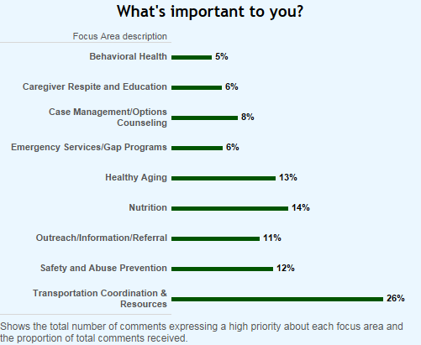
More than half the respondents indicated that ease of use was important, followed by access to bus passes, and transportation to medical appointments. Many people rely on alternative transportation provided by friends or family members, but this option was not available to everyone, every time it was needed.

Goal: Transportation coordination and resources will be readily available, easy to navigate, and distributed equitably across ADVSD service areas.
Objective: Promote inter-agency coordination and centralization of network information, referral and scheduling systems.

SECTION C – 10 Transportation Coordination & Access
Goal: Transportation coordination and resources will be readily available, easy to navigate, and distributed equitably across ADVSD service areas.

Measurable Objectives  Promote inter-agency coordination and centralization of network information, referral and scheduling systems. | Key Tasks |  | Lead Position & Entity | Timeframe for 2017-2020  (by Month & Year) |  | Accomplishment or Update
 |  |  |  | Start Date | End Date
 | a | Participate in regional Information and Referral Systems Integration planning, “early win” implementation project, and a long-range systems integration plan. | Ride Connection, ADVSD Program and Contract Liaison | July 2016 | December 2018 | The “One-Call/One-Click” planning committee has met regularly since late 2016. OC/OC committee has completed the work with consultants to create a plan that identifies and is reflective of the necessary conditions for developing a successful one-call/one-click transportation system that is easily accessible to community members, transit agencies, referral organizations, and transportation providers alike. Members of the committee presented the OC/OC project to the Joint MPAC/TPAC in 2018.  Ride Connection is pursuing funding to being the next phase of the project.
 | b | Conduct preliminary ADVSD Transportation Coordination program analysis | ADVSD Program and Contract Liaison | July 2016 | September 2016 | Completed.
 | c | Structured quality improvement analyses to Improve, re-engineer or innovate for more effective internal business processes | DCHS Quality Improvement Specialist ADVSD Community Services Program and Transportation Services Contract Liaison | September 2016 | December 2017 | Identified and corrected inconsistent billing process that had created high program administration costs. Made structural changes to OAA Transportation Coordination & Resources provider contracts beginning January 1, 2018. Transportation coordination is now a service provided by only qualified I & R providers and is billed at a percentage of the allocation awarded to contracted agencies to purchase transportation services. We have shifted from an exclusive38% of total transportation allocation to culturally specific providers.
 | d | Provide transportation coordination training and consultation, identify efficiencies, and conduct quality assurance activities. | ADVSD Transportation Services Contract Liaison, I & R, and contracted transportation providers | January 2019 | December 2019 | Conducted 682 transportation assessments and served 908 clients in FY 18.  Conducted bi-monthly training with I & R staff and transportation coordinators. Conducted customer satisfaction and usage survey via phone in English and with a random sampling of clients whose primary language is not English.
 | e | Staff participate in interagency transportation workgroups and committees | ADVSD Planning & Development Specialist & Contract Liaison | January 2018 | December 2020 | ADVSD staff now participate regularly in the Medical Transportation Advisory Committee, Tri-Met Committee on Accessible Transportation (CAT), Special Transportation Funds Advisory Committee (STFAC)

Section D: OAA/OPI Services and Method of Service Delivery

D-1: Administration of Oregon Project Independence (OPI)

Below are the procedures (supported by policies) that ADVSD and its contractors follow in administering the OPI program.

a. Describe how the agency will ensure timely response to inquiries for service.
OPI case managers are required by the ADVSD contract agreement and ADVSD case management policy and procedures to respond to inquiries for service within five (5) days of the referral. Gatekeeper referrals, which are more urgent requests, must be followed-up by face-to-face contact within five (5) days unless the caller indicates the situation requires more immediate investigation.

b. Explain how clients will receive initial and ongoing periodic screening for other community services, including Medicaid.
OPI case management is based on a holistic assessment of the client’s situation and client choice. It considers and finds services for the total needs of the client and does not restrict the assessment to an evaluation of problems for which an agency has services. The case manager plans, coordinates and implements a program of care, taking into consideration the client’s natural support system, such as family and non-family unpaid caregivers; client co-pays; and third party payments, etc. and uses these prior resources before OPI. Case managers may serve as advocates to obtain help for their clients by working with other service agencies and to identify and coordinate community resources and natural supports systems for all new referrals and ongoing clients. OPI may be used as a supplement to these primary resources as the client’s care necessitates. Clients are reassessed using the CAPS Tool and OPI Risk Assessment Tool annually or sooner as needed. The case manager documents the gross monthly income of the household, the allowable deductions of the household and determines a co-pay fee, if any, for services. If the client meets the eligibility criteria for Medicaid, the case manager will make the appropriate referral to a Medicaid branch office.

c. Describe how eligibility will be determined and by whom.
Eligibility is determined by two ADVSD staff specializing in OPI case management, at five District Senior Centers, and four culturally specific organizations contracted to administer OPI case management using the CAPS Tool in Oregon ACCESS and the OPI Risk Assessment tool found in the RTZ/Care tool. An applicant is eligible to receive OPI services if they:
- Are 60 years old or older; or under 60 years of age and diagnosed as having Alzheimer’s Disease or a related disorder (for OPI) or are between the ages of 18 and 59 (OPI Pilot);
- Are not receiving financial assistance or Medicaid, except Food Stamps, Qualified Medicare Beneficiary or Supplemental Low Income Medicare Beneficiary Programs;
- Are at immediate risk for nursing facility placement. Immediate risk is defined as the probability that the client’s condition will deteriorate in eight to ten months after loss of OPI services to a point that nursing facility placement is necessary;
- Score high on the OPI Risk Assessment Tool. The risk assessment considers activities of daily living, natural supports, the frequency of falls, etc. and is used to determine priority of clients served when OPI wait lists are being maintained;
- Do not have, or, have exhausted sufficient other resources to meet needs, such as personal income, personal assets, third party payment;
- Are already receiving an authorized OPI service and their condition indicates the service is needed; and
- Meet eligibility criteria of the OPI Rules and Oregon Administrative Rules.

d. Describe how the services will be provided.
ADVS contracts with five (5) district senior centers and four (4) culturally specific organizations to provide OPI case management services for eligible clients and provides OPI Pilot case management with two County Case Managers. An OPI case manager assesses the client using the Oregon Access Client Assessment and Planning System and develops a comprehensive plan of care with the client. If the client’s assessment and care plan warrants the provision of supportive services to maintain independence in activities of daily living in their home, case managers may authorize OPI services, depending on the needs and preferences of the client. Authorized hours are subject to the extent of client need and the availability of funds. Case managers authorize in-home services only to the extent necessary to supplement potential or existing resources within the client’s natural support system. Case managers select an appropriate service provider based on the client’s needs and preferences, availability of the service and the cost.
Personal care services, housekeeping services and respite care for eligible clients are provided by ADVSD contracts with in-home care agencies and the state Home Care Worker (HCW) program and by local, target service providers for approved and allowable OPI services. Before considering the HCW program to provide in-home services, the case manager assesses the capacity of the client to supervise and direct the work of the HCW. Services are established (via a service plan) and authorized by the Case Manager and provides detailed information to the client and the agency or HCW. The case manager monitors and evaluates the services being provided by the agency or HCW through visits to the client’s home, client feedback and communication with the caregiver/HCW. Case manager reassessments are conducted annually or sooner as needed for OPI clients. HCW rates are established by the Home Care Commission collective bargaining agreement and agency rates are established in the contracting process and written into the contracts.
Other OPI funded providers under contract with ADVS are adult day service centers and personalized grocery shopping service, all of which are contracted with ADVSD and authorized by district senior center case managers.
For all services for which OPI funds are used, the case manager makes the referral and authorizes the number of hours of service per week/month to the provider along with any other instructions needed to support the client’s plan of care. The service provider and the case manager communicate regularly with one another and when there are concerns or changes in the client’s condition or when there is a change in the number of authorized service hours.
ADVSD plans to make culturally specific OAA Case Management and culturally specific OPI service option available through an RFPQ to be released in May 2017.

e. Describe the agency policy for prioritizing OPI service delivery.
OPI services are prioritized for frail and vulnerable adults who are lacking or have limited access to other long-term care services; those who lack natural supports; and those meet the OPI service priority rule.
When OPI wait lists are being maintained, OPI case managers will prioritize clients who score high on the Risk Assessment Tool and are at the greatest risk for nursing facility placement if OPI services are reduced or eliminated. In order to maintain our funding and sustain the program most effectively, we also have implemented a cap of 15 hours per client.

f. Describe the agency policy for denial, reduction or termination of services.
Clients are informed in writing 30 days before the effective date of termination, reduction or denial of services. When a client’s services are terminated, reduce or denied, the case manager will continue to work with the client to identify and coordinate other supportive services for the client.
Contracted in-home care providers are required to provide services for all clients referred by district centers. Providers will make a special effort to meet the needs of clients with unique living and personal situations, including clients with challenging behavioral issues, and are expected to initiate and continue services under less than ideal conditions while an acceptable plan is being developed in cooperation with the case manager.
In-home care providers may not refuse service to any client referred by district centers unless the in-home worker would be in danger of immediate physical injury, including active use of illegal drugs. In such cases, the provider will immediately contact the case manager with the pertinent details, to be followed by a written confirmation from the provider of the situation to ADVSD within two (2) working days.
A provider may discontinue services to any client who sexually harasses in-home workers or professional staff after having provided a warning to the client to desist in such behavior. The provider will notify the case manager with a written copy of the warning communicated to the client.
In the event the provider is unable to retain a worker for a client due to other client-related causes:
  - The provider supervisor will investigate the problem and report findings to the case manager for mutual resolution. The provider will then place a second caregiver with the client after appropriate instructions are given.
  - If the second caregiver is unable to fulfill the required service, the provider will advise the case manager and client of the problem both via phone and in writing. The case manager will discuss the situation with the client and notify provider when a third caregiver may be assigned to the client.
  - If the third caregiver is unable to provide the services authorized, the provider may be released from serving this client.

g. Describe the agency policy for informing clients of their right to grieve adverse eligibility and/or service determination decisions or consumer complaints.
Clients are informed of their rights and responsibilities, in writing, at the time of determination. They are also informed of both the District Senior Center and ADVSD escalating grievance policies. They are provided this information each time they have a consumer complaint or have had services reduced, denied, or terminated. Each District Senior Center must have their policy approved by ADVSD and they may vary. See Appendix G.

h. Explain how fees for services will be implemented, billed, collected and utilized.
A one-time fee of $25.00 is applied to all individuals receiving OPI authorized services who have adjusted income levels at or below federal poverty level. The fee is due at the time eligibility for OPI authorized services has been determined. This fee does not apply to home-delivered meals.
Fees for authorized services are charged based on a sliding fee schedule to all eligible individuals whose annual gross income exceeds the minimum, as established by the State Department of Human Services. The OPI case manager determines the appropriate fee in an initial assessment visit, documenting all monies coming into the client’s household, and itemizes the income on the OPI Income/Fee Determination worksheet. The client’s gross monthly income is determined based on a sum total of the itemized amounts. Income that is itemized includes social security, VA benefits, pensions, salaries, interest, dividends and annuities, railroad benefits, rental and sale of property and other income. The case manager documents the allowable deductions, which include prescription drugs, over-the-counter medications, supplemental insurance, doctors’ co-pays, dental/vision exams, hospital costs, medical equipment/supplies and other medically related deductions. The case manager adjusts the monthly income (monthly income minus allowable deductions) and using the adjusted income and the OPI In-Home Service Fee Schedule determines the fee for service. The client is asked to sign the OPI Income/Fee Determination Worksheet to acknowledge that he/she understands the OPI fee schedule and to agree to pay the fee per month for services.
For contract agency (non-HCW) providers the case manager informs the provider of the client’s monthly fee. The provider of the service bills client fees monthly and reports this to the case manager. Clients submit their fee payments to the provider monthly. For the HCW program the case manager bills the client monthly for the client fees. Clients send their fee payment to ADVS, where it is collected and reported to the case manager. Client fees for both contract agency and the HCW program are used to expand in-home services so that the service can be offered to others who need it.

I. Describe the agency policy for addressing client non-payment of fees, including when exceptions will be made for repayment and when fees will be waived.
Client fees are a mandatory feature of OPI service provision and not voluntary. If the client refuses income information or refuses to pay appropriate fees, the case manager cannot authorize OPI services. In circumstances where client payment of fees is in arrears, these collection procedures are followed:
- Service provider provides OPI case managers with names of clients with unpaid balances.
- Case manager monitors payment of fees and is responsible for the investigation and correction of non-payment situations using these steps:
  - Confirms client payment status with provider prior to speaking with client.
  - Informs client of arrearage and discusses payment with client, reviewing client co-payment expectations of the OPI program.
  - Clarifies client income information, medical expenses, and adjusts client fees where appropriate.
  - Determines whether money management services are indicated due to client difficulty in handling bill payment generally.
  - Notifies client orally and in writing that non-payment may result in termination of service and establishes deadline for payment not more than 30 days from day of notice.
  - Reminds client at least 2 weeks prior to termination that service will end and reason for termination.
- Client non-payment of OPI fees results in termination of service.
Exceptions to the repayment of fees will only be made in extreme situations, such as when it would become a financial hardship for the client. Even then, the OPI case manager will make every effort to work with the client on a plan to repay the balance of the fees.

j. Delineate how service providers are monitored and evaluated.
ADVSD conducts regular monthly monitoring of our service providers at the time of invoicing. This monitoring includes:
- Timeliness of invoice submission
- Accuracy of invoice, reconciled with client data
- Validating that clients who receive services through an in-home agency have a current assessment and service plan
In addition, ADVSD is instituting random audits of in-home agency invoices, comparing invoiced data with actual time sheets to ensure that services billed were actually provided.
ADVSD also conducts monitoring on various programs and partners via the SUA monitoring schedule, including nutrition, Adult Day Services, and EBHP providers.

D-2 Services Provided to OAA and/or OPI Clients
See Section B-3 AAA Services and Administration and Attachment C Service Matrix and Delivery Method
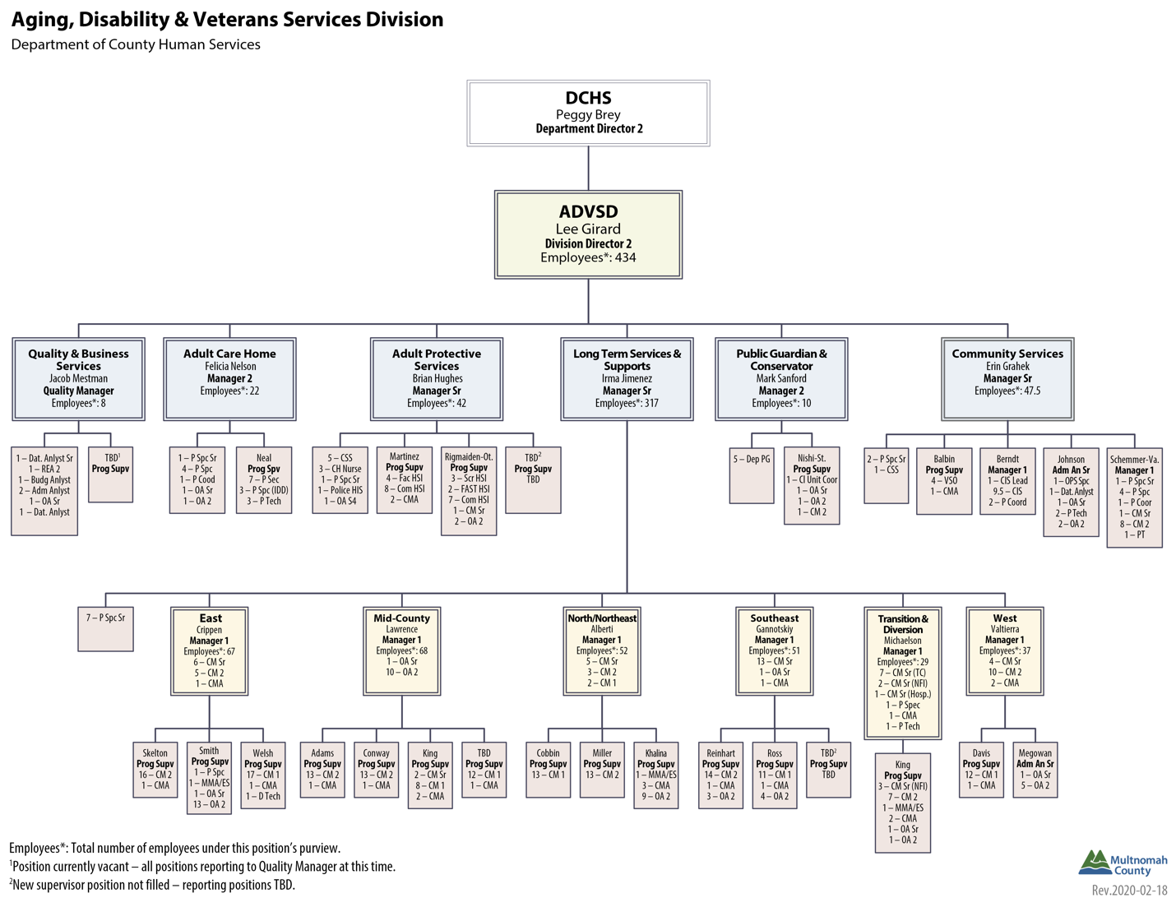
Appendices
Appendix A: Organizational Chart

Appendix B: Advisory Council(s) and Governing Body

Aging Services Advisory Council (ASAC)

Muz Afzal  503-232-0010  muz@seuplift.org | Bill Richard  202-236-3717  bill.richard.rpg@gmail.com
Rai McKenzie
503-754-9879
Raizmckenzie@gmail.com

Betty Cox
408-712-7484
bcox55@sbcglobal.net
Semion Gurvich  971-340-9240  s.b.gurvich@gmail.com | Amy Yum  503-739-4000  amy5622@comcast.net
David Daley
503-341-7243
David.l.daley@gmail.com

Demographic Data

Total number age 60 or over = 7
Total number minority = 5
Total number rural = 0
Total number self-indicating having a disability = 2

Disability Services Advisory Council (DSAC)
Grace Reed
503-484-6672
grace@negotiatingshadows.com
Ashley Carroll  503-988-7649  Ashley.carroll@multco.us | Barb Rainish  503-519-9334  Brain71698@gmail.com
Rai McKenzie
503-754-9879
Raizmckenzie@gmail.com

Demographic Data:

Total number age 60 or over = 2
Total number minority = 1
Total number rural = 0
Total number self-indicating having a disability = 4

Multicultural Action Committee
The Multicultural action Committee has been invited to join the Aging Services Advisory Council as of November 2019. A seat will be allowed for each organization and an organizational representative of their choosing will be named to the ASAC beginning February 2020.
Mission: To proactively advise and shape Multnomah County Aging, Disability, & Veteran Services Division policies, programs, and services to create equitable access, culturally responsive programming, and identify and advocate for the unmet needs of elders and people with disabilities who also identify as members of underrepresented groups; such as cultural, racial, and ethnic minorities, LGBT, immigrants, and refugees. Membership is open to ADVSD Enhancing Equity contractors, community stakeholders, and community representatives. Current membership consists of representatives from the following organizations:
African American Health Coalition | Impact NW
Asian Health & Service Center | Immigrant & Refugee Community Organization
Ecumenical Ministries of Oregon | Latino Network
El Programa Hispano Católico | Native American Youth & Family Center
Elders in Action | Neighborhood House, Inc
Friendly House/SAGE Metro Portland | Urban League of Portland

Governing Body – Multnomah Board of County Commissioners
Name & Contact Information | Office | Date Term Expires
Deborah Kafoury  (503) 988-3308 | Chair, Multnomah County Board of Commissioners | 12/31/2022
Sharon Meieran  (503) 988-5220 | Commissioner, District 1 | 12/31/20
Susheela Jayapal  (503) 988-5219 | Commissioner, District 2 | 12/31/2022
Jessica Vega Pederson  (503) 988-5217 | Commissioner, District 3 | 12/31/20
Lori Stegmann  (503) 988-5213 | Commissioner, District 4 | 12/31/20

Appendix C: Public Process
The planning and review process outlined in Section A-3 Planning and Review Process discusses efforts ADVSD undertook to assess the needs of the county’s older adults and people with disabilities, and seek input from the community about agency goals and objectives for 2017 through 2020. A timeline of these activities is listed below.

- April-May 2015: ADVSD Community Services RFPQ Workgroup convened that helped establish five foundational assumptions for OAA funded services: 1) Maintain a regional and culturally specific approach to service delivery; 2) Maintain the major service areas; 3) Maintain commitment to funding culturally specific services; 4) Be participant-centered and participant-directed; and 5) Build on recent service system changes.

- Feb-May 2015: Community Services Consumer Satisfaction survey conducted by PSU at congregate meal sites.

- August-September 2015: Community Satisfaction community workgroup convened to review Consumer Satisfaction report and determine next steps.

- October 2015: Community stakeholder workgroup outcomes issued in five languages.

- January 2016: Advisory council members and stakeholders help ADVSD staff to develop the approach for the Area Plan outreach process and tools to be used in identifying community needs.

Community Listening Session Schedule
April 14  2-3:30pm  Rose Schnitzer Tower  1430 SW 12th Ave, Portland | April 20  1:45-3:15pm  Oregon Building  800 NE Oregon, Portland | April 25  11:45am-1:15pm  NAYA  5135 NE Columbia Blvd, Portland
May 17*(Russian, Nepali)  10:30am-12pm  IRCO  10301 NE Glisan St, Portland | May 19*(Vietnamese)  10-11:30am  Asian Health & Service Center  3430 SE Powell Blvd, Portland | May 24*(Korean)  10-11:30am  Asian Health & Service Center  3430 SE Powell Blvd, Portland
May 25* (Spanish)  1-2:30pm  El Programa Hispano Católico  138 NE 3rd Street, Gresham | May 26*(Swahili, Eritrean, Arabic, Oromo, Ukranian)  10:30am-12pm  IRCO/Africa House  631 NE 102nd, Portland | May 26 *(Spanish, ASL)  2:30-4pm  YWCA  600 NE 8th St, Gresham
June 2*(Mandarin)  10-11:30am  Rose Schnitzer Tower  1430 SW 12th Ave, Portland | June 7*(Cantonese)  10-11:30am  Asian Health & Service Center  3430 SE Powell Blvd, Portland | June 8  10-11:30am  Hollywood Senior Center  1820 NE 40th Ave, Portland
June 8  3-4:30pm  NE Multicultural Senior Ctr.  5325 NE MLK Jr. Blvd, Portland | June 9 *(Cantonese, Mandarin, Vietnamese)  10:30-12pm  APASC/Impact NW  4610 SE Belmont St | June 10  4-6pm  Private residence
June 21  9:30-11am  Allen-Fremont Plaza  221 NE Fremont St, Portland | June 23  2-3:30pm  Friendly House/SAGE Metro Portland  1737 NW 26th Ave, Portland | June 25  10-11:30am  Q Center  4115 N. Mississippi Ave, Portland
Community listening sessions were advertised using flyers in each of the languages identified and interpretation was available as indicated. This message was provided on all publicity materials: *Interpretation scheduled for languages indicated in parenthesis. For interpretation or other accommodations for any of these events, please call (503) 988-3646. Schedule subject to change without notice. Visit www.multco.us/ads for updates.

- July - August 2016: Distribute paper surveys to Multnomah County Library Books-by-Mail Program participants.

- July 2016: Advisory council members and staff draft goals and objectives using community listening session data.

- August 2016: Draft Area Plan released. Public comment accepted via postal mail, email, or phone through September 13, 2016.

Public Hearings
- August 23, 2016: 2:00-3:30pm; Multnomah County Board Room; 501 SW Hawthorne Blvd, Portland.
- August 24, 2016: 5:30-7:00pm; Sharron Kelley Room; 600 NE 8th, Gresham

Additional Public Process
- September 2016: Revised 2017-2020 Area Plan Draft reviewed with advisory councils and governing board for final approval.
- October-March 2016: Revisit community listening session locations and provide an overview of the listening session data, in multiple languages, and demonstrate how it was used to develop the Area Plan. Use these meetings to educate the public about the current services and to better understand the barriers experienced by community members. Subsequent annual updates to the Area Plan will reflect learning and any new opportunities developed from these public meetings.

Appendix D: Final Updates on Accomplishments from 2013-2016 Area Plan

Family Caregiver Support Program:
Family Caregivers will have access to information about community resources that can assist them in caring for older adults.
Objectives:
1. The FCSP will sponsor three (3) public events yearly throughout Multnomah County to provide information to family caregivers.
The FCSP sponsored or co-sponsored six community events in FY16 specifically for family caregivers. Three events were co-sponsored with AARP and Providence Elder Place. They were well publicized and well attended because of the outreach capability of these partners. We also held two “Families Talk about Elder Care” series, one at the City of Portland and one at Concordia University. These series consist of three to four workshops which are targeted specifically for working caregivers. Participants rated all workshops in the series as being helpful and high in quality. There was a third series in Gresham that was cancelled due to lack of attendance. It is unclear why this series did not get registrants as prior events in Gresham have been well attended. We intend to work with Gresham’s community newspaper to promote this series in the future.

2. The FCSP Coordinator will meet six (6) times per year with community partners to promote Information and Assistance (I & A) services provided by ADVSD’s Helpline.
The FCSP Coordinator participated in a presentation with I & A staff and supervisors from all the Senior District Centers to discuss specific FCSP workshops and interventions offered for family caregivers caring for elders with Alzheimer’s or another Dementia. An additional visit to each of the five District Senior Centers was made to provide technical assistance to case managers; information is also regularly provided via email to the ADVSD community services network. The FCSP Coordinator has begun additional outreach efforts with culturally-specific providers and Community Health Specialists to share caregiver resources and discuss needs specifically in minority communities. These efforts have shown preliminary success in reaching new family caregivers.

3. District Senior Center Case Managers and community agencies will provide a minimum of 3,500 hours of Options Counseling to family caregivers annually.
We provided an average of 1900 hours of Caregiver Access Support for caregivers under the Family Caregiver Support Program. Additionally, we provided approximately 11,000 hours of Options Counseling through District Senior Center Case Managers. The impact of Alzheimer’s and related Dementia is more apparent in people seeking services and our program is seeking innovative ways to leverage existing resources to serve the growing demand.

Information & Assistance/ADRC Goals:
1. Older adults, people with disabilities (includes physical, intellectual and behavioral disabilities), veterans and their family members and professional support networks will have access to information, community resources, decision support and transition support across care settings.
2. Older adults, people with disabilities, veterans and their families will have streamlined access to public benefits.
3. Older adults, people with disabilities, veterans and their families will have access to the full spectrum of ADRC supports within the four-county Metro region, regardless of where they “enter” the system.
Objectives:
As part of our ongoing regional ADRC customer satisfaction survey, Multnomah County ADRC exceeded state standards for quality assurance in 2015, as reflected in our consumer satisfaction with both quality of service and ease of access. Survey results are routinely shared with the Community Information Specialists across the Metro ADRC. We have used this as an opportunity to develop customized training and support for staff.
1. 80 percent of consumers will report that ADRC staff was good or excellent in helping them understand the service system.
In 2014, 56% of respondents rated ADRC staff as Excellent with regard to explaining how to get the help or information they needed and 23% of respondents rated the ADRC staff as Good for a total of 79%. In 2015, 54% of respondents rated ADRC staff as Excellent with regard to explaining how to get the help or information they needed and 34% of respondents rated the ADRC staff as Good for a total of 88%.
We attribute this 9% one-year improvement to our focus on quality at a regional and local level. Our staff is AIRS certified and the ADRC team is actively engaged in continuous quality improvement. We not only consistently monitor for the quality of experience by our consumers, but we monitor the quality of the data input into the system, the validity and appropriateness of information listed on the searchable website, and provide technical assistance to ensure our contractors providing these services are also successful.

2. 100 percent of Volunteer Benefits Assistance Team members will be centrally dispatched to work with Medicaid branch offices.
This goal was achieved by the end of 2014 and was removed during the 2015 Area Plan update.

3. 75 percent of consumers at District Senior Centers; agencies that specifically serve racial, ethnic, and sexual minority elders; and meal sites will express satisfaction with services and activities at these community access points.
In 2014, ADVSD hired PSU Institute on Aging to conduct consumer satisfaction surveys and the results, in part, have shaped many of our quality improvement efforts since then. ADVSD has not yet set up a standardized means for gathering consumer experience information but are on track to roll this out in 2017 as part of our performance management efforts. The challenge has been creating a valid sample to measure the satisfaction of racial, ethnic, and sexual minority elders. We worked with a diverse group of stakeholders to guide the evaluation process.

4. 75 percent of consumers will report that it would be easy or very easy to contact the ADRC again.
In 2014, 66% of respondents selected Very Easy with regard to how easy it would be for them to contact the ADRC again and 18% selected Somewhat Easy for a total of 84%. In 2015, 70% of respondents selected Very Easy and 19% selected Somewhat Easy for a total of 89%, demonstrating a 5% improvement and accomplishment of the objective. We hear at every community event when we present, or with new interactions, that many people are unaware of this invaluable resource until a crisis occurs. ADVSD will continue to strive for positive connections with returning users, but we will also seek opportunities to reach new people with this thriving resource.

Elder Abuse & Legal Assistance Goals:
1. ADVSD will develop and implement a strategic plan to ensure that older adults and people with disabilities have access to protection against abuse, financial exploitation, and neglect, with particular attention focused on resources, access, public education and outreach, and policies.
2. Improve and expand access to education on health care fraud for Medicare beneficiaries through the Senior Medicare Patrol project.
3. Older adults with civil cases will have access to free legal services.
4. Reach low income Oregonians eligible for, but not currently receiving, a Medicare Savings Plan (MSP) or Low-Income Subsidy benefits (LIS), particularly those in rural areas.
Objectives:
1. 80 percent of vulnerable adults served by the APS Multi-Disciplinary Team will have an improved living situation after 90 days of an intervention.
The APS Multi-Disciplinary Team has been involved in a project to evaluate many elements of this program including, but not limited to, the current utilization of the program, client outcomes, and services used by client before and after referral to the MDT. While 20 percent of all MDT clients saw an improvement in living arrangements at the close of MDT, not all clients had living situation risk upon receiving services. ADVSD identified the outcome data was inadequate and the objective itself may mask more important questions, such as those mentioned previously. Tools and processes are being developed now to address these issues.

2. 1,500 Multnomah County Medicare/Medicaid beneficiaries will receive personalized counseling by skilled volunteers through the Senior Medicare Patrol project, with special attention devoted to increasing the number of Hispanic/Latino and urban American Indian/Alaskan Native beneficiaries.
Approximately 1575 Medicare/Medicaid beneficiaries received personalized counseling by SHIBA/SMP volunteers each year 2013-2016. Approximately 2%, 5%, and less than 1% of those visits were with Hispanic/Latino, African-American, and Native American elders respectively. The combined SHIBA/SMP program's outreach events targeted to Hispanic/Latino and African-American elders have decreased from 69% of outreach events to 36% in recent years. Targeted outreach to urban American Indian/Alaskan Native beneficiaries has decreased from 59% to 17%. This decrease in outreach has not substantially changed the number of appointments made with individuals, pointing to a need to change our strategies and redouble our efforts to provide services equitably. We will address these barriers by providing dedicated staff resources to effectively and continuously engage in relationship building in these diverse communities, and address gaps in cultural competency through continued training of current volunteers and engagement of new volunteers that identify within these communities.

3. 800 older adults will receive civil legal assistance yearly.
ADVSD served an average of 897 older adults with civil legal assistance, annually. This program has benefited from a consistent provider and the well-informed and connected aging network that refers people to this service. New efforts will be made in the future to reach into underserved communities to ensure this program is accessible for all people.

4. ADVSD will coordinate with advocacy organizations to provide guidance, education, resources, and support to older adults in financial crisis with regards to local taxes.
ADVSD supports consumers with two property tax programs. The first is our ongoing property tax reimbursement fund, involving a partnership with the Oregon Department of Revenue, advocacy with financial institutions and tax authorities on behalf of clients, and assisting clients in obtaining the pertinent documentation needed to issue accurate reimbursements. The second program was also a partnership with the Oregon DOR and the ADRC, where we contacted 152 homeowners last spring to assist them in recertifying their Senior Property Tax Deferral. Additionally, as issues arise, such as the City of Portland Arts Tax, we work with volunteer advocates to provide information to the public and assist in the completion of paperwork to quality for a tax exemption.

5. 2,000 individuals will have been screened and 255 assisted in applying for a Medicare Savings Plan and 2,500 will have been screened and 595 assisted in applying for LIS benefits.
Multnomah County conducted 1429 of the 6262 (22%) individuals screened statewide for Medicare Savings Plan and helped 119 of the 490 (24%) applicants enroll into the program statewide. Multnomah County conducted 1,444 of the 8537 (17%) statewide screenings for the Low-Income Subsidy program and enrolled 93 of the 735 (13%) statewide applicants. Considering that Multnomah County is home to just 16% of the State’s Medicare enrollees and 13% of the state’s LIS/MSP eligible, we are proud to have exceeded or met our goal in each category. Our success is due to a well-trained and well-coordinated team of SHIBA volunteers, Medicaid branch offices, OPI sites, and I & A coordinators that understands the value of this program.

Health Promotion Goals:
1. Older adults and people with disabilities will maintain or improve their physical and emotional health through participation in evidence-based programs.
2. Older adults and people with disabilities with chronic conditions will improve their ability to manage their illness or disease through participation in Stanford Chronic Disease Self-Management Programs,
3. Health disparities in communities of minority group elders will be partially addressed with targeted evidence-based health promotion and disease prevention programs through contracts with culturally specific organizations.
Objectives:
1. Seventy-five (75) percent of participants in evidence-based exercise programs at contracted district senior centers and community agencies serving minority group elders will attend the minimum number of classes required to meet completion rate standards determined by the State Unit on Aging.
None of the exercise programs offered in FY 15 reached the 75% target, and only one was successful in 2016. Health promotion activities continue to face similar successes and similar challenges. The evidenced-based exercise classes are among the most widely offered and favored classes provided by the county, however the high frequency of classes in any given week lowers the likelihood of completion per State Unit on Aging standards. There are dedicated attendees, but also many who choose not to attend during busy times of the year or when they are not well. Incentivizing participants who consistently attend and complete these exercise programs may provide additional motivation, but it seems that relationships with others, access to transportation, and many other factors also play a part in a person’s willingness or ability to attend classes consistently for months on end. Despite these low completion rates, these classes remain popular and meet other important needs, such as drawing people to congregate meal sites, helping reduce isolation, and providing a means of checking on attendee’s well-being.

2. Seventy-five (75) percent of participants in Stanford Chronic Disease Self-Management Programs, including Living Well with Chronic Conditions, Tomando Control de su Salud, and Diabetes Self-Management Program workshops provided by contracted district senior centers and community agencies that serve minority group elders will complete four of six classes.
In FY15, 14 out of 18 classes maintained a 75%+ completion rate; for FY16, 5 out of 7 classes maintained a 75%+ completion rate. The Stanford workshops continue to be valued courses in the community, however there are common issues that the contracted partners face when working towards the target completion. First, preparation and coordination of these workshops can be complicated by a lack of trained leaders, poor attendance due to planning inconsistencies, and issues with attendance for participants based on their health or transportation needs. Developing good relationships with participants is essential, as is consistent communication, and building in a web of support to ensure people can overcome barriers. ADVSD will be creating more guidance and technical support in the future to support even greater success.

3. ADVSD will collaborate with community partners to promote SNAP, SFDNP, farmers market SNAP match programs, and other initiatives that help improve older adults’ access to healthy food at a minimum of three (3) public events yearly.
Despite meeting these objectives, many older adults and people with disabilities are not accessing benefits for which they are eligible. The Department of County Human Services has hired a Food Policy Coordinator, who will work with ADVSD, and others, to address this, and other hunger and nutrition related issues.

4. Implement a process for referring ADVSD clients to appropriate health promotion activities by June 2015.
The referral process now utilizes a county-wide calendar that lists all current health promotion activities provided by ADVSD funded programs. The ADRC Helpline and case managers have been educated and encouraged to actively refer clients to these workshops. In the near future, this process will be improved through the use of the COMPASS Portal. The COMPASS Portal is a web based online application that will allow easy registration by any resident in the county. It will also provide quick and easy access to available workshops and classes for most of the health promotion classes offered within our county, regardless of payer or provider.

5. Implement evidence-based mental health programs to serve the needs of older adults and people with disabilities.
In 2014, ADVSD began offering a home-based program for older people experiencing anxiety, depression, or substance use issues called Program to Encourage Active and Rewarding Lifestyles (PEARLS). In 2014 and 2015, with these same grant funds, we offered successful suicide awareness and prevention training for professional and unpaid caregivers. PEARLS served an estimated 160 people in its first full year and will continue. With the addition of the Older Adult Behavioral Health Initiative, ADVSD has increased it understanding and skill in serving the behavioral health needs of aging adults that do not neatly fit into any one system.

Older Native Americans Goal:
Goal #1: Enhance services for urban Native American elders by promoting capacity-building in agencies that serve them.
Objectives:
1. ADVSD will contract with NARA to provide 580 hours of short-term case management and 120 recreation activities yearly.
The NARA contract had been non-functioning for more than 3 years. When new liaison was assigned, several attempts in FY 16 were made to reach the organization with no follow through from NARA as it appeared to be unassigned to any staff person. Towards the end of 2016 a letter giving a 30-day termination notice was sent to the agency and at that point NARA leadership engaged with the ADVSD and we met and changed the terms of the contract to recreation only with support for an ongoing elder group, a Pow Wow and an elder conference. Currently the contract is going better with more contact with NARA and support from ADVSD. It appears to be working now as NARA staff is assigned to the contract and more involved with ADVSD.

2. ADVSD will contract with NAYA to provide 732 hours of Older Americans Act Case Management, 130 classes of Tai Chi: Moving for Better Balance, six (6) Recreation activities and 1,418 congregate meals yearly.
NAYA provided Options Counseling and not Older Americans Act Case Management. They provided 348 hours in FY 16 and 664 hours in FY 15. 828 classes of Tai Chi provided in FY16, an increase from 251 in FY 15. Seven Recreation Activities in FY16 and six in FY15. NAYA added breakfast as a nutrition service in FY 16, increasing ethnic meals from 1,409 in FY 15 to 2,085 in FY 2016.

3. ADVSD will contract with NAYA to provide one (1) Savvy Caregiver workshop, two (2) Powerful Tools for Caregivers workshops, two (2) Walk with Ease Workshops as part of the State Unit on Aging Evidence-Based Health Promotion expansion in FY 2015.
NAYA hosted Savvy Caregiver training in FY 15, but funding for this program was provided under one-time expansion funds. Although they were successful in conducting the Savvy Caregiver training and thereby creating some capacity in the community to provide the program it is unfunded. NAYA hosted Powerful Tools for Caregivers and two Walk with Ease series in FY 15.

Nutrition Goal:
Older adults will have ready access to healthy food that is affordable.
Objectives:
1. Meals on Wheels People will deliver 390,000 meals containing 1/3 of the US RDA to homebound older adults.
This objective was met with increasing participation. As many as 415,350 meals were delivered in FY 16, an increase of approximately 9,000 meals in one year.

2. Meals on Wheels People’s congregate nutrition sites will serve fresh fruits and vegetables for a minimum of four (4) months each year.
This goal was consistently met.

3. Meals on Wheels People’s congregate nutrition sites will provide 220,000 meals containing 1/3 of the US RDA to older adults who attend the sites regardless of their ability to make a monetary donation.
This objective was not quite met in FY 15 or FY 16, with 215,012 and 193,133 meal provided, respectively. Although no person was turned away, these numbers do highlight an opportunity for better promotion of congregate meals and possibly a need for program innovation to draw more people.

4. Culturally-specific congregate meal providers—Asian Health and Service Center, NAYA Family Center, El Programa Hispano, and the Immigrant and Refugee Community Organization-- will serve 10,780, 1,418, 919, and 5,950 meals containing 1/3 of the US RDA, respectively, to older adults who attend the sites regardless of their ability to make a monetary donation.
Asian Health and Service Center provided 14,769 and 10,393 meals in FY 16 and FY 15, respectively. NAYA served 1,340 and 1,409 meals in FY 16 and FY 15, respectively. El Programa Hispano served 2,085 in FY 16 and increase from 831 in FY 15. IRCO served 7,891 in FY 16 and 6,518 in FY 15. These culturally specific organizations were able to maintain or increase the number of meals served because of a one-time allocation of County General Funds at ADVSD request. Some of the organizations had a lack of available physical space to hold meals, others a lack of access to affordable transportation for participants, and for some, meeting the nutritional standards when using restaurants to provide culturally specific meals was a barrier. These barriers were largely overcome through flexibility and creative problem solving.

5. Twelve (12) Meals on Wheels People’s congregate nutrition sites will provide nutrition education a minimum of four (4) times yearly.
Meals on Wheels People provided this education as an in-kind service 8-10 times per quarter throughout these various congregate meal sites.

6. Eight (8) Meals on Wheels People’s congregate nutrition sites will provide information about the Senior Nutrition Assistance Program a minimum of one (1) time each year.
The program is still underutilized. Working with DCHS Food Policy coordinator to reach underserved populations and maximize utilization of SNAP benefits among older adults.

7. ADVSD will promote SNAP authorized farmers markets and SNAP match markets.
ADVSD completed their role in this particular work in 2014. The DCHS Food Policy Coordinator will be working on this and other senior nutrition programs.

Equity Goal:
Make equity the foundation of planning, programming, and service delivery.
Objectives:
1. The Multicultural Action Committee (MAC) will identify and implement three (3) actions annually related to advocacy, advising, and education.
MAC members have advised Multnomah County on a multitude of issues and participate in legislative action days, helped host a People’s Forum to raise awareness of the important of Oregon Project Independence. This committee has improved marketing materials for ADRC, older adult behavioral health, served on hiring panels for key AAA staffing positions, developed recommendations that influence RFP that impact older adults and people with disabilities, etc. This group is now working collaboratively with two other advisory council groups, SAC and DSAC to elevate the understanding of how racial, ethnic, and cultural minorities may be disparately or differently impacted to improve overall advocacy at these important intersections.

2. In collaboration with the MAC, ADVSD will host two (2) annual trainings on the Equity & Empowerment Lens for its staff, community partners, and advisory council members.
The Equity & Empowerment Lens training continues to be a mandatory training for ADVSD Staff, and many advisory council members have had the opportunity to participate in the full training or elements of it.

3. ADVSD will implement Multnomah County’s Equity & Empowerment Lens by January 2014.
The Equity & Empowerment Lens (EEL) is being utilized in every program area of Aging, Disability, and Veterans Services Division. The EEL is one tool that has many applications. We have trained champions within every program area to facilitate the use of the EE Lens so we are able to expand the work in everyday projects and long-range planning efforts. This intentional focus on equity is becoming part of our organizational DNA and is embodied in staff meetings, data collection improvements, woven throughout workplans, and reinforced through shifts in funding that address disparities experienced by racial, ethnic, and cultural minorities.

4. ADVSD will implement Visibility Initiative standards to improve recording and tracking of client race and ethnicity data by June 2013.
This work continues in all ADVSD controlled data activities. For instance, the Veterans Services Office recently implemented a new referral form that offers expanded options for identifying gender, ethnicity, and sexuality. Unfortunately, many of our programs are required to use data systems outside of ADVSD control and in these cases; our ability to collect data to Visibility Initiative standards is limited.

5. ADVSD will sponsor five (5) activities annually to gather information about LGBT veterans’ needs and educate staff and community partners about issues affecting the entire LGBT elder population.
We met this goal through partnership with community leaders, stakeholder organizations, and informant interviews. We have developed marketing and information materials to better reach our intended audiences, and with the help of a regional LGBT Alliance have begun to expand these efforts across multiple counties. Connecting with and service to LGBT-identified people is an ongoing effort for Veterans Services Officers and other ADVSD staff.

6. ADVSD employees will receive training and education about the issues facing LGBT older adults.
Through the LGBT Alliance, a group of county ADVSD staff dedicated to this objective, we are raising awareness and identifying needs both internal and external to our division. Two of our most visible successes were participation in PRIDE Portland over the past few years and the development of Safe Space posters for each of our offices and the associated trainings to make the campaign effective. ADVSD staff and leadership have presented our LGBT outreach and education efforts at national conferences and we are often lauded as leaders in this arena. Staff training consists of monthly diversity conversations during all-staff program meetings and Gen Silent continues to be a required training for all ADVSD staff members.

7. ADVSD will increase the capacity of providers to meet the needs of underrepresented groups residing in the Adult Care Homes.
In 2014, the LGBT Welcoming Designation was created in response to consumer and stakeholder concerns and the desire to create culturally responsive Adult Care Homes. We currently have 9 such designated homes and there are currently five more Operators going through the designation process.
In 2015, ACHP added a mandatory core curriculum called Honoring Diversity aimed at improving the cultural competency of all providers. 620 providers were trained and every new provider is required to take the class.
While the majority of Adult Care Home operators are Slavic immigrants and people of color, many of our current operators are reaching retirement age and closing their homes. As we continue to open new homes to replace the old we have begun to see a shift from a majority of Slavic immigrant operators to a more diverse operator base.
In general, there is an increased need for adult care homes. The program struggles with recruiting new homes that can meet the current demands of our area, including homes that are culturally responsive, can manage complex medical needs, and who have skills in supporting consumers who are experiencing issues of mental health and addictions.
Our region is growing older, becoming more diverse, and housing costs are rising. There is also an increased expectation for operators to provide a person-centered environment. The focus of our work ahead will be to define the populations that need resources and to continue to improve the cultural competency and readiness of all operators to serve diverse communities. The ACHP will continue to expand the knowledge of providers about issues of diversity and equity. We are working towards a better understanding of the barriers to becoming an operator through surveys and focus groups, and meeting with culturally specific providers to understand how we might address any barriers in application process.

Health System Transformation Goal:
ADVSD, regional Long-Term Care (LTC) partners, and regional Coordinated Care Organizations (CCOs) will partner to coordinate care and share accountability for individuals receiving Medicaid-funded long-term care services in an effort to reduce costs and deliver high quality, person-centered health and long-term care.
Objective:
ADVSD will establish formal agreements and protocols with regional CCOs beginning in December 2014, and as needed, to address:
- High needs members;
- Individualized care planning;
- Transitional care practices;
- Member engagement and preferences; and
- Member care teams.
ADVSD established formal Memorandums of Understanding with both Health Share of Oregon and Family Care CCO that were effective July 1, 2014. ADVSD formed a Tri-County Joint Aging, Disability and Health Steering Committee that has met at least bi-monthly since July 1, 2014. With guidance from this Committee, ADVSD has established uniform protocols and processes for holding inter-disciplinary care coordination conferences with both CCOs. This included incorporating the principles of individualized care planning, seeking information about member engagement and preferences, and forming member care teams that reflected all of the health, behavioral health, and Medicaid-funded service providers working with each CCO member.
Between July 1, 2014 and June 30, 2016, approximately 100 inter-disciplinary care coordination conferences were held. A partial analysis of the outcomes from these care coordination conferences indicated close to a 50% decrease in emergency and inpatient hospitalization for the members whose care needs we addressed in these care coordination conferences. ADVSD also sought to document transitional care practices among the members of the Tri-County Joint Aging, Disability, and Health Steering Committee members. However, during this period, all of the local health systems have been engaged in developing and refining their approaches to care transitions, making it difficult to document their practices or forge new partnerships.
Despite this challenge, ADVSD has been able to develop pilot projects as well as new contractual relationships related to offering Coleman-model Community Care Transitions to Medicaid and Medicare members at Portland Providence Medical Center, Oregon Health Sciences University Hospital, an Avamere nursing facility, and a Prestige nursing facility. ADVSD has also sought to increase CCO understanding and utilization of the Medicaid LTSS program’s transition and diversion services across the region.

Appendix E: Emergency Preparedness Plan(s)

DCHS: ADVSD Continuity Plan Summary
Document can be found at https://multco.us/ads

Severe Weather SOP
Document can be found at https://multco.us/ads

Appendix F: List of Designated Focal Points

ADSD’s contracted District Senior Centers are the designated focal points in the county and are listed below.
West Consortium
- Friendly House (Lead Agency)
1737 NW 26th Ave, Portland, OR 97209
- Neighborhood House Partner Agency)
7688 SW Capitol Highway, Portland, OR 97219

North/Northeast Consortium
- Hollywood Senior Center (Lead Agency)
1820 NE 40th Ave, Portland, OR 97212
- Urban League Multicultural Senior Center (Partner Agency)
5325 NE Martin Luther King, Jr. Blvd, Portland, OR 97211
Southeast
- Impact Northwest Multicultural Senior Center
4610 SE Belmont, Portland, OR 97215
Mid-County
- Immigrant & Refugee Community Organization
10615 SE Cherry Blossom Drive, Portland, OR 97236
East County
- YWCA
600 NE 8th St, Room 100, Gresham, OR 97030

Appendix G: OPI Policies and Procedures

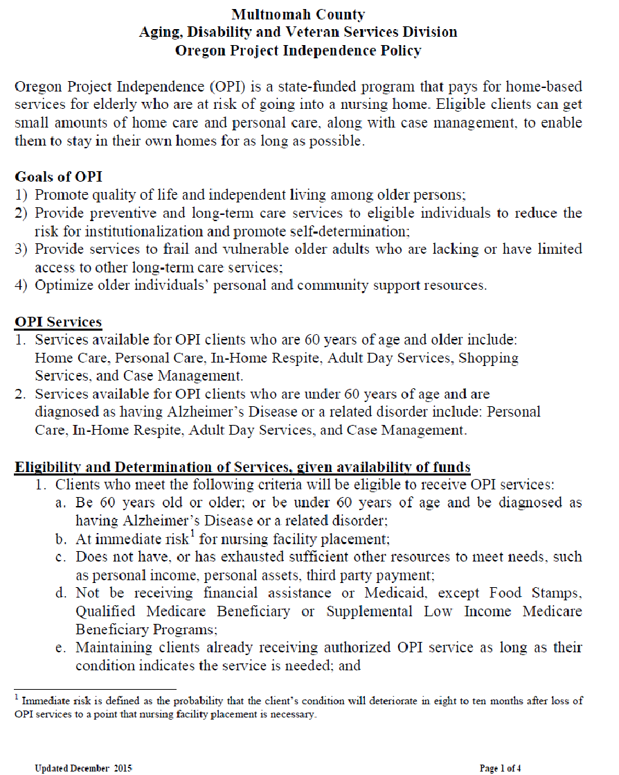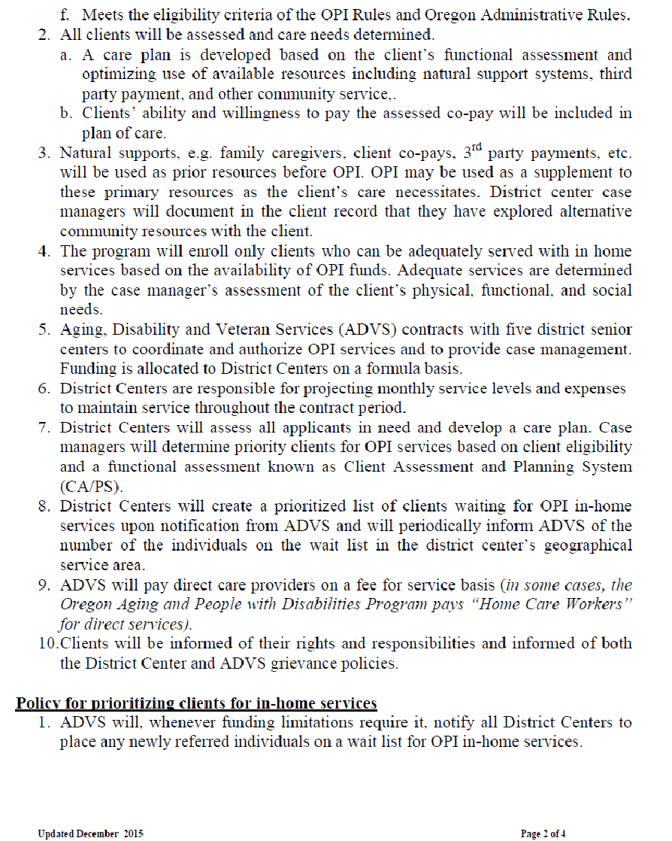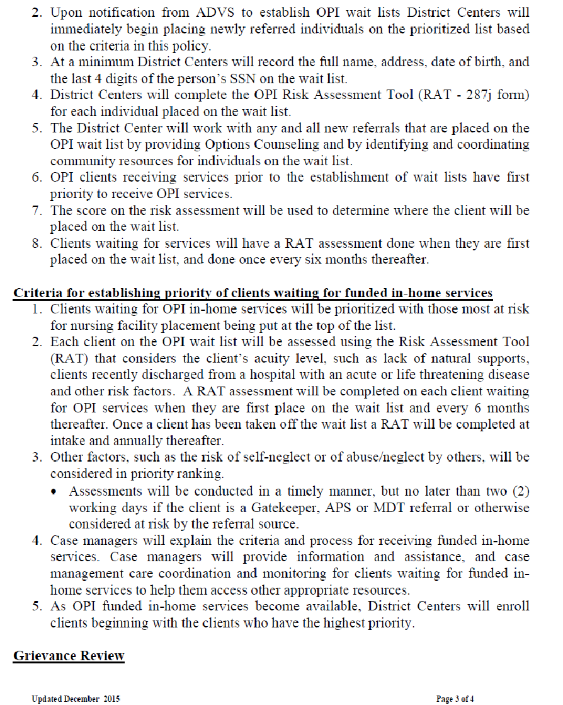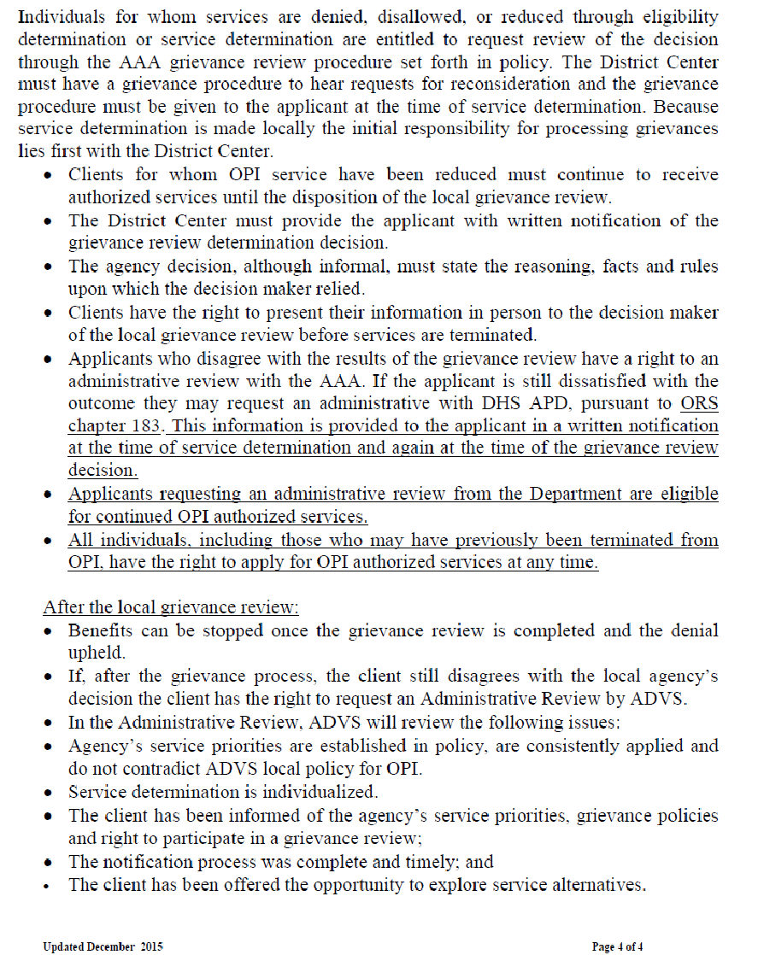

OPI Expansion and MPI Services Guidelines

Updated 5/19/16

- Client service plans will not exceed 24 hrs/month.
- No exceptions over 34 hours.
o Updated 5/19/16 This no longer allowed due to budget restraints.
- Bus pass (including Honored Citizen, Adult or Lift) will be approved based on usage (a cost comparison of estimated number of trips and return trips and selecting the most cost-efficient type of fare-- pass vs. tickets-- If client is infrequent user of TriMet, CM will authorize tickets rather than a pass.)
- DME can be approved by CM not to exceed $200 per client per fiscal year. Any DME above $200 per fiscal year must have manager approval. No DME approval over $500 per fiscal year will be approved. Note: Case Managers will need to track spending of DME for clients to ensure that limits have not been exceeded.

TACTICS FOR COST/BUDGET SAVINGS:
-Identify and approach clients with SPL 1-13, and whose financial circumstances will meet criteria for Medicaid LTC services.

WRITTEN COMMUNICATION FOR CHANGES/REDUCTIONS IN SERVICES:
- WRITTEN NOTIFICATION TO BE SENT TO CLIENTS:
  - Letter sent 30 days prior to reduction of services notifying client (or representative) of reduction.
- WRITTEN NOTIFICATION TO BE SENT TO HCWS OR AGENCIES:
  - Letter sent 30 days prior to reduction of services notifying HCW of reduction (see attached).
  - Letter to include 4105 (see attached).
  - 106 form sent to agencies

Client Rights and Grievance Procedure
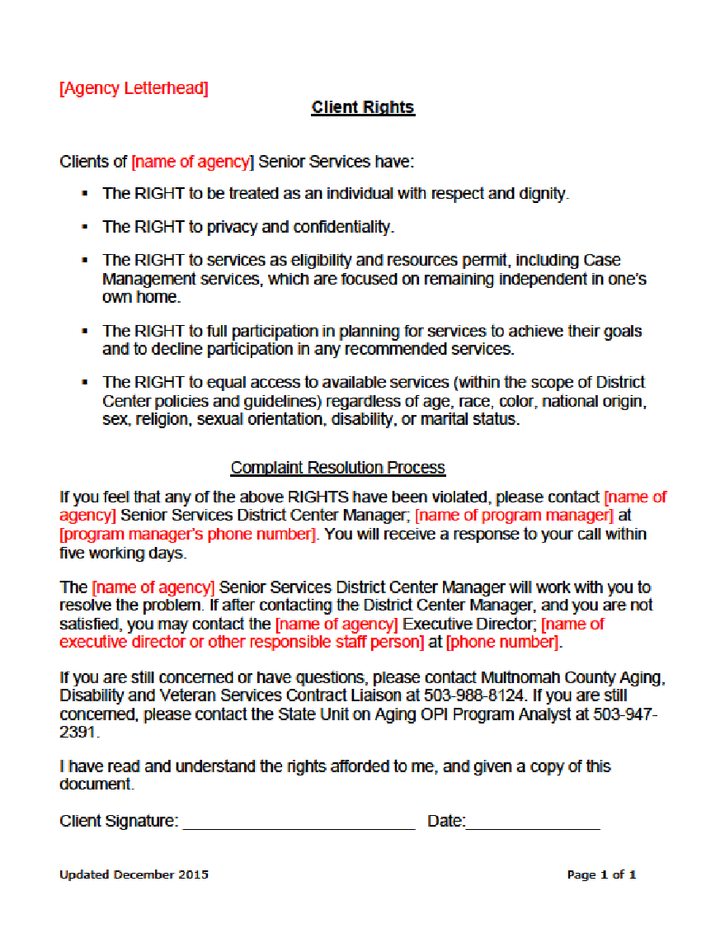

Appendix H: Partner Memorandums of Understanding

This page intentionally left blank. Multnomah County is a Type B AAA and therefore is not required to submit Appendix H.

Appendix I: Statement of Assurances and Verification of Intent

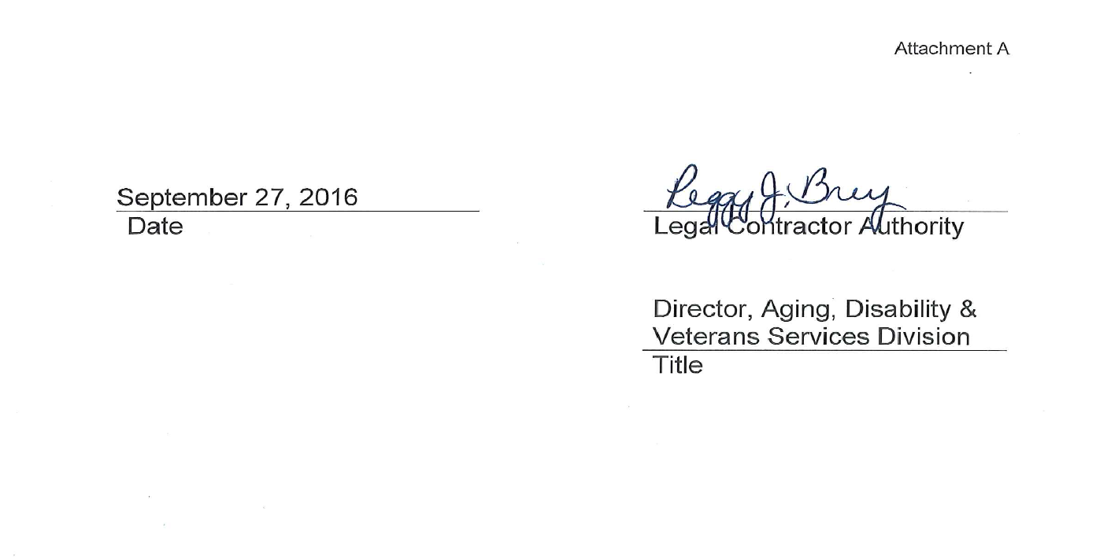

Attachment C: Service Matrix and Delivery Method

☒#1 Personal Care (by agency)
Funding Source: ☒OAA ☒OPI ☒Other Cash Funds
☒Contracted ☐Self-provided
Contractor name and address (List all if multiple contractors):
Affordable Care NW, 6901 SE Lake Rd., Ste. 22, Milwaukie, OR 97267 (Helping Hands Home Care)
Bahandi, Inc. dba Comfort Keepers, 1225 NW Murray Rd. Suite 101, Portland, OR 97229
Caregivers NW, 4804 NE 106th Ave, Portland, OR 97220
Marquis at Home, dbd Adams & Gray Home Care, 4560 SE International Way, Ste. 100, Milwaukie, OR 97222
Synergy HomeCare, 4317 NE Thurston Way #230, Vancouver, WA 98662
These are all for profit agencies
Note if contractor is a “for profit agency”
☒#1a Personal Care (by HCW) Funding Source: ☐OAA ☒OPI ☐Other Cash Funds
☒#2 Homemaker (by agency)
Funding Source: ☐OAA ☒OPI ☒Other Cash Funds
☒Contracted ☐Self-provided
Contractor name and address (List all if multiple contractors):
Affordable Care NW, 6901 SE Lake Rd., Ste. 22, Milwaukie, OR 97267 (Helping Hands Home Care)
Bahandi, Inc. dba Comfort Keepers, 1225 NW Murray Rd. Suite 101, Portland, OR 97229
Caregivers NW, 4804 NE 106th Ave, Portland, OR 97220
Marquis at Home, dbd Adams & Gray Home Care, 4560 SE International Way, Ste. 100, Milwaukie, OR 97222
Store to Door, 7730 SW 31st Ave, Portland, OR 97219
Synergy HomeCare, 4317 NE Thurston Way #230, Vancouver, WA 98662
These are all for profit agencies
Note if contractor is a “for profit agency”
☒#2a Homemaker (by HCW) Funding Source: ☐OAA ☒OPI ☐Other Cash Funds
☒#3 Chore (by agency)
Funding Source: ☐OAA ☒OPI ☐Other Cash Funds
☒Contracted ☐Self-provided
Contractor name and address (List all if multiple contractors):
Pegasus Social Services, 1509 SE 122nd Ave, Portland, OR 97233
Supportive Services of Oregon, PO Box 1086, Oregon City, OR 97045
Note if contractor is a “for profit agency”
☐#3a Chore (by HCW) Funding Source: ☐OAA ☐OPI ☐Other Cash Funds
☒#4 Home-Delivered Meal
Funding Source: ☒OAA ☐OPI ☒Other Cash Funds
☒Contracted ☐Self-provided
Contractor name and address (List all if multiple contractors):
Meals on Wheels People, 7710 SW 31st, Portland OR 97280
Note if contractor is a “for profit agency”
☒#5 Adult Day Care/Adult Day Health
Funding Source: ☒OAA ☒OPI ☒Other Cash Funds
☒Contracted ☐Self-provided
Contractor name and address (List all if multiple contractors):
Volunteers of America, 3910 SE Stark Street, Portland, OR 97214
Note if contractor is a “for profit agency”
☒#6 Case Management
Funding Source: ☒OAA ☒OPI ☒Other Cash Funds
☒Contracted ☐Self-provided
Contractor name and address (List all if multiple contractors):
Hollywood Senior Center, 1820 NE 40th Avenue, Portland, OR 97212
Impact NW, PO Box 33530, Portland, OR 97292
Immigrant & Refugee Community Organization, 10301 NE Glisan Street, Portland, OR 97220
Neighborhood House, 7780 SW Capitol Hwy, Portland, OR 97219
YWCA, PO Box 16130, Portland, OR 97292
Catholic Charities, 2740 SE Powell Blvd, Suite 5, Portland, OR 97202
Friendly House, 2617 NW Savier, Portland, OR 97210
Native American Youth & Family Center, 5135 NE Columbia Blvd., Portland, OR 97218
Asian Health & Service Center, 3430 SE Powell Blvd, Portland, OR 97202,
Urban League of Portland, 10 N. Russell St., Portland, OR 97227
Note if contractor is a “for profit agency”
☒#7 Congregate Meal
Funding Source: ☒OAA ☐OPI ☒Other Cash Funds
☒Contracted ☐Self-provided
Contractor name and address (List all if multiple contractors):
Meals on Wheels People, 7710 SW 31st, Portland, OR 97280
Asian Health & Service Center, 3430 SE Powell Blvd, Portland, OR 97202
Native American Youth & Family Center, 5135 NE Columbia Blvd, Portland OR 97218
Catholic Charities, 2740 SE Powell Blvd, Portland, OR 97202
Immigrant & Refugee Community Organization, 10301 NE Glisan Street, Portland OR 97220
Note if contractor is a “for profit agency”
☐#8 Nutrition Counseling
Funding Source: ☐OAA ☐OPI ☐Other Cash Funds
☐Contracted ☐Self-provided
Contractor name and address (List all if multiple contractors):

Note if contractor is a “for profit agency”
☐#9 Assisted Transportation
Funding Source: ☐OAA ☐OPI ☐Other Cash Funds
☐Contracted ☐Self-provided
Contractor name and address (List all if multiple contractors):

Note if contractor is a “for profit agency”
☒#10 Transportation
Funding Source: ☒OAA ☐OPI ☒Other Cash Funds
☒Contracted ☐Self-provided
Contractor name and address (List all if multiple contractors):
Ride Connection, 3030 SW Moody Ave, Portland, OR 97201
Radio Cab (for profit agency), 1613 NW Kearney St., Portland, OR 97209
Hollywood Senior Center, 1820 NE 40th Avenue, Portland, OR 97212
Impact NW, PO Box 33530, Portland, OR 97292
Immigrant & Refugee Community Organization, 10301 NE Glisan Street, Portland, OR 97220
Neighborhood House, 7780 SW Capitol Hwy, Portland, OR 97219
YWCA, PO Box 16130, Portland, OR 97292
TriMet, 4012 SE 17th Ave, Portland, OR 97202
Note if contractor is a “for profit agency”
☒#11 Legal Assistance
Funding Source: ☒OAA ☐OPI ☒Other Cash Funds
☒Contracted ☐Self-provided
Contractor name and address (List all if multiple contractors):
Legal Aid Services of Oregon, 520 SW Sixth Avenue, Ste 1130, Portland, OR 97204
Note if contractor is a “for profit agency”
☒#12 Nutrition Education
Funding Source: ☐OAA ☐OPI ☐Other Cash Funds
☒Contracted ☐Self-provided
Contractor name and address (List all if multiple contractors):
Meals on Wheels People, 7710 SW 31st, Portland, OR 97280
Asian Health & Service Center, 3430 SE Powell Blvd, Portland, OR 97202
Native American Youth and Family Center, 5135 NE Columbia Blvd, Portland, OR 97218
Catholic Charities, 2740 SE Powell Blvd, Suite 5, Portland, OR 97202
Immigrant & Refugee Community Organization, 10301 NE Glisan Street, Portland OR 97220
Note if contractor is a “for profit agency”
☒#13 Information & Assistance
Funding Source: ☒OAA ☐OPI ☒Other Cash Funds
☒Contracted ☒Self-provided
Contractor name and address (List all if multiple contractors):
Hollywood Senior Center, 1820 NE 40th Avenue, Portland, OR 97212
Impact NW, PO Box 33530, Portland, OR 97292
Immigrant & Refugee Community Organization, 10301 NE Glisan Street, Portland, OR 97220
Neighborhood House, 7780 SW Capitol Hwy, Portland, OR 97219
YWCA, PO Box 16130, Portland, OR 97292
Note if contractor is a “for profit agency”
☒#14 Outreach
Funding Source: ☒OAA ☐OPI ☒Other Cash Funds
☒Contracted ☒Self-provided
Contractor name and address (List all if multiple contractors):
Hollywood Senior Center, 1820 NE 40th Avenue, Portland, OR 97212
Impact NW, PO Box 33530, Portland, OR 97292
Immigrant & Refugee Community Organization, 10301 NE Glisan Street, Portland, OR 97220
Neighborhood House, 7780 SW Capitol Hwy, Portland, OR 97219
YWCA, PO Box 16130, Portland, OR 97292
Note if contractor is a “for profit agency”
☒#15/15a Information for Caregivers
Funding Source: ☐OAA ☐OPI ☒Other Cash Funds
☐Contracted ☒Self-provided
Contractor name and address (List all if multiple contractors):

Note if contractor is a “for profit agency”
☒#16/16a Caregiver Access Assistance
Funding Source: ☒OAA ☐OPI ☒Other Cash Funds
☒Contracted ☒Self-provided
Contractor name and address (List all if multiple contractors):
Hollywood Senior Center, 1820 NE 40th Avenue, Portland, OR 97212
Impact NW, PO Box 33530, Portland, OR 97292
Immigrant & Refugee Community Organization, 10301 NE Glisan Street, Portland, OR 97220
Neighborhood House, 7780 SW Capitol Hwy, Portland, OR 97219
YWCA, PO Box 16130, Portland, OR 97292
Note if contractor is a “for profit agency”
☒#20-2 Advocacy
Funding Source: ☒OAA ☐OPI ☒Other Cash Funds
☒Contracted ☒Self-provided
Contractor name and address (List all if multiple contractors):
Elders in Action, 1411 SW Morrison St #290, Portland, OR 97205
Hollywood Senior Center, 1820 NE 40th, Portland, OR 97212
Immigrant & Refugee Community Organization, 10301 NE Glisan Street, Portland, OR 97220
Impact NW, PO Box 33530, Portland, OR 97292
Neighborhood House, 7780 SW Capitol Hwy, Portland, OR 97219
YWCA, PO Box 16130, Portland, OR 97292
Note if contractor is a “for profit agency”
☒#20-3 Program Coordination & Development
Funding Source: ☐OAA ☐OPI ☒Other Cash Funds
☐Contracted ☒Self-provided
Contractor name and address (List all if multiple contractors):

Note if contractor is a “for profit agency”
☐#30-1 Home Repair/Modification
Funding Source: ☐OAA ☐OPI ☐Other Cash Funds
☐Contracted ☐Self-provided
Contractor name and address (List all if multiple contractors):

Note if contractor is a “for profit agency”
☐#30-4 Respite Care (IIIB/OPI)
Funding Source: ☐OAA ☐OPI ☐Other Cash Funds
☐Contracted ☐Self-provided
Contractor name and address (List all if multiple contractors):

Note if contractor is a “for profit agency”
☐#30-5/30-5a Caregiver Respite
Funding Source: ☐OAA ☐OPI ☐Other Cash Funds
☐Contracted ☐Self-provided
Contractor name and address (List all if multiple contractors):

Note if contractor is a “for profit agency”
☐#30-6/30-6a Caregiver Support Groups
Funding Source: ☐OAA ☐OPI ☐Other Cash Funds
☐Contracted ☐Self-provided
Contractor name and address (List all if multiple contractors):

Note if contractor is a “for profit agency”
☐#30-7/30-7a Caregiver Supplemental Services
Funding Source: ☐OAA ☐OPI ☐Other Cash Funds
☐Contracted ☐Self-provided
Contractor name and address (List all if multiple contractors):

Note if contractor is a “for profit agency”
☒#40-2 Physical Activity and Falls Prevention
Funding Source: ☒OAA ☐OPI ☐Other Cash Funds
☒Contracted ☐Self-provided
Contractor name and address (List all if multiple contractors):
Hollywood Senior Center, 1820 NE 40th Avenue, Portland, OR 97212
Impact NW, PO Box 33530, Portland, OR 97292
Immigrant & Refugee Community Organization, 10301 NE Glisan Street, Portland, OR 97220
Neighborhood House, 7780 SW Capitol Hwy, Portland, OR 97219
YWCA, PO Box 16130, Portland, OR 97292
Native American Youth & Family Center, 5135 NE Columbia Blvd, Portland, OR 97218
Note if contractor is a “for profit agency”
☐#40-3 Preventive Screening, Counseling and Referral
Funding Source: ☐OAA ☐OPI ☐Other Cash Funds
☐Contracted ☐Self-provided
Contractor name and address (List all if multiple contractors):

Note if contractor is a “for profit agency”
☒#40-4 Mental Health Screening and Referral
Funding Source: ☐OAA ☐OPI ☒Other Cash Funds
☒Contracted ☐Self-provided
Contractor name and address (List all if multiple contractors):
Asian Health & Service Center, 3430 SE Powell Blvd, Portland, OR 97202
Jewish Family & Child Services, 1221 SW Yamhill St #301, Portland, OR 97205
Note if contractor is a “for profit agency”
☒#40-5 Health & Medical Equipment
Funding Source: ☐OAA ☐OPI ☒Other Cash Funds
☐Contracted ☐Self-provided
Contractor name and address (List all if multiple contractors):

Note if contractor is a “for profit agency”
☐#40-8 Registered Nurse Services
Funding Source: ☐OAA ☐OPI ☐Other Cash Funds
☐Contracted ☐Self-provided
Contractor name and address (List all if multiple contractors):

Note if contractor is a “for profit agency”
☐#40-9 Medication Management
Funding Source: ☐OAA ☐OPI ☐Other Cash Funds
☐Contracted ☐Self-provided
Contractor name and address (List all if multiple contractors):

Note if contractor is a “for profit agency”
☒#50-1 Guardianship/Conservatorship
Funding Source: ☐OAA ☐OPI ☒Other Cash Funds
☐Contracted ☒Self-provided
Contractor name and address (List all if multiple contractors):

Note if contractor is a “for profit agency”
☒#50-3 Elder Abuse Awareness and Prevention
Funding Source: ☒OAA ☐OPI ☐Other Cash Funds
☐Contracted ☒Self-provided
Contractor name and address (List all if multiple contractors):

Note if contractor is a “for profit agency”
☐#50-4 Crime Prevention/Home Safety
Funding Source: ☐OAA ☐OPI ☐Other Cash Funds
☐Contracted ☐Self-provided
Contractor name and address (List all if multiple contractors):

Note if contractor is a “for profit agency”
☐#50-5 Long Term Care Ombudsman
Funding Source: ☐OAA ☐OPI ☐Other Cash Funds
☐Contracted ☐Self-provided
Contractor name and address (List all if multiple contractors):

Note if contractor is a “for profit agency”
☒#60-1 Recreation
Funding Source: ☐OAA ☐OPI ☒Other Cash Funds
☒Contracted ☐Self-provided
Contractor name and address (List all if multiple contractors):
Hollywood Senior Center, 1820 NE 40th Avenue, Portland, OR 97212
Impact NW, PO Box 33530, Portland, OR 97292
Immigrant & Refugee Community Organization, 10301 NE Glisan Street, Portland, OR 97220
Neighborhood House, 7780 SW Capitol Hwy, Portland, OR 97219
YWCA, PO Box 16130, Portland, OR 97292
Native American Rehabilitation Association, 1776 SW Nadusin, Portland, OR 97205
Catholic Charities, 2740 NE Powell Blvd, Suite 5, Portland, OR 97202
Friendly House, 2617 NW Savier, Portland, OR 97210
Native American Youth & Family Center, 5135 NE Columbia Blvd, Portland, OR 97218
Urban League of Portland, 10 N. Russell St, Portland, OR 97227
Note if contractor is a “for profit agency”
☒#60-3 Reassurance
Funding Source: ☐OAA ☐OPI ☒Other Cash Funds
☒Contracted ☐Self-provided
Contractor name and address (List all if multiple contractors):
African-American Health Coalition, 77 NE Knott St, Portland, OR 97212
Urban League of Portland, 10 N. Russell St., Portland, OR 97227
Note if contractor is a “for profit agency”
☐#60-4 Volunteer Recruitment
Funding Source: ☐OAA ☐OPI ☐Other Cash Funds
☐Contracted ☐Self-provided
Contractor name and address (List all if multiple contractors):

Note if contractor is a “for profit agency”
☒#60-5 Interpreting/Translation
Funding Source: ☒OAA ☐OPI ☒Other Cash Funds
☒Contracted ☐Self-provided
Contractor name and address (List all if multiple contractors):
IRCO International Language Bank, 10301 NE Glisan, Portland, OR 97220
Linguava Interpreters, 7931 NE Halsey St, Ste. 305, Portland, OR 97213 - for profit agency
Passport to Languages, 3912 SW 43rd Ave, Portland, 97221 - for profit agency
Note if contractor is a “for profit agency”
☒#70-2 Options Counseling
Funding Source: ☒OAA ☐OPI ☒Other Cash Funds
☒Contracted ☐Self-provided
Contractor name and address (List all if multiple contractors):
Hollywood Senior Center, 1820 NE 40th Avenue, Portland, OR 97212
Impact NW, PO Box 33530, Portland, OR 97292
Immigrant & Refugee Community Organization, 10301 NE Glisan Street, Portland, OR 97220
Neighborhood House, 7780 SW Capitol Hwy, Portland, OR 97219
YWCA, PO Box 16130, Portland, OR 97292
Catholic Charities, 2740 SE Powell Blvd, Suite 5, Portland, OR 97202
Friendly House, 2617 NW Savier, Portland, OR 97210
Native American Youth & Family Center, 5135 NE Columbai Blvd., Portland, OR 97218
Asian Health & Service Center, 3430 SE Powell Blvd, Portland, OR 97202,
Urban League of Portland, 10 N. Russell St., Portland, OR 97227
Note if contractor is a “for profit agency”
☐#70-2a/70-2b Caregiver Counseling
Funding Source: ☐OAA ☐OPI ☐Other Cash Funds
☐Contracted ☐Self-provided
Contractor name and address (List all if multiple contractors):

Note if contractor is a “for profit agency”
☐#70-5 Newsletter
Funding Source: ☐OAA ☐OPI ☐Other Cash Funds
☐Contracted ☐Self-provided
Contractor name and address (List all if multiple contractors):

Note if contractor is a “for profit agency”
☐#70-8 Fee-based Case Management
Funding Source: ☐OAA ☐OPI ☐Other Cash Funds
☐Contracted ☐Self-provided
Contractor name and address (List all if multiple contractors):

Note if contractor is a “for profit agency”
☒#70-9/70-9a Caregiver Training
Funding Source: ☒OAA ☐OPI ☒Other Cash Funds
☒Contracted ☒Self-provided
Contractor name and address (List all if multiple contractors):
Hollywood Senior Center, 1820 NE 40th Avenue, Portland, OR 97212
Friendly House, 2617 NW Savier, Portland, OR 97210
Note if contractor is a “for profit agency”
☒#70-10 Public Outreach/Education
Funding Source: ☐OAA ☐OPI ☐Other Cash Funds
☐Contracted ☒Self-provided
Contractor name and address (List all if multiple contractors):

Note if contractor is a “for profit agency”
☒#71 Chronic Disease Prevention, Management/Education
Funding Source: ☒OAA ☐OPI ☒Other Cash Funds
☒Contracted ☐Self-provided
Contractor name and address (List all if multiple contractors):
Hollywood Senior Center, 1820 NW 40th, Portland, 97212
Impact NW, PO Box 33530, Portland, OR 97292
Immigrant & Refugee Community Organization, 10301 NE Glisan Street, Portland, OR 97220
Neighborhood House, 7780 SW Capitol Hwy, Portland, OR 97219
YWCA, PO Box 16130, Portland, OR 97292
African American Health Coalition, 2800 N. Vancouver, Suite 100, Portland, OR 97227
Asian Health & Service Center, 3430 SE Powell Blvd, Portland, OR 97202
Native American Youth & Family Center, 5135 NE Columbia Blvd, Portland, OR 97218
Note if contractor is a “for profit agency”
☐#72 Cash and Counseling
Funding Source: ☐OAA ☐OPI ☐Other Cash Funds
☐Contracted ☐Self-provided
Contractor name and address (List all if multiple contractors):

Note if contractor is a “for profit agency”
☒#73/73a Caregiver Cash and Counseling
Funding Source: ☒OAA ☐OPI ☒Other Cash Funds
☒Contracted ☒Self-provided
Contractor name and address (List all if multiple contractors):
Hollywood Senior Center, 1820 NE 40th, Portland, OR 97212
Impact NW, PO Box 33530, Portland, OR 97292
Immigrant & Refugee Community Organization, 10301 NE Glisan Street, Portland, OR 97220
Neighborhood House, 7780 SW Capitol Hwy, Portland, OR 97219
YWCA, PO Box 16130, Portland, OR 97292
Note if contractor is a “for profit agency”
☒#80-1 Senior Center Assistance
Funding Source: ☒OAA ☐OPI ☒Other Cash Funds
☒Contracted ☐Self-provided
Contractor name and address (List all if multiple contractors):
Hollywood Senior Center, 1820 NE 40th, Portland, OR 97212
Impact NW, PO Box 33530, Portland, OR 97292
Immigrant & Refugee Community Organization, 10301 NE Glisan Street, Portland, OR 97220
Neighborhood House, 7780 SW Capitol Hwy, Portland, OR 97219
YWCA, PO Box 16130, Portland, OR 97292
Note if contractor is a “for profit agency”
☒#80-4 Financial Assistance
Funding Source: ☐OAA ☐OPI ☒Other Cash Funds
☐Contracted ☒Self-provided
Contractor name and address (List all if multiple contractors):

Note if contractor is a “for profit agency”
☒#80-5 Money Management
Funding Source: ☐OAA ☐OPI ☒Other Cash Funds
☐Contracted ☒Self-provided
Contractor name and address (List all if multiple contractors):

Note if contractor is a “for profit agency”
☒#Volunteer Services
Funding Source: ☒OAA ☐OPI ☒Other Cash Funds
☒Contracted ☒Self-provided
Contractor name and address (List all if multiple contractors):
Catholic Charities, 2740 SE Powell Blvd, Suite 5, Portland, OR 97202
Friendly House, 2617 NW Savier, Portland, OR 97210
Immigrant & Refugee Community Organization, 10301 NE Glisan Street, Portland, OR 97220
Note if contractor is a “for profit agency”

Attachment D: Congregate Nutrition Sites

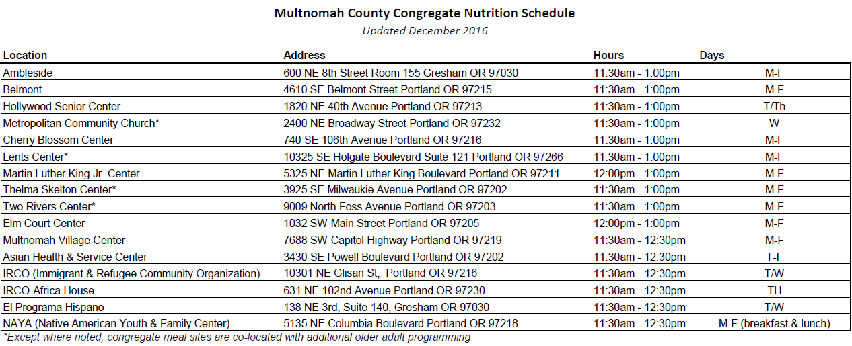

Attachment E: Adult Protective Services Screening Protocol
APS Screening

Scope and Expectations

Leave your caseload behind while you are screening. Screening is to get your full attention.

- Interviewing the Caller
  - You lead the interview with the caller; the caller does not lead you. Redirect if needed. Use your investigative skills from the start.
  - Gather all the information needed to complete the referral form:
    - Where did this happen? Facility or community?
    - What occurred?
    - Who was involved?
    - When did this happen?
    - How do you know this happened?
    - Gather demographic and collateral information.
    - If abuse is financial in nature, ask the amount of money misappropriated.

- When Caller doesn’t have all the information you need
  - Collateral calls
  - The screener will make collateral calls when those calls are needed to:
    - clarify conflicting information
    - establish that abuse or neglect occurred
    - to identify an allegation
B. The screener will do computer searches to verify basic demographic information
  - All screeners are expected to use the following resources to complete the referral form:
    - Oregon Access
    - The Mainframe (WEBM, DMV)
    - Catbird
    - LUCI
  - Screeners are expected to use these computer programs to verify addresses, previous contacts with social services and other relevant information.
  - Check on Oregon Access for an assigned Case Manager. Write Case Manager name on screening form.

- Timeliness of referrals
  - All referrals are expected to be written up on the date they are received at screening.
  - If you are waiting for a call back to complete writing up a referral at the end of your shift, check with management or the incoming screener to ensure the referral gets completed.
  - The date on the referral form should be the date the referral is sent to the investigator. This should match the date of the initial call.
  - Any referrals not completed by the end of your screening shift should be reviewed by a manager or supervisor. No referrals should be left on the desk unless they have been reviewed by management.
  - The expectation is that you get the information, write the referral and move on.

- Returning Voice Mails and Calls
  - Remember “Write-Triage-Respond”
  - All messages received during your shift will be addressed. Clear your voice mail throughout your shift.
  - Voice mails will be listened to promptly in order to determine their level of urgency.
  - All voice messages received during your shift will be taken off the phone by the end of your shift.
  - If you cannot respond to a voice mail right away, write down the voice message so the call and the information can be triaged.
  - It is the screeners’ responsibility to ask for help if they feel unable to complete their tasks by the end of the workday. Any backlog of calls needs to be brought to attention of management by 4 pm.

Tracking Information

Do not create duplicate cases on Oregon Access.

Entering a New Referral into Oregon Access

- When you get a new referral, search Oregon Access for clients with the same name.
  - If multiple clients exist with the same name, use date of birth to verify which client is the correct one.
  - If you have no date of birth, use DMV to get a date of birth and to verify spelling. Use Catbird to verify address.
  - Do not create a new screening without accurate information. Make a note on the referral sheet that the information was unclear and it should be entered into Access by the investigator when verified.
  - Remember to inactivate the screening.

- If there is an existing Case but no Screening, create a Screening on the existing case.
  - Do not put APS information in a Case.
  - All APS information goes on a Screening.

- If there is no existing case, then create a new screening.
(Casey and Ronda’s screen shots go here)

4. Check Oregon Access for a case manager. Look in both the narrative section and under the case manager tab on the Oregon Access tool bar. List the name of the case manager on the referral form. This ensures case managers are notified there is APS activity on the case.

What to Narrate on a Screening and Where to Narrate it

- Narrate in the Screening narrative “New referral to APS. Sent to XXX team”. Do not narrate the type of abuse in this area.

- Go to the Referral tab. Open the Referral. Click on “New Record”. Add a new protective services referral under “referral type”.

- Narrate the type of abuse in the box at the bottom of the Referral page.

Tracking Referrals to FAST

- The criteria for FAST is posted by the FAST referral box in the screening room.

- When you get a new referral of financial exploitation, establish whether the referral meets criteria for review by the FAST team.

- If the referral meets the criteria for FAST, put in the FAST referral box and narrate in Oregon Access, “New APS referral sent to FAST”. If the FAST team does not accept the referral, they will change the narration.

Referrals to MDT

- Screeners do not make referrals to MDT.

- If the referral seems appropriate for MDT, note on the Consult sent to the case manager “consider MDT”.

Additional information on open cases

- If you get a call about a client who already has an open APS case, gather information as you would for a new referral.

- Sent the new information to the assigned investigator as “additional information”.

- Narrate in Oregon Access “additional information sent to XXX branch”.

- If you get referrals from After Hours, Protocall or Police on an open APS case, stamp and send as “additional information”.

Facility Referrals

- Enter the referral into Oregon Access, the same as you would with a community referral. Refer to the “Tracking Information” instructions on what information to enter; do not create duplicate cases.

- Use the Facility form when the facility is the perpetrator. Fill this form out completely. Include:
  - The Complainant’s name, relationship to the RV, contact information and whether they would like a copy of the report.
  - The facility name, address, phone number and zip code.
  - What type of facility it is. Many facilities have multiple levels of care on their grounds.
  - Complete RV, RP and Witness information. Include prime number.
  - A description of the problem or incident and the facility’s corrective plan.
  - Fully describe the situation.
  - Resident to resident incidents go on a facility referral form.
  - There is no self neglect in facilities.
  - If you have questions or are uncertain about something, ask management, the other screener or a facility investigator for clarification.

- Use the Community form when a person from outside the facility is the perpetrator.
  - Clarify that the perpetrator is not facility staff.
  - Fill the form completely.

- Triage the referral.
A. There are two response time frames for facility cases (cases where the facility is the RP):
- Within two hours. If the resident’s health or safety is in imminent danger as a result of abuse or neglect.
- By the end of the next working day if circumstances exist that could result in abuse.
B. The response time for community referrals (cases where an outside party, not the facility, is the RP):
- Within two hours for imminent danger.
- Next day for hazardous cases.
- Five day for chronic situations.

- Client Care Monitoring Unit (CCMU) referrals
A. CCMU investigates serious health and safety violations in nursing homes. The criteria for CCMU cases are very specific:

- Falls, whether or not there is an injury
- All bone fractures
- All pressure ulcers on any part of the body
- All hospitalizations, emergency room visits or Urgent Care visits
- All deaths
- Any concerns related to the use of restraints or a restraining device

B. CCMU will take referrals with multiple allegations as long as at least one of the allegations meets their criteria.
C. CCMU may also get involved if there are concerns with the overall level of care provided by a facility or other facility-wide systemic problems.
D. Use the CCMU form, “Licensed Facility Complaint Intake From”. It is located in the screening room in a file marked” CCMU”. Ask for help finding it, if needed.
- Fill out the form completely.
- The “local unit log number” is taken from a list in the screening room. This goes on both the front and back of the CCMU form.
- Fill out the “APS office use only” portion on the bottom of the second page listing the time received and the time sent to CCMU.
- The referral is put in the box to be logged in and faxed to CCMU.

- Facility Self Report Forms
  - Facilities send Self Report forms when an incident has occurred in an NF, ALF or RCF. The incident may or may not be abuse. Each of these forms needs to be screened as a new referral.
  - Enter the client information into Oregon Access as with all other referrals.
  - Make sure that all required screening information is on the Self Report form. If there are gaps in information regarding the incident, call the facility to complete the form. Include the prime number and social security number.
  - Verify what shift the incident occurred during.
  - Identify the type of abuse to be investigated.
  - If there is no abuse, list as a consult.
  - Put the referral into the box to be logged in and assigned.

Gatekeeper, After Hours and Police Reports

Most Gatekeeper, After Hours and Police Reports come to the screeners as paper referrals, not phone calls. These referrals are treated with the same priority as phone calls and require timely and accurate screening.

1. They will be printed out by office assistants and placed in a centrally located bin that sits between the two screening desks.

2. Screeners are to take out the referrals one at a time so each referral is completed before a new one is started.

- Screeners are to go through the box throughout their shift to ensure these referrals are distributed to investigators as quickly as possible.

After Hours Referrals
- All referrals must be screened promptly.
- Clarify if the referral is Community or Facility.
- All After Hours referrals must be entered into Oregon Access.
- Verify that the information (spelling of name, address, phone number, etc) on the referral is accurate.
- Check to see if the client is open in another system (i.e. LUCI)
- If the referral is NOT entered into Oregon Access note the reason why.
- Clarify the type of abuse to be investigated.
- Triage the response time and note on the referral.

Here is an example of what to put on the bottom of the page:

(Put the Stamp here)

Gatekeeper Referrals
- Gatekeeper referrals should be treated the same as After Hours referrals. Enter the referral into Oregon Access and check for involvement with other systems.
- All Gatekeeper referrals must be seen, there are no Consults.
- All Gatekeeper referrals should be triaged the same as other referrals.
- There are no forms to return to ADS Central.

Police Reports
- All Police Reports need to be read by Screeners.
- Assess for abuse, neglect or exploitation issues.
- If abuse issues are present, the referral must be assigned for investigation.
- Clearly indicate who the Reported Victim is, i.e. mark a star by their name.
- Enter the client into Oregon Access and proceed as with other new referrals.
- All police reports are chronic, 5 day response time from APS.
- If the reported victim is a client of ADS, send a copy of the police report to the case manager. Be sure to put the case manager’s name on the stamp.
- If no abuse or neglect appears to have taken place, this becomes an unassigned report. Write “unassigned” and put in the tray for filing. Do not enter into Oregon Access.
- If no abuse or neglect has taken place, do not send the case to an APS team.
- There are no “FYIs” in APS.
- If you are uncertain about what to do, consult with another investigator or management.

Consults

A consult is a call regarding a particular client or situation where there is no abuse or neglect at this time. Any conversation about a specific person needs to be written up on a referral form.

Information to gather on all Consults
- Get names, addresses, dates of birth. Gather all available demographic information.
- Gather information regarding the situation the caller is concerned about. What made the caller contact APS?
- If the caller does not have the client’s name, take the information as “unknown” and continue to gather all available data.
- Check LUCI and call mental health to see if the client may be connected to either of those systems. Send a copy of the consult to the involved agency if the client is involved with them.

Entering Consults into Oregon Access
- All consults, when there is a name known for the client, are to be entered into Oregon Access.
- Enter them into the Screening module as with any referral.
- Narrate “APS consult only. No abuse or neglect”.

Facility Consults
To determine whether a Facility referral is assigned or consulted, assess whether abuse or neglect occurred. Determine:
- Was there a negative outcome? If no, then this may be consult.
- Have there been prior incidents like the one called in? If no, then this may be a consult.
- Was the situation predictable or preventable? If no, then this may be a consult.
- Is there a plan to correct the problem and prevent further similar incidents? If yes, then this may be a consult.

Screening Desk Expectations and Procedures

The screening desks are shared by all members of the APS team who participate in screening duties. The desk, the resource information and the phones and voice mail all need to be readily usable by multiple parties. This means all Screeners need to be responsible for completing referrals in a timely manner, responding to voice mails and keeping the area free of clutter.

Arrival
- There is a designated box for passing screening information from one shift to the next.
- When arriving for a screening shift, look for notes from the previous shift’s screener.
- Address the incomplete referrals promptly.
- When arriving for an afternoon shift, take time to debrief with the person you are replacing.

Phone
- Check your voice mail throughout your shift.
- Return calls within one hour.
- Delete voice mails as you process them.
- Do not leave any voice mails at the end of your shift.

Desk Area
- Clear the desk at the end of each shift.
- Do not leave any items on the desk, including personal items, notes or unfinished referrals.
- The phone message light should not be blinking.

Attachment F: OPI In-Home Fee Schedule

Household of One
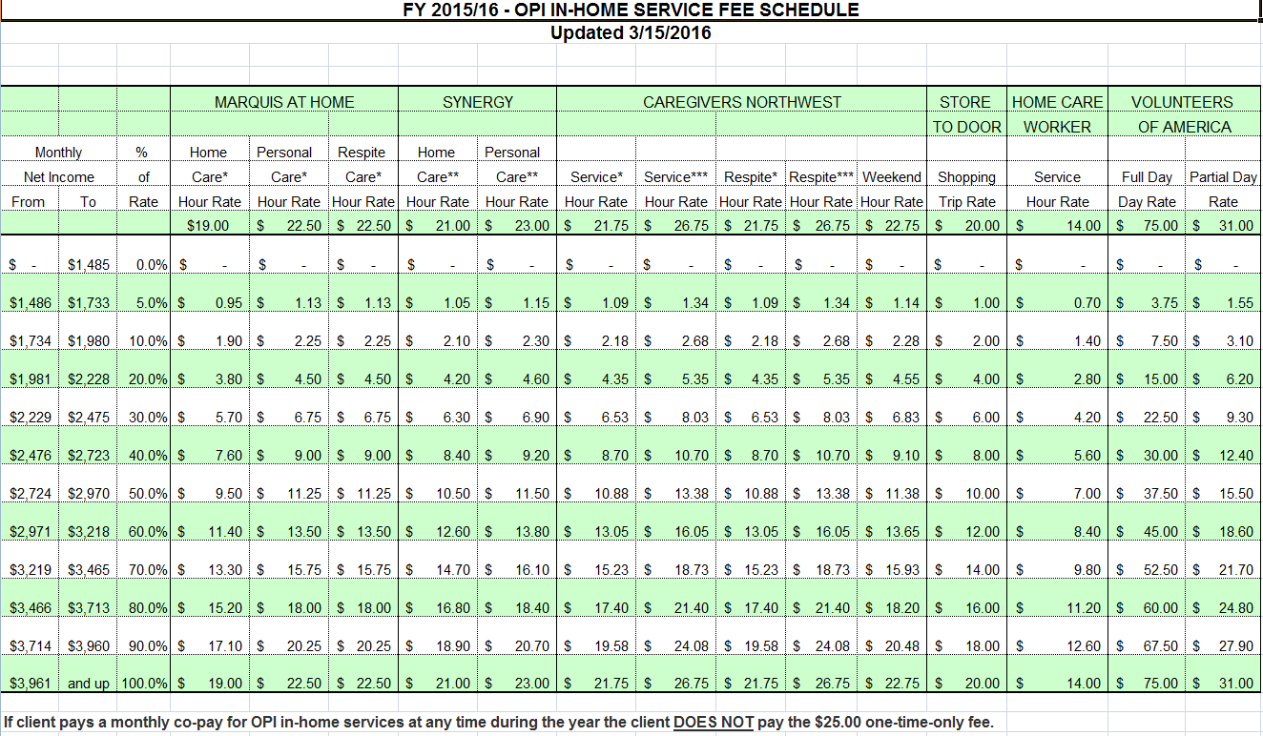

Household of Two

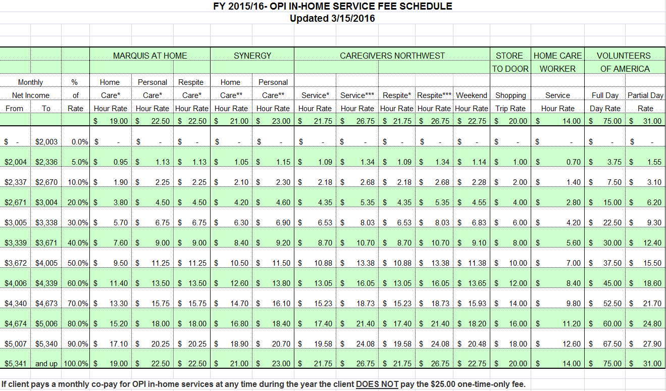

American Community Survey 1-Year Estimates by County (Series S0102). 1-Year estimates are chosen at a county level to reflect recent population shifts. Margin of error is +-2,240 residents (1.6%).
American Community Survey 2014 1-Year Estimates for Multnomah County (DP05), 2010 Census (DP1).
Steven Ruggles, Katie Genadek, Ronald Goeken, Josiah Grover, and Matthew Sobek. Integrated Public Use Microdata Series: Version 6.0 [Machine-readable database]. Minneapolis: University of Minnesota, 2015. ACS 2014 5-Yr Estimates.
2014 American Community Survey (1-Year Estimates) Series B18101.
∗ Multnomah County Aging Disability and Veterans Services Estimates.

