MULTNOMAH COUNTY, OREGON
EXECUTIVE RULE NO. 395

Declaration of Emergency Due to Extreme Heat

- Multnomah County is authorized under ORS 401.305 to act as an emergency management agency, including authority to establish policies and protocols for defining and directing responsibilities during times of emergency.

- Multnomah County has enacted a local ordinance, Multnomah County Code § 25.410 et seq., pursuant to the authority granted by ORS 401.025 et seq., and the Multnomah County Charter, that provides for executive responsibility in times of emergency and specifically delegates authority to declare a state of emergency to the County Chair, or in the Chair’s absence or inability to perform the functions of office, the most senior member of the Board, or in the senior member of the Board’s absence or inability, the Sheriff, or in the Sheriff’s absence or inability, the Chair’s designated interim, or in the Chair’s designated interim’s absence or inability, the Sheriff’s designated interim.

- The Chair is authorized pursuant to Multnomah County Code § 7.007, to adopt Executive Rules to implement and enforce provisions of the Multnomah County Code and to carry out the Chair’s duties under the Charter. Pursuant to Multnomah County Code Section § 25.440(15) the Chair or the authorized successors may order any action to address and alleviate the emergency.

- The following conditions have resulted in the need for a state of emergency declaration:

- The National Weather Service issued an Excessive Heat Warning from August 11, 2021 through August 14, 2021 citing dangerously hot conditions with temperatures up to 105 degrees expected in the Greater Portland Metro area and surrounding communities.
- Extreme heat events can trigger a variety of heat stress conditions, such as heat stroke. This condition can cause death or permanent disability if emergency treatment is not given.
- Small children, the elderly, and certain other groups including people with chronic diseases, low-income populations, and outdoor workers have higher risk for heat-related illness.

- The COVID-19 pandemic has further increased vulnerability among community members, impacting overall health outcomes, economic mobility and social connection in Multnomah County.

- The following damage to lives and property can be expected from the above conditions:

From June 24 to June 29, the Pacific Northwest endured record breaking high temperatures caused by a heat dome that trapped hot air over the region for about two weeks. Several high temperature records were shattered across the state, with Portland reaching 116 degrees, breaking its own record for three days in a row. The heatwave led to more than 500 deaths in Oregon, Washington, Idaho and Canada, with the majority of Oregon deaths occurring in the Portland area.

- The following actions are representative of some heat response activities:

1. In collaboration with other local government partners, Multnomah County will open cooling centers and stations throughout the County.

2. Multnomah County will leverage the community and individual relationships that their departments have throughout the County to communicate with organizations and individuals about the resources available.

- An emergency is declared for the entire County.

- All local resources have not been expended.

NOW, THEREFORE, the following Executive Rule is adopted:

- The undersigned formally declares a state of emergency for Multnomah County, effective on August 10, 2021 at noon throughout Multnomah County.

- The following additional actions are authorized under Multnomah County Code Chapter 25:

  - The Director of the Multnomah County Department of Emergency Management shall take all necessary steps authorized by law to coordinate response and recovery from this emergency, including, but not limited to, requesting assistance from the State of Oregon.

  - Price gouging prohibited; the value received for goods and services sold within the designated disaster area may not exceed the prices ordinarily charged for comparable goods and services in the same market area at, or immediately before, the time of the emergency.

  - The Director of County Management is authorized to suspend purchasing rules and to direct the Multnomah County purchasing manager to make or authorize others to make procurements of goods and services under the authority provided in the County’s Public Contracting Review Board Rule 47-0280 and ORS 279B.080.

  - The Director of County Management is authorized to suspend or modify personnel rules and administrative procedures or enter into memorandums of agreement or exception with union partners if compliance with such provisions would in any way prevent, hinder, or delay necessary action in coping with the emergency or pose hardship on the communities we serve or employees of Multnomah County.

  - The Chief Operating Officer may direct County officers and employees to perform or facilitate emergency services.

- This declaration of emergency shall expire on August 16, 2021, unless rescinded or extended further.

FOR THE MULTNOMAH COUNTY CHAIR  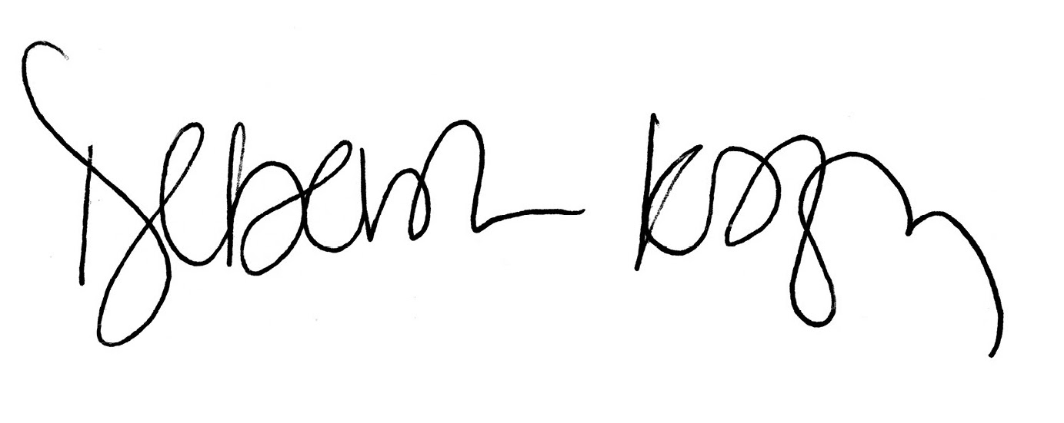  By:_Deborah Kafoury, Multnomah County Chair | REVIEWED: COUNTY ATTORNEY  FOR MULTNOMAH COUNTY, OREGON:  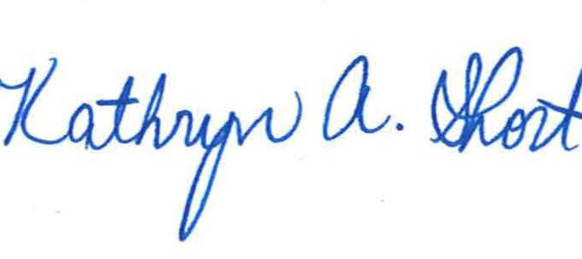  By: _________________________________  County Attorney

