Ticket Home Program
Do you have a safe place to go in the US but don’t have a way to get there? Transition Projects’ Ticket Home Program can help. Visit our Resource Center Downtown on 650 NW Irving Street, call our Shelter Diversion Case Manager at 503-488-7757, or email Ticket.Home@Tprojects.org to see if you qualify.
We will arrange transportation, purchase tickets, and cover travel costs for anyone trying to reunite with their loved ones. Most individuals over 18, currently experiencing homelessness in Multnomah County and have not accessed the program in the last two years will qualify.

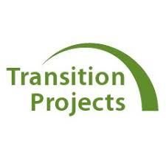
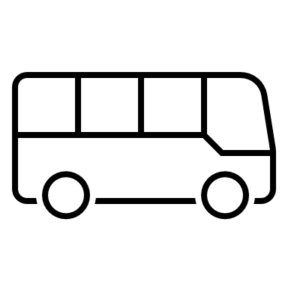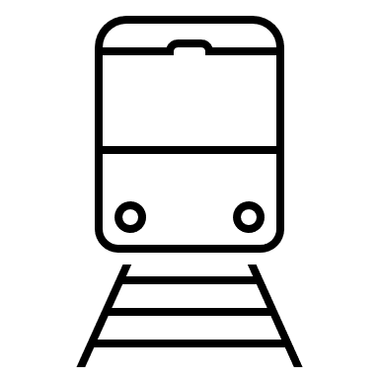
Phone: 503-488-7757
E-mail: Ticket.Home@Tprojects.org

Transition Projects
650 NW Irving St.

Ticket Home Program
Phone: 503-488-7757
E-mail: Ticket.Home@Tprojects.org
Ticket Home Program
Phone: 503-488-7757
E-mail: Ticket.Home@Tprojects.org
Ticket Home Program
Phone: 503-488-7757
E-mail: Ticket.Home@Tprojects.org
Ticket Home Program
Phone: 503-488-7757
E-mail: Ticket.Home@Tprojects.org
Ticket Home Program
Phone: 503-488-7757
E-mail: Ticket.Home@Tprojects.org
Ticket Home Program
Phone: 503-488-7757
E-mail: Ticket.Home@Tprojects.org
Ticket Home Program
Phone: 503-488-7757
E-mail: Ticket.Home@Tprojects.org
Ticket Home Program
Phone: 503-488-7757
E-mail: Ticket.Home@Tprojects.org
Ticket Home Program
Phone: 503-488-7757
E-mail: Ticket.Home@Tprojects.org

