CREATING PICTURE ID’S IN SERVICEPOINT
- Navigate to a client record, then to the Client Profile tab
- Upload a photo of your client with the Change button; remove photo with the Clear button
- Hit the Issue ID Card button to set up the ID
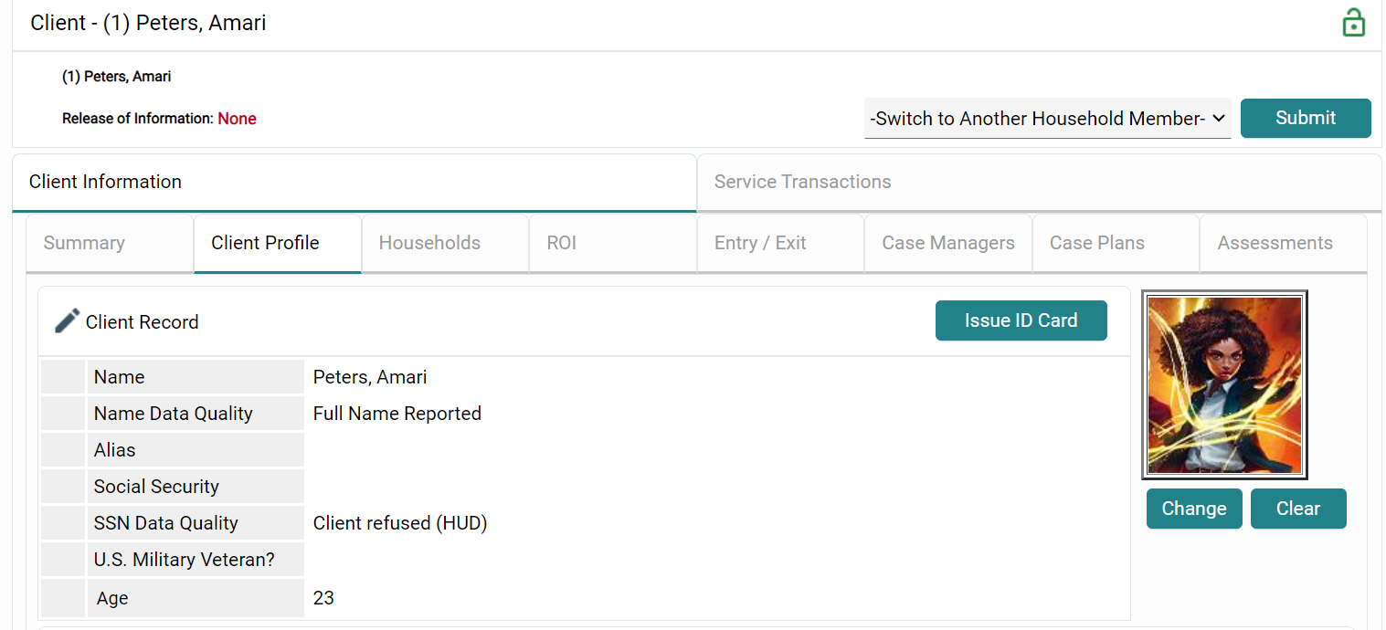
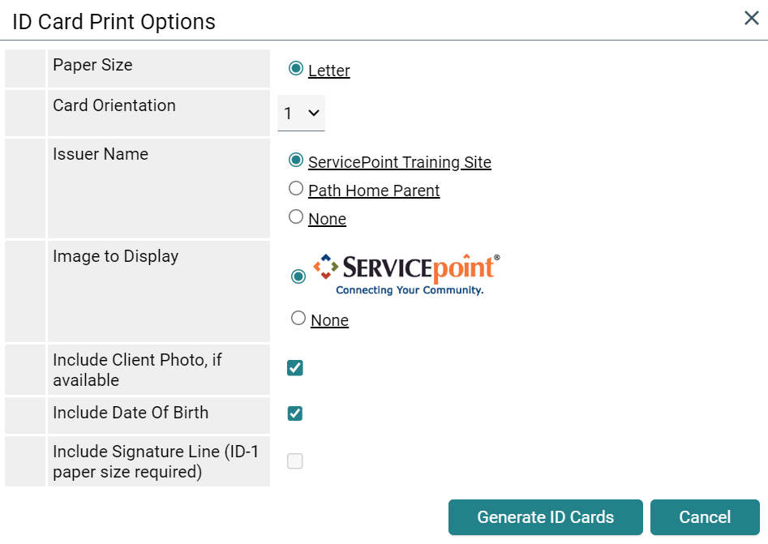

- You can choose to have ServicePoint or your agency be the ID issuer
- I recommend having the system logo
- Include Photo and Date of Birth if you like
- Hit the Generate ID Cards button to print

