
Department of County Human Services
Mental Health and Addiction Services Division

Mental Health and Addiction Services Division
2009 Annual Verity Quality Report

Report Date Verity QM Committee: February 15, 2010
Final 2009 Report Date April 2010

Data Complete As Of: January 1, 2010

Authors:

Charmaine Kinney, MPA-HA  Senior Quality Management Coordinator  503-988-5464 ext. 24424  Contact for questions | Sara Hallvik  Sr. Research and Evaluation Analyst

Other Mental Health and Addiction Services Division staff contributing to the report:

Joan Rice, RN
Quality Management Director

Christina Gardner, MPA
HIPAA Privacy and Compliance Officer

Deborah Danner
Supervisor, Family Care Coordination Team

Sara Carter, Data Analyst
John Anhaack, Data Analyst
Christi Taylor, Data Analyst

We would like to express our appreciation to JeVona Maniex for providing staff support for the Quality Management Committee.

Acknowledgements:
The accomplishments described in this report could not have been made without the dedication of the family advocates, consumers, providers, and other partners who lend their experience and expertise to the Verity Quality Management Committee. We gratefully acknowledge their commitment over the past year.

Tom Curtin, Family Advocate; Christine Lau, Asian Health & Service Center; Debra Hubbard, Human Advocate; Lori, Barron, Cascadia Behavioral Healthcare; Margie McLeod, Morrison Child and Family Services; Brenda McSweeney, Family Member; Tom Woodruff, Western Psychological and Counseling Services; Tundi Balogh, Trillium Family Services; Leslie Tallyn, Central City Concern; Christi Hildebrand, CODA; Juanita Lawson, Consumer Advocate; Anthony Kramer, Lifeworks Northwest; Margaret Brayden, NAMI Portland; David Sones, Luke-Dorf; Crystal Riley, OHSU Child IPP; Essie Morphis, Consumer Advocate; Drew McWilliams, Morrison Child and Family Services; Shannon McLean, Luke-Dorf; Ryan Hamit, Consumer Advocate; Cathy Dunwoody, Family Member; Kathy Robertson, Cascadia Behavioral Healthcare; Anna Long, Morrison Child and Family Services; Andrew Grover, ChristieCare; Victoria Anne Taylor; Consumer Advocate.

Table of Contents

Section | Page
Acknowledgements | 2
Executive Summary | 4
Utilization | 4
Penetration Rates | 9
MHASD Dashboard | 10
Plan: Initiation and Engagement | 15
Plan: Coordinated Healthcare with Physical Health Plan | 17
Plan: Community Based Treatment | 21
Plan: Hospital Discharge | 23
Plan: Youth Satisfaction | 25
Plan: Adult Satisfaction | 28
Plan: Outcome Measures | 30
Plan: Suicide Prevention | 33
Plan: Cultural Competency | 35
Plan: Chart Documentation | 38
Plan: Consumer Representation | 40

2009 Annual Verity Quality Report
The Mental Health and Addiction Services Division (MHASD) operates a mental health organization called Verity. Verity manages the mental health benefit of Oregon Health Plan (OHP) members in Multnomah County who have selected it as their mental health plan. The 2009 Annual Quality Report is organized into three sections. The Executive Summary is a brief overview of system changes, consumer satisfaction, and utilization for the year. The MHASD Verity Dashboard is a table of key performance indicators we use to monitor the system of care. The information on the dashboard is from fiscal year 2005 to fiscal year 2009. Additional detail and graphs about several key performance indicators from the MHASD Verity Dashboard are highlighted in the pages following the dashboard. MHASD uses a Plan, Do, Study, Act (PDSA) method to monitor the success of improvement efforts.

Executive Summary

System of Care
The Mental Health and Addiction Services Division (MHASD) continues to support the Verity provider panel’s use of evidence-based practices, and a standardized assessment tool, to ensure that the appropriate level of care to each client.

MHASD uses the Level of Care Utilization System (LOCUS) for all adult Verity providers. The creators of the LOCUS, Deerfield Behavioral Health, held a train the trainer session in December 2009 that was attended by all adult Verity providers. Verity also hosted a Stephen Langer training on Brief Solution Focused Therapy for child Verity providers to improve the service utilization levels in the outpatient children’s system of care.

Pursuant to a 2009 State of Oregon Department of Human Services Budget Note on health care integration, MHASD began to examine the possibilities for integrating mental health and physical health services for persons with severe mental illness in Multnomah County. Some providers under contract with MHASD offer integrated care, including Central City Concern’s 12th Avenue Recovery Center.

The Provider Review Committee composed of MHASD staff and clinical staff from Verity providers are addressing barriers to integration as well as developing standards for providing mental health treatment in a primary care setting. Physicians from most Verity contracted mental health agencies have been meeting with primary care physicians from Federally Qualified Health Centers, OHSU primary care, and local hospitals.

Utilization

Initiation and Engagement (I&E)
Adults: Adult providers achieved a 1 – 2% improvement over last year in the number of persons seen twice in fourteen days and four times in forty-five days for a new episode of care.

Children: There was a statistically significant decrease in children seen twice in fourteen days (initiation) between FY08 and FY09 for outpatient care. X2=, p=.027 and a non-significant decrease in children seen four times in forty-five days for a new episode of care. On a positive note, the Intensive Outpatient Service providers made small improvements in this area.

MHASD began a pay-for-performance initiative in FY09 for Verity providers who improved their I&E score. The data will be continually monitored and any significant improvement should be reflected by FY11.

Adult Hospitalizations
MHASD has worked to maintain Verity member hospitalizations at or below 2.0 discharges Per Thousand Members Per Month (PTMPM). Verity staff continue to improve initial and concurrent utilization review. They use hospital diversion options such as dispatching the county’s mobile crisis outreach team to emergency departments and improve treatment follow up by assisting members with multiple hospitalizations in transitioning to outpatient services.

In FY09, the Verity Adult hospital discharge rate remained stable at 2.1 PTMPM .

Outcomes
Both the child and adult systems of care have taken the subject of outcomes under consideration in the past year. While most children’s providers are utilizing the Child and Adolescent Needs and Strengths-Mental Health (CANS-MH ) assessment tool, data analysis and reporting varies greatly between agencies. As a result, MHASD cannot accurately report on Verity provider outcomes at the MHO level. To address this problem, a committee is investigating methods to improve Verity provider training, certification, tool administration, and data management and analysis. This committee is also reviewing the purpose of measuring outcomes within the children’s system, and evaluating use of the CANS-MH versus other options.

All adult agencies under contract to serve Verity members are required to use an outcomes tool in their practice, although this requirement has been viewed as an optional guideline in the past. This year, MHASD took the lead in standardizing outcomes data collection. After reviewing many different outcomes tools, MHASD decided to pilot the Center for Clinical Informatics, A Collaborative Outcomes Resource Network (ACORN) tool; implementing outcomes informed care in five volunteer adult Verity provider agencies.

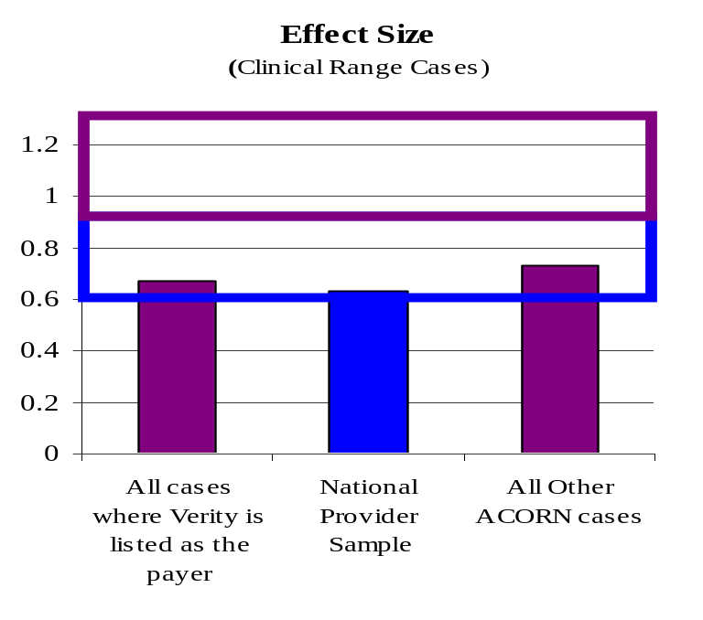
According to the ACORN data, Verity members assessed in pilot agencies received effective treatment. Verity members averaged slightly more improvement than the National Provider Sample after the fist six months in the pilot.

Customer Satisfaction

Adult Satisfaction Survey

Adult Verity member satisfaction scores have remained stable between 2008 and 2009. Verity member scores continue to be higher than overall State of Oregon scores and with the exception of outcome scores, comparable to national data. Due to differences in data collection method and the time frame the data were collected, comparisons with state and national data are general and not fully comparable.

Percent Agree for Verity, State & National
 | Verity May 2007 | Verity May 2008 | Verity May 2009 | Oregon (2006) | National (2006)
 | (n=941 ) | (n=795) | (n=832) | (n=2,684) | (n=137,024)
Access | 83% | 81% | 84% | 70% | 85%
Quality | 85% | 90% | 91% | 75% | 87%
Satisfaction | 87% | 87% | 90% | 57% | 71%
Outcome | 71% | 71% | 77% | 78% | 88%

Youth Satisfaction Survey and Youth Satisfaction Survey – Family
Youth Verity member satisfaction scores continue to be higher than state scores. With the exception of outcome scores, Verity member scores are comparable to national data. Survey returns increased by 31% percent in FY09 due to the efforts of providers.

Percent Agree on YSSF for Verity, State & National
 | Verity May 2007 | Verity May 2008 | Verity May 2009 | Oregon (2006) | National (2006)
 | (n=348) | (n=361) | (n=522) | (n=2,143) | (n=63,054)
Access | 82% | 79% | 76% | 70% | 83%
Appropriate | 82% | 82% | 83% | 64% | 81%
Outcomes | 62% | 64% | 67% | 56% | 73%
Participation | 87% | 77% | 84% | 74% | 87%
Cultural Sensitivity | 94% | 90% | 92% | 88% | 91%

Cultural Competency

MHASD held a series of focus groups, surveys, and community meetings in 2009 to gather feedback on the cultural competency of its system of care. Consumers, stakeholders, community member, and providers all provided valuable information that helped identify opportunities for improvement in the existing system.

The following gaps and themes were identified by the various groups.

Issues | Solutions/Suggestions
Customer Service Environment | - Customer service training  - Form consumer councils in planning for design and any relocation plans  - Provider staff should reflect diversity of population served
Access | - Offer evening and weekend appointments  - Locate mental health services at settings where diverse groups meet
Assessment/Treatment | Cultural Competency:  - Have all provider staff take the Multnomah County survey on cultural competence  - Assess population presently being served to identify and address cultural knowledge gaps  - Attend county training designed to address gaps in cultural knowledge  Technical Competency:  - Develop staff competencies at all levels and incorporate into performance evaluations. Include assessment for all populations, customer service, and cultural treatment approaches.
Language Barriers | - Evaluate therapists’ language competency and include on provider specialty report  - Offer training on cross-cultural communication and working with interpreters
Stigma/Feeling Judged | - Participate in campaign development and event planning  - Increase the availability of peer-delivered services

Complaints

The increasing number of Verity member complaints regarding clinical care returned to previous averages in 2009. The following graph illustrates an increase in member complaints that tend to correspond to times the system of care experiences major changes. Fluctuations in OHP enrollment, funding constraints and significant changes in the provider system all impact the frequency of complaints.

Although member complaints have trended downward, there has been an increase in appeals filed as a result of denial of payment. In 2009 Verity intentionally changed the internal process to ensure denials for retroactive authorizations are issued within twenty-four hours of request. We attribute the increase in appeals to this process change for retroactive authorization requests from acute care providers.

In 2009, MHASD received 37 formal complaints from Verity members in 2009, a decrease from 2008. There were 55 denials 52 of which were appeals.

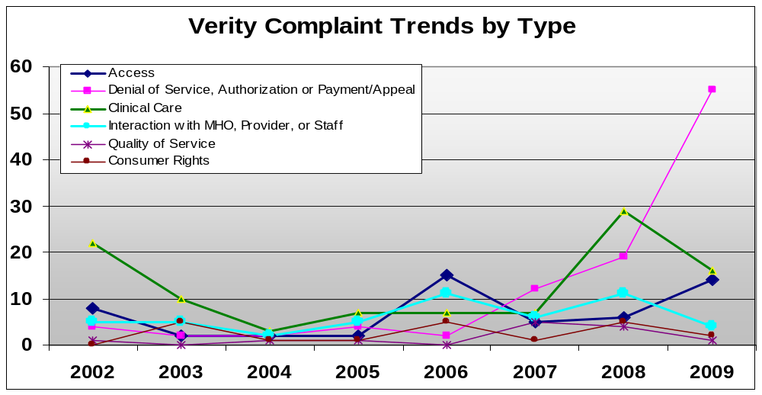
Utilization
Multnomah County is geographically the smallest county in Oregon, but contains approximately 20% of the state's population due to the high urban density in Portland and the surrounding cities. Twenty one percent (21%) of Medicaid enrollees in Oregon reside in Multnomah County. The county also has 40% of all mental health residential treatment facility beds in the state. A high percentage of Verity members have a severe mental illness. Verity has 21% of the state encounters for Schizophrenia, 29% of Pervasive Developmental Disorders, and 19% of Bipolar Disorders. Frequently these psychiatric diagnoses are complicated by co-occurring physical health or addictive disorders.

In FY09, 7,027 unique adult Verity members and 4,111 unique child Verity members used mental health services. This is a slight increase from FY08. A total of 2.8% percent of Verity members are in treatment and 24.9% of total Verity members in treatment were in higher levels of care. In this total group in treatment, 33.7% of adults and 21.4% of children were in higher levels of care.
Verity Member Treatment Use in fiscal year 2009 | Total | Adults | Children
Total individuals enrolled as members in Verity | 98,329 | 44,533 | 53,796
Total Verity members engaged in treatment | 11,138 | 7,027 | 4,111
Percent of Verity members served (penetration rate) | 11.3% | 15.8% | 7.6%
Total Verity members in higher (more intensive) levels of care | 2,775 | 2,369 | 880
Percent of total Verity members in treatment | 2.8% | 5.3% | 1.6%
Percent of enrollees engaged in treatment who are served in higher (more intensive) levels of care | 24.9% | 33.7% | 21.4%

Penetration rates

As indicated in the preceding chart, the penetration rate (the percent of people enrolled in Verity who are engaged in mental health treatment) for Verity in FY09 was 11.3 % for all members. The penetration rate for Verity adults was 15.8%. The penetration rate for children of any age was 7.6%. The rate increases to 12% when we do not include data about children five years of age or younger.

MHASD is examining ways to get more accurate data from state enrollment files about the ethnicity of Verity members. Accurate information about the ethnicity of individuals identified in state files as other or undetermined would be particularly helpful. Available penetration by ethnicity is shown in the chart below.

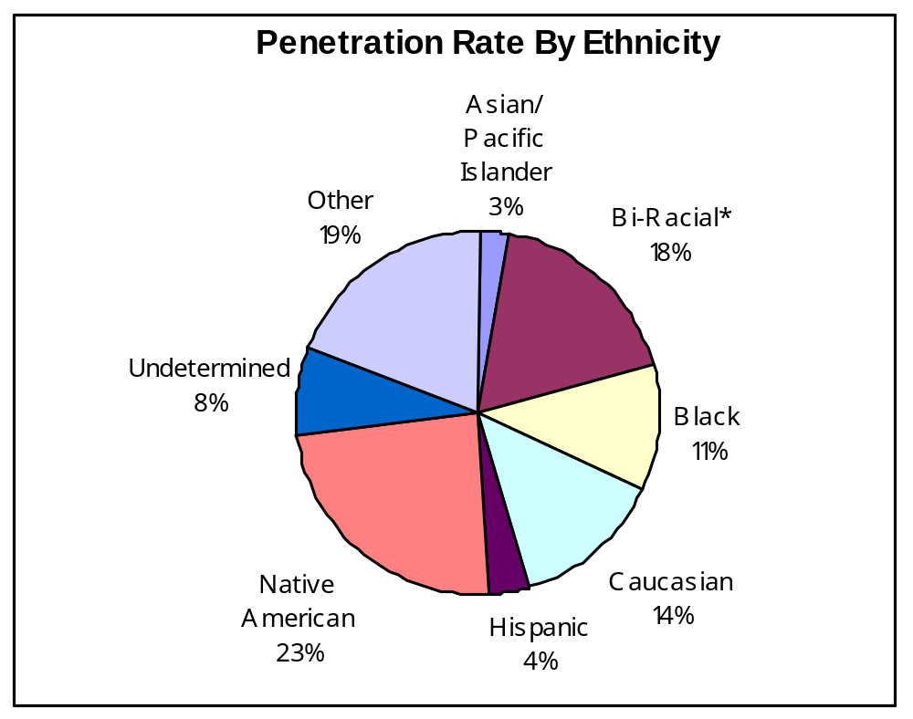

MHASD Performance Dashboard for Verity
This dashboard highlights critical measures MHASD uses to track the clinical and financial performance of the system of care for Verity members.
CLINICAL PERFORMANCE
Category |  | FY 06 |  |  | FY 07 |  |  | FY 08 |  | FY 09 |  |  |  |  | Comments
Total Member Months |  | 799,170 |  |  | 774,793 |  |  | 793,979 |  | 856,407 |  |  |  |  | Increases in FY09 are predominantly children
Unique Adults Served |  | 6,443 |  |  | 6,767 |  |  | 6,795 |  | 7,027
Unique Children Served |  | 4,319 |  |  | 4,226 |  |  | 4,100 |  | 4,111
Adult Penetration |  | 14.92% |  |  | 16.22% |  |  | 16.3% |  | 15.8%
Child/Adolescent Penetration (Children aged 0-17) |  | 8.55% |  |  | 8.20% |  |  | 8% |  | 7.6% |  |  |  |  | Children % is from ages 0-17. Children from 6-17 is 12%
Adult Hospital Discharges Per Thousand Members Per Month (PTMPM) |  | 2.0 |  |  | 2.3 |  |  | 2.0 |  | 2.1 |  |  |  |  | Verity began developing plans for evidence-based intensive case management to further decrease hospitalizations.
Adult Inpatient Days PTMPM |  | 14.2 |  |  | 14.9 |  |  | 14.3 |  | 13.8 |  |  |  |  | Current target 12.1. Verity data minus Medicare is 347 fewer hospital days overall.
Adult Hospital Average Length of Stay (ALOS) Days |  | 6.9 |  |  | 6.6 |  |  | 6.9 |  | 6.6 |  |  |  |  | Verity only  Non-Medicare
Adult Hospital Readmissions in 30 Days (includes readmissions in 0-7 days) |  | 26% |  |  | 21.9% |  |  | 18.0% |  | 16.74% |  |  |  |  | Verity and Medicare combined. Verity Utilization program initiated an outreach and engagement program targeting individuals that were not enrolled in outpatient service but were repeatedly hospitalized.
Child/Adolescent Hospital Discharges PTMPM |  | .3 |  |  | .4 |  |  | .3 |  | .2 |  |  |  |  | System continues to be able to support children in intensive community-based care.
Child/Adolescent Inpatient Days PTMPM |  | 2.6 |  |  | 2.6 |  |  | 2.3 |  | 1.5
Child/Adolescent Hospital ALOS |  | 7.7 |  |  | 6.8 |  |  | 7.5 |  | 7.3
Child/Adolescent Hospital Readmissions in 30 Days (includes readmissions  1-30 days) |  | 17% |  |  | 9.4% |  |  | 5.5% |  | 5.6%
Psychiatric Residential Treatment Services (PRTS) Admissions PTMPM |  | .15 |  |  | .12 |  |  | .1 |  | .1 |  |  |  |  | System continues to be able to support children in intensive community-based care.
Intensive Evaluation Services (IES) Admissions PTMPM |  | .21 |  |  | .25 |  |  | .23 |  | 0 |  |  |  |  | Authorization type eliminated early in 2009
PRTS Days PTMPM |  | 9.1 |  |  | 13.7 |  |  | 9.2 |  | 11.0
CLINICAL PERFORMANCE
Category |  | FY 06 |  |  | FY 07 |  |  | FY 08 |  | FY 09 |  |  |  |  | Comments
IES Days PTMPM |  | 6.5 |  |  | 7.1 |  |  | 4.8 |  | .6 |  |  |  |  | Authorization type eliminated early in 2009
PRTS average length of stay (days) |  | 68.1 |  |  | 94.3 |  |  | 88.9 |  | 90.3
IES average length of stay (days) |  | 32.3 |  |  | 28.2 |  |  | 19.2 |  | 29.1 |  |  |  |  | Authorization type eliminated early in 2009
Percent of Intensive Community-Based Treatment Services (ICTS) in home/community |  | ICTS  33% |  |  | ICTS  61.4% |  |  | SMI  28.4%  ICTS 58.0% |  | SMI  24.7%  ICTS  51.2% |  |  |  |  | SMI = Severe Mental Illness
Initiation:  Clients have a second outpatient visit within 14 days of the first visit |  | 6-12 yrs: 49%  13-17 yrs: 53% |  |  | 6-17 yrs:  48.39% |  |  | 6-17 yrs:  50.14% |  | 6-17 yrs:  44% |  |  |  |  | 1. Measures were collapsed in FY07 for validity. The total number was very low when broken into categories.
 |  | 18-64 yrs 48%  65+ yrs 35% |  |  | 18+ yrs  49.01% |  |  | 18+ yrs  51.12% |  | 18+ yrs  52.11%
Engagement:  Clients have four visits within the first 44 days |  | 6-12 yrs: 34%  13-17 yrs: 34% |  |  | 6-17 yrs:  34.52% |  |  | 6-17 yrs:  35.31% |  | 6-17 yrs:  30.53%
 |  | 18-64 yrs 28%  65+ yrs 16% |  |  | 18+ yrs  28.68% |  |  | 18+ yrs  29.55% |  | 18+ yrs  30.13%
MENTAL HEALTH CALL CENTER PERFORMANCE
Category | FY06 |  |  |  | FY07 |  |  | FY08 |  |  | FY09 |  |  | Comments
Total Crisis Line calls received | 66,420 |  |  |  | 63,811 |  |  | 64,247 |  |  | 53,119
Total Crisis Line calls answered | 61,928 |  |  |  | 60,393 |  |  | 60,932 |  |  | 50,638
Average speed of answer in seconds | 18 |  |  |  | 15 |  |  | 15 |  |  | 14
Abandonment rate | 7.2% |  |  |  | 5.3% |  |  | 5.1% |  |  | 4.76%
VERITY FINANCIAL PERFORMANCE
Category | FY06 |  |  | FY07 |  |  | FY08 |  |  |  | FY09 |  | Comments
Total Oregon Health Plan payment for Verity membership | $33,491,713 |  |  | $34,878,339 |  |  | $36,072,468 |  |  |  | $39,022,799 |  | Amount of Verity revenue fluctuates based on number of Verity members
Verity revenue per member per month (PMPM) | $42.42 |  |  | $45.56 |  |  | $45.86 |  |  |  | $49.77
Verity expense PMPM | $40.78 |  |  | $40.52 |  |  | $41.41 |  |  |  | $42.10
CUSTOMER SATISFACTION ADULT OUTCOMES
Category |  |  | FY 06 |  |  | FY 07 |  |  | FY 08 |  |  | FY09 |  |  |  | Comments
Outcome Domain (outcome questions below) |  |  | 69% |  |  | 70.6% |  |  | 71.0% |  |  | 77% |  |  |  | N = 1269 in FY 06, 931 in FY07, 764 in FY08, 832 in FY09
Deal more effectively with daily problems. |  |  | 76.5% |  |  | 77.7% |  |  | 81.6% |  |  | 84.1%
Getting along better  with my family. |  |  | 69% |  |  | 72.8% |  |  | 73.9% |  |  | 74.4%
Better able to control my life. |  |  | 75.1% |  |  | 77.3% |  |  | 78.2% |  |  | 79.9%
Better able to deal with crisis. |  |  | 72% |  |  | 72.9% |  |  | 75.8% |  |  | 77.9%
I do better in social situations. |  |  | 68% |  |  | 67.4% |  |  | 68.9% |  |  | 68.9%
My symptoms are not bothering me as much. |  |  | 59.9% |  |  | 66.1% |  |  | 64.2% |  |  | 64.3%
My housing situation has improved. |  |  | 61.1% |  |  | 62.5% |  |  | 64.3% |  |  | 62.9%
I do better in school and/or work. |  |  | 57.8% |  |  | 63.4% |  |  | 61.6% |  |  | 62.5%
Access Domain |  |  | 78% |  |  | 83% |  |  | 81.0% |  |  | 84%
Quality Domain |  |  | 83% |  |  | 85% |  |  | 88.0% |  |  | 91%
Satisfaction Domain |  |  | 85% |  |  | 87% |  |  | 87.0% |  |  | 90%
CUSTOMER SATISFACTION CHILD AND ADOLESCENT OUTCOMES
Outcome Domain (outcome questions below) |  |  | 57% |  |  | 62.5% |  |  | 64.0% |  |  | 64% |  |  |  | N = 694 in FY 06 and 497 in FY 07, 499 in FY 08. 522 in FY09.
I/my child are doing better in school and work. |  |  | 66.8% |  |  | 62.9% |  |  | 64.5% |  |  | 61.0%
I/my child get along better with friends and other people. |  |  | 66.5% |  |  | 65.7% |  |  | 66.3% |  |  | 61.4%
I/my child are better at handling daily life. |  |  | 66.6% |  |  | 66.5% |  |  | 69.0% |  |  | 59.8%
I/my child get along better with my family. |  |  | 64.6% |  |  | 63% |  |  | 65.9% |  |  | 60.5%
I/my child are better able to cope when things go wrong. |  |  | 58.3% |  |  | 61.3% |  |  | 62.1% |  |  | 57.4%
I/my child are satisfied with our family life right now. |  |  | 54.4% |  |  | 55.3% |  |  | 57.9% |  |  | 55.9%
Access Domain |  |  | 77% |  |  | 82% |  |  | 79.0% |  |  | 70%
Participation Domain |  |  | 85% |  |  | 87% |  |  | 77.0% |  |  | 77%
Cultural Sensitivity Domain |  |  | 94% |  |  | 94% |  |  | 90.0% |  |  | 86%
Appropriateness Domain |  |  | 80% |  |  | 82% |  |  | 82.0% |  |  | 78%

Domain: Access
Program Area: All Adult Verity Clients

Plan: Initiation and Engagement (non-clinical Performance Improvement Project)

Objectives
Improve Verity clients’ initiation and engagement in treatment services to prevent more serious illness

Questions/Predictions
Increasing initiation and engagement of clients will:
- Increase the likelihood that clients will actively engage in treatment services and successfully complete treatment
- Decrease the utilization of hospital and residential beds by Verity clients engaged in outpatient services
- Reduce noncompliance for future appointments
- Resolve brief crisis episodes and intervene before symptoms become chronic

Indicators
Initiation
- General outpatient Verity clients who have a second outpatient visit within 14 days of the first visit
- Intensive Community Treatment Services (ICTS) clients who have a second outpatient visit within seven days of the first visit

Engagement
General outpatient clients will have met the initiation indicator and had two additional visits within the first 44 days
ICTS clients will have met the initiation indicator and had two additional visits within the first 21 days

Performance Goal for Outpatient Services
Initiation
Child (6-17 years) Baseline: 47.2% Yearly Target: 60%
Adult (18+) Baseline: 43.3% Yearly Target: 60%
Long term target for both Children and Adults: 70% (2007 QM Committee Recommendation)

Engagement
Child (6-17 years) Baseline: 32% Yearly Target: 50%
Adult (18+) Baseline: 23.6% Yearly Target: 50%
Long term target for both Children and Adults: 50% (2007 QM Committee Recommendation)

Engagement without Initiation
Child (6-17 years) Baseline: 52.2% Yearly Target: 50%
Adult (18+) Baseline: 40% Yearly Target: 50%
Long term target for both Children and Adults: 50% (2007 QM Committee Recommendation)

Performance Goal for ICTS
Initiation
ICTS Baseline: 84.4% Yearly Target: 98%
Long term target for ICTS: 100%

Engagement
ICTS Baseline: 78.5% Yearly Target: 90%
Long term target for ICTS: 95%

Engagement without Initiation
ICTS Baseline: 84.2% Yearly Target: 95%
Long term target for ICTS: 98%

Measurement Method
Initiation
- Percent of Verity clients with a second general outpatient visit within 14 days of the first visit
- Percent of Verity clients with a second ICTS outpatient visit within 7 days of the first visit

Engagement
- Percent of Verity clients who have met the general outpatient initiation indicator and had two additional visits within the first 44 days
- Percent of Verity clients who have met the ICTS initiation indicator and had two additional visits within the first 20 days

Engagement without Initiation
- Percent of Verity clients who have had a total of 4 visits within the first 45 days
- Percent of Verity clients who have had 4 visits within the first 21 days

Measurement Source
Verity OHP claim data

Do: Action Steps
- Implement performance payments for encounters that meet initiation and engagement standards; additional payment if the total percentage of agency encounters meet or exceed the goals
- MHASD will give Verity providers their data on a quarterly basis
- MHASD QM staff will meet with Verity provider executives annually to discuss performance measures including initiative and engagement and assess how they are implementing this measure
- MHASD will work with Verity providers to develop an improvement plan, if indicated, for initiation and engagement
- Review clinical staff capacity from Verity provider specialty reports submitted to MHASD

Interventions were revised during 2009 as a result of pay for performance implementation.

Results

MHASD has been using initiation and engagement for four years to measure general outpatient access to Verity provider agencies. Access has remained stable with incremental increases in both the adult and children’s system in FY2007 and FY2008. The data for adults shows a continued trend upward in FY 2009. However, initiation and engagement data for children and adolescents decreased from FY08 to FY09.
MHASD was unable to monitor the measure during the first half of 2009 due to issues with the Oregon Health Plan data system and inability to get current Verity enrollment files.

Verity continued interventions during fiscal year 2009 to increase “front-loading” of services and increasing access to new clients in their system. These interventions included the sharing of data and providing a series of educational visits to 16 of the 18 outpatient agencies in 2009. Agency specific I&E data was discussed with each agency visited. The visits have been invaluable in clarifying expectations and promoting discussion concerning how to increase access for Verity enrollees. Continued discussion and modification of the measure occurred with all agencies participating in the QM committee meetings. MHASD anticipates that the addition of improvements made in FY10 will increase successful initiation and engagement.

In the spring of 2009 Verity developed pay-for-performance measures for FY2010 including performance pay for I&E. Verity discusses performance in the network provider executive meetings along with the discussions at the QM meetings and with each agency. The result of these interventions is not yet reflected in the data. We expect to see increases in FY 2010-2011. MHASD will perform outreach visits to additional Verity providers in 2010. During these visits, we review agency performance, clarify expectations, and discuss methods for increasing access to Verity members.

Verity Member Initiation and Engagement Results
Initiation | Goal | FY07 | FY08 | FY09
Adult | 60% | 48.80% | 51.20% | 52.41%
Children/Adolescents | 60% | 48.40% | 48.25% | 44.05%
Individually Tailored Outpatient (INTOP) | 90% |  | 80.10% | 81.16%
Engagement | Goal | FY07 | FY08 | FY09
Adult | 50% | 28.69% | 29.55% | 30.40%
Children/Adolescents | 50% | 34.52% | 35.31% | 30.59%
Individually Tailored Outpatient (INTOP) | 90% |  | 73.15% | 78.53%
Engagement without Initiation | Goal | FY07 | FY08 | FY09
Adult | N/A | 37.83% | 39.41% | 40.31%
Children/Adolescents | N/A | 57.51% | 57.41% | 52.92%
Individually Tailored Outpatient (INTOP) | 90% |  | 86.60% | 93.41%

Adults: There was a slight upward trend in FY09 for all measures. In the summer of 2008, the provider network serving Verity members became more diversified. Some of the Verity business contracted at one agency was distributed to other agencies. Despite this shift in the network there was no downward trend in performance measure.

Children: There was a statistically significant decrease in children’s initiation between FY08 and FY09, p=.027. There was also a downward trend for engagement and engagement without initiation. The decrease from April 2008 to March 2009 may be a reflection of changes in the children’s system of care. In the fourth quarter of 2008 the expenses of several agencies exceeded their Verity revenue. MHASD requested that Verity provider agencies assure that Verity clients were being appropriately served according to medical necessity criteria. MHASD asked agencies to institute formal review process. Providers are also now required to use the level of care assessment tool to match the amount and type of care to what is needed.

MHASD hosted a Brief Solution Focused Therapy clinical training for the Verity provider panel in 2008.

Provider agencies have shifted procedures in response to these changes, which initially resulted in an overcorrection. The data indicates that the system is returning to appropriate levels.

MHASD QM staff identified problems in 2009 with how the initiation and engagement measure was implemented across agencies. Although the problem has been resolved, there is no data between November 2008 and June 2009.

Individually Tailored Outpatient Services (INTOP) initiation was above the mean between March 2008 and March 2009 as shown on the chart below.

With the pay for performance incentive for improved initiation and engagement implemented in FY09 MHASD expects Verity data to show an upward trend. We anticipate that significant improvement will not be reflected in the data until FY11 due to the time it takes to implement new procedures. Verity will continue to monitor the measurement in FY10 and will be providing quarterly data and visiting all of the Verity provider agencies in the next year.

Percentage of Verity Client Individually Tailored Outpatient (INTOP) Successful Initiation
0
0.2
0.4
0.6
0.8
1
1.2
1.4
Jul-07
Sep-07
Nov-07
Jan-08
Mar-08
May-08
Jul-08
Sep-08
Nov-08
Jan-09
Mar-09
May-09

Domain: Integration and Coordination
Program Area: All Adult Verity Clients

Plan: Coordinate Health Care with Physical Health Plan for Clients With a Severe Mental Illness (Clinical Performance Improvement Project)

Objectives
- Screen Verity clients at behavioral health clinics for medical problems
- Increase compliance with medication and laboratory protocols
- Refer clients to primary care practitioners (PCP)
- Decrease avoidable use of emergency and urgent services

Questions/Predictions
Does the integration and coordination of physical health services in the behavioral health setting result in Verity clients with an identified PCP? Does it increase the number of routine physical health care appointments and subsequently decrease the use of the emergency department?
Does having an Exceptional Needs Care Coordinator (ENCC) at a physical health plan dedicated to Verity clients increase integration and coordination with behavioral health providers? Does it increase client compliance with medication and laboratory protocols? Does it decrease use of the emergency department?

The average lifespan of individuals with a severe mental illness (SMI) is approximately 25 years less than the general population. Providing physical health screening to Verity clients in the behavioral health setting and connecting clients to a PCP is predicted to increase life expectancy. By accessing preventive and routine health care clients are predicted to use the emergency department less and have an overall improvement in health care outcomes.

Indicators
- Number of clients enrolled in project at Lifeworks NW Gresham site
- Number of referrals to Kaiser ENCC
- Number of clients in compliance with medication and laboratory protocol
- Number of PCP referrals resulting in a client being assigned to a specific PCP
- Number of clients who had an encounter with a PCP within the last 12 months
- Number of emergency department visits per client

Performance Goal
- Establish baseline and increase percent of records with documented communication between behavioral and physical health care service providers regarding service coordination.
- Develop standard protocol laboratory testing and metabolic monitoring for clients prescribed medication
- Establish baseline and increase percent compliance with prescribed medication regimes and associated laboratory tests.
- Decrease the use of emergency department for physical health care.
- Increase the number of Verity client appointments with primary care practitioners.

Measurement Method
Percent of clients with documented exchange of information between behavioral and physical health care providers
Percent of clients who comply with Kaiser laboratory protocol as indicated in chart documentation
Percent of clients who attend appointments with a primary care practitioner
Percent of Lifeworks clients who have had an encounter with a PCP
Number of Lifeworks clients ED encounters

Measurement Source
Agency screening tools
Encounter data at Verity and physical health plan(s)
Pharmacy and Laboratory database at Kaiser Permanente

Do: Action Steps
Run baseline data
Nurse hired for Lifeworks site
Communication tools developed
Exchange of data between mental health and physical health

Results
This collaboration will promote:
- Timely identification and assessment of the client’s medical conditions
- Detection of co-morbid medical condition(s)
- Coordination in dialogue and joint treatment plan development between the behavioral and medical care teams

MHASD is collaborating with two physical health plans to coordinate care for Verity members. The collaborative efforts will first determine if case management increases the exchange of information between physical health and mental health care systems. It will also inform us if case management by the nurse care coordinators increases Verity member visits to their primary care provider, decreases inappropriate emergency room usage and increases screening for metabolic syndrome.

Two models were implemented simultaneously. Model A is a face-to-face encounter with a nurse in a behavioral health setting. A Registered Nurse (RN) who has experience in both medical and mental health was be placed in a behavioral healthcare setting to screen and assist clients in establishing care with a PCP. Model B consists of a chart review with follow-up through telephone encounter. There is limited face-to-face contact with an Exceptional Needs Care Coordinator (ENCC) who is also a RN. Nurses in both models screen Verity clients for physical health risk, which include not having an established Primary Care Provider (PCP) and/or identification of a physical health care concern. The nurses help establish care with a PCP and coordinate care between the physical health care and mental health care provider until the patient is fully established with a PCP and major concerns are addressed.

Project participants include two physical health plans, CareOregon, Inc. and Kaiser Physician Care Organization, as well as Verity, the mental health organization run by MHASD. Mental health agencies in the Verity provider network are also participating in the project. LifeWorks NW hosts the nurse in its Gresham clinic for Model A.

Both models have been successful in identifying unaddressed or unknown problems. Anecdotally, there has been increased information exchange in both models that has increased coordination of care. Increased communication between systems has resulted in better prescription tracking for individuals who may be abusing medication and improved health outcomes. The models have highlighted inconsistencies in monitoring laboratory work of individuals prescribed psychotropic medications. Verity members who rarely, if ever, visited a primary care practitioner did so as a result of these models.

Model A
Data for the Verity/CareOregon face-to-face model was collected by the registered nurse hired and jointly funded by Verity and CareOregon to provide care coordination for Lifeworks NW Gresham clinic. Lifeworks NW initially recruited study participants primarily through the metabolic screening clinic. However, as clients have discovered that a physical health care nurse is available, they are seeking her out and enrolling in the program.

Physical and Behavioral Health Care Coordination for Verity Members in 2009
Measure | Clients | Percent
Clients served | 89 | 100%
Clients with no PCP | 23 | 25.8%
Clients with a PCP | 66 | 74.2%
Clients with positive Metabolic Syndrome | 24 | 27.0%
Clients with negative Metabolic Syndrome | 20 | 22.5%
Clients with unknown Metabolic Syndrome | 45 | 50.6%
Number of labs requested | 76 | 85.4%
Number of labs received | 47 | 52.8%
Number of clients prescribed atypical antipsychotics | 74 | 83.1%
Number of clients prescribed Zyprexa | 19 | 21.3%
Number of clients following lab protocols | 6 | 6.7%
Aggregate data was submitted, but not individual client data, so it is difficult to see client outcomes. More than 83% of clients were prescribed atypical antipsychotics and 27% of the individuals had positive metabolic syndrome. However, only 50% of clients were screened for metabolic syndrome. The agency is using their internal lab protocol, which includes a pregnancy test, which was the primary reason clients did not meet the protocol. We will be working with LifeWorks NW to standardize data collection to better indicate outcome.

Model B
Data for the Kaiser/Verity project was collected by the Kaiser Nurse Care Coordinator. There are a total of 182 individuals with Kaiser PCO who are being served by all participating agencies. Kaiser’s recent medical record review revealed a total of 39 charts out of 182 (21%) contained an up to date Release of Information (ROI) for the Verity client’s current mental health provider. Verity clients seen at Morrison had most ROIs in Kaiser records with 42% containing signed releases. See chart for details
Percent of Current Agency Release of
Information for Current Mental Health Provider in
Kaiser Medical Chart
18%
13%
16%
6%
42%
0%
5%
10%
15%
20%
25%
30%
35%
40%
45%
Cascadia
CCC
LWNW
Western
Morrison

The Verity provider agencies sent the Kaiser ENCC mental health clinical data on 24 of the 182 Kaiser/Verity clients (13.2%). Kaiser returned physical health clinical information for 23 of the 24 clients. One client was discharged from the mental health agency and exchange of information with Kaiser was no longer needed. Kaiser sent clinical information back to the agency within an average of 3 days.

A breakdown by authorization type revealed that data was exchanged for all of the Verity clients who had exceptional needs and a higher percentage of data was exchanged for Verity clients with a severe mental illness (SMI). The data exchange for children exchange is low, but expected to increase as Morrison begins to exchange information. Anecdotally, the Kaiser ENCC feels that data exchange was most successful with the RN at LifeWorks NW than with any of the other agencies. She felt that the data was meaningful and that she had someone to coordinate physical health concerns and appointments for the clients being served.

Seventeen of the 24 clients now have their mental health diagnosis entered into EPIC, Kaiser’s Electronic Medical Record. Of the information exchanged for the 10 clients with an SMI, only one of them had their mental health diagnosis documented in EPIC. After the exchange, 10 clients in the SMI group have mental health diagnosis in EPIC. It is particularly important for the medical providers to have mental health diagnosis available for clients with a severe mental illness. A significant increase in the amount of clinical information being exchanged occurred in this initial 3-month exchange for Kaiser/Verity clients with an SMI.

During data exchanges four Kaiser/Verity clients were identified as requiring lab work. It is unclear how many of the 24 clients needed to be monitored for lab work due to the medications they were prescribed as the data tool did does not contain a list of prescribed medication. MHASD will revise its forms based on this finding.
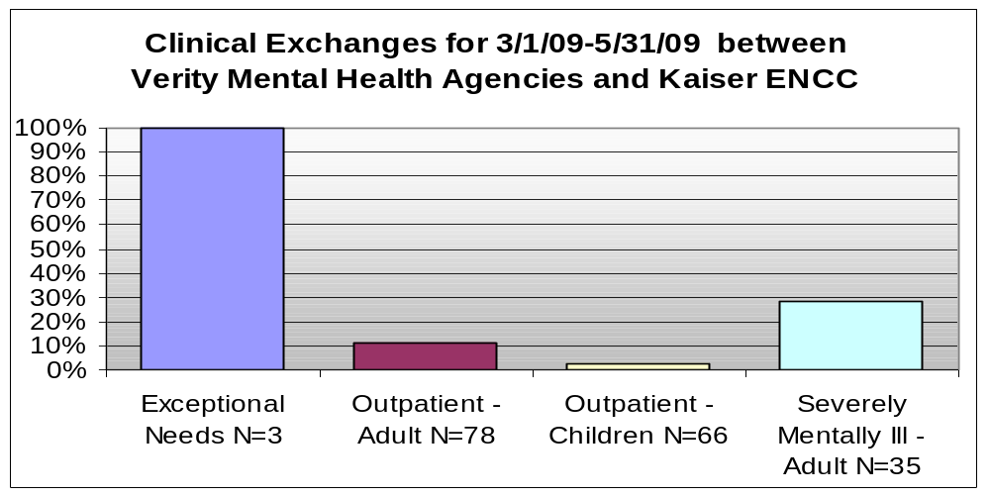

Domain: Access
Program Area: All Verity Clients

Plan: Community-Based Treatment for Clients Authorized for Intensive Levels of Care

Objectives
- Increase the amount of mental health services provided in non-office settings for clients in intensive levels of care
- Reduce total days in psychiatric residential treatment services (PRTS), hospital and day treatment.
- Develop indicators for monitoring that adults and children are being served at the appropriate level of care

Questions/Predictions
- Agencies with increased non-office visits will improve successful discharge outcomes
- Increasing community based services will decrease total days in higher level of services
- Clients who have non-office visits will remain in treatment and have improved outcomes

Indicators
- Percent of all outpatient services provided in non-office settings stratified by level of care
- Percent of days in which members receive PRTS services
- Increased overall claims for treatment of clients with a severe mental illness who have a level of care score of four.
- Sum of total day treatment days

Performance Goal
Establish baselines and set performance goal targets

Measurement Method
- Percent of outpatient encounters in a non-office setting
- Percent of total PRTS days
- Sum of total day treatment days
- Total hospitalizations of adults in highest level of care

Measurement Source
Verity OHP claim data

Do: Action Steps
- Continue the implementation and monitor data of home and community-based services for adults with an SMI and children in the ICTS program
- Provide technical assistance to agencies in using Place of Service Codes (POS)
- Increased incentives for community-based INTOP services in FY09
- Incentives for all SMI, LOCUS level 4 services in FY09

Results
Community-based services for Individually Tailored Outpatient Services (INTOP) remains stable with a slight upward trend. There has been no significant increase in community-based servcies. In fiscal year 2009, 52% percent of all INTOP services to children were provided in a community-based setting, an increase of 2% from the prior year. All of the Verity provider serving children are implementing plans to increase these services in 2010. MHASD pays higher rates for all community-based services delivered to Verity clients. In addition, incentive pay for INTOP community-based services was added in the first quarter FY09.

Individually Tailored Mental Health Services Community-Based Encounters
7/1/07-6/30/09
0
0.1
0.2
0.3
0.4
0.5
0.6
0.7
Jul-07
Sep-07
Nov-07
Jan-08
Mar-08
May-08
Jul-08
Sep-08
Nov-08
Jan-09
Mar-09
May-09
The percent of community-based encounters for adults with a SMI dropped significantly between the first quarter and second quarter in FY08 and has not recovered. Increased rates for community-based services have been in place since April 2006. Payment incentives for community-based care for LOCUS level clients with an SMI were put into place in FY10. Improvements should be reflected in future data.
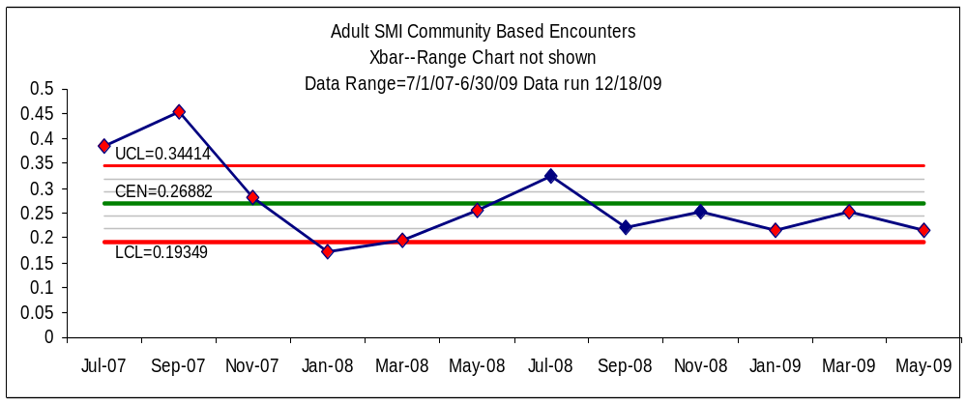

Domain: Integration and Coordination
Program Area: All Verity Clients

Plan: Hospital Discharge Planning

Objectives
- Increase the number of Verity clients whose outpatient treatment provider was involved in discharge planning prior to the client’s discharge from the hospital.
- Increase the number of Verity clients who have a follow-up appointment with their outpatient treatment provider within seven days of being discharged from the hospital.

Questions/Predictions
- Clients whose outpatient provider is involved in their discharge planning will have shorter hospital stays
- Clients who are connected with an outpatient medical provider for ongoing prescriptions and medication monitoring will have fewer readmissions to the hospital

Indicators
- Outpatient provider claim received for involvement in discharge planning prior to discharge
- Outpatient provider claim received for client appointment within 7 days following hospital discharge

Performance Goal
MHASD changed the performance goal from the 2009 Verity QM Plan to better reflect the general Adult and Child categories. However, we have continued to separate those with outpatient authorizations and those unaffiliated remains to measure the difference between the two. Individuals at all levels of care should receive similar follow-up after a crisis as their previous level of need may have changed. In addition, there have been concerns regarding access to prescribers after hospitalization. We added a measure to establish a baseline so that we can monitor this issue over time.

In hospital:
Adults with outpatient treatment authorizations Target 90%
Children with outpatient treatment authorizations Target 95%
All adults without outpatient treatment authorizations Target 20%

Within seven days of hospital discharge:
Adults with outpatient treatment authorizations Target 98%
Children with outpatient` treatment authorizations Target 100%
All adults without outpatient treatment authorizations Target 50%
All children and adults medical follow-up Establish Baseline

Measurement Method
Percent of Verity clients with an outpatient authorization who are hospitalized and have at least one contact with their outpatient provider during hospitalization
Percent of Verity clients with an outpatient authorization who are hospitalized and have at least one outpatient encounter within seven days of hospital discharge
Percent of Verity clients with no outpatient authorization who are hospitalized and have at least one contact with an outpatient provider during hospitalization
Percent of Verity clients with no outpatient authorization who are hospitalized and have at least one outpatient encounter within seven days of hospital discharge
Percent of Verity clients who have a follow-up appointment with a medical provider

Measurement Source
Verity OHP claim data

Do: Action Steps
- Continue monitoring data
- Contract with hospitals will contain language for aftercare coordination
- Call Center outreach team coordination for all Verity clients that do not have an identified outpatient provider

Results
There continue to be disparities between Verity members unaffiliated with a provider and affiliated with a provider. The number of unaffiliated clients decreased substantially in FY08 but increased again in the first half of FY09. The number of unaffiliated clients who follow up with a provider has not been improved through any of our interventions. General outpatient claims while in the hospital and follow-up within 7 days have remained below target levels. There has been no substantive change for any of the measures. A decline in FY09 was likely due to disruptions that occurred during the first half of the fiscal year.

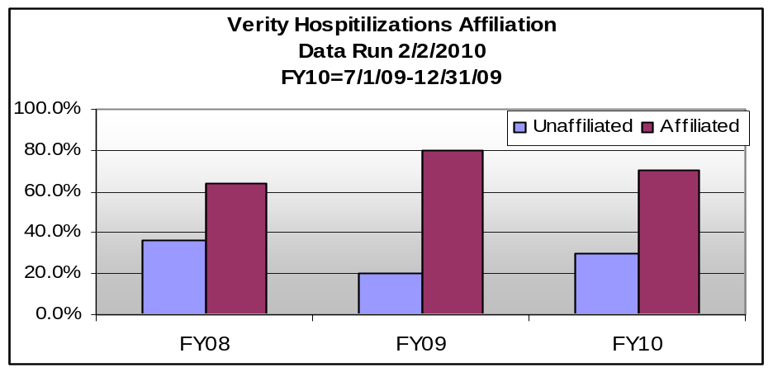

All Verity Clients  U=Unaffiliated  A=Affiliated with OP provider | FY08-U | FY08-A | FY09-U | FY09-A | FY10-U | FY10-A
General Outpatient Claims In Hospital | 21.5% | 68.3% | 14.9% | 67.8% | 20.5% | 62.8%
General Outpatient 7 Day Follow-up | 24.4% | 67.2% | 19.7% | 70.4% | 24.7% | 67.0%
7 Day Follow-up with Medical Provider | 3.4% | 17.5% | 2.2% | 19.9% | 5.1% | 24.5%
(FY 10 7/1 through 10/30)
During 2009 several groups expressed concern that there was insufficient or delayed access to medical providers. Only 24.5% of members had seven day access to a prescriber after hospitalization in FY10. As a result of these concerns we added a measure to track medical appointment follow-up after hospitalization in 7 days. MHASD and Verity provider agency medical directors will focus on improving access to medical staff.

Domain: Quality/Child and Family Satisfaction
Program Area: Child and Youth Programs (Excluding Crisis and Inpatient Services)

Plan: Quality—Youth Satisfaction

Objectives
To improve youth satisfaction as indicated by the outcome score

Questions/Predictions
- Focusing on items predictive of satisfaction with services we will increase outcome scores

Indicators
Verity will primarily focus on increasing scores in the Outcome domain. Questions highly predictive of outcome satisfaction in 2009:
- “My family got as much help as we needed for my child”
- “The people helping my child stuck with us no matter what”

Performance Goal
Improve score of outcome domain for clients who have been in outpatient treatment more than 6 months or in residential treatment more than two weeks.

Measurement Method
DENOMINATOR: Consumers who received a mental health service during a specified period of time and who have completed a YSS/F consumer survey

NUMERATOR: Consumers included in the denominator who responded either "strongly agree" or "agree" with the positively stated satisfaction questions

Measurement Source
Youth Satisfaction Survey or Youth Satisfaction Survey for Families administered to each adolescent /family at discharge from residential or administered every May as a waiting room survey for outpatient clients

Do: Action Steps
- Among agencies with at least 30 YSS or YSSF surveys, Verity will share each agency’s scores with the other participating agencies. Verity will schedule a time to discuss interventions aimed at increasing satisfaction around the items most strongly relating to outcome at internal agency staff or quality management meetings.
- A full satisfaction report, with all statistical analysis and detail, will be completed and available for any agency, quality management staff, or interested people.

Results
The YSS and YSSF are administered across the state and nationally which provides a reasonable comparison for Verity data. However, national surveys are administered after a child has completed service, while the state administers surveys to anyone who received service within the last calendar year, regardless of current service enrollment. MHASD administers surveys only to Verity youth and families actively receiving treatment services. These differences in administration should be noted when comparing satisfaction scores, especially in the outcomes domain.

Youth and family satisfaction was measured in 2009 with the Youth Satisfaction Survey (YSS) and Youth Satisfaction Survey for Families tool (YSS-F, www.mhsip.org). The youth and family surveys are identical except for wording to clarify “my experience” in the YSS and “my child’s experience” in the YSS-F. The full report can be found at 2009 Family/Youth Satisfaction Survey located on the MHASD quality management web page.
Over a three week period in May 2009, providers distributed the YSS and YSS-F surveys to outpatient Verity children and their families when they arrived for appointments. Children in residential services were surveyed once during their residential stay. No names or identifying numbers were associated with any survey.
 | Verity (n=522) (2009) | Oregon State (2008) | National (2006)
Access | 76% | 70% | 83%
Participation | 84% | 76% | 87%
Cultural Sensitivity | 92% | 88% | 91%
Appropriateness | 83% | 65% | 81%
Outcome | 67% | 58% | 73%
Nine agencies returned 790 valid YSS and YSS-F surveys. Results were stratified by type of agency.

Residential providers submitted 268 surveys. Roughly one in five Verity youth returned a satisfaction survey (21%) while one in four Verity family members returned a survey (24%). The demographic distribution of survey respondents was not reflective of overall Verity membership.

- Hispanic and Asian/Pacific Islander Verity members were under-represented.
- Caucasian Verity members were over-represented.
- Black/African American and Native American respondents were accurately represented.
- There were no significant differences in satisfaction between racial/ethnic groups.
- Youth who reported receiving services for one year or more reported significantly higher satisfaction with cultural sensitivity of treatment than those in services less than three months (p=.005).

The age distribution of youth survey respondents was also not reflective of overall Verity membership as older youth submitted more surveys.

- Boys and girls were similarly satisfied in all domains.
- Child’s age was not a determining factor of satisfaction.
- Family members were significantly (p<.01) more satisfied than youth in several domains.
- Family members of youth in outpatient services were significantly more satisfied than youth in the domains of Satisfaction, Access, Participation, and Cultural Sensitivity.
- Family members of youth in residential services were significantly more satisfied than youth in the domains of Access and Outcomes.

Questions from the Appropriateness domain are consistently correlated to the Outcome score. The following questions are strongly correlated to Outcome scores:

YSS
- I got the help I wanted (Appropriateness)

YSSF
- My family got as much help as we needed for my child (Appropriateness)
- Staff treated me with respect (Cultural Sensitivity)
- I felt my child had someone to talk to when he/she was troubled (Appropriateness)

There were no significant changes in satisfaction in any domain between 2008 and 2009.

Domain: Quality/Satisfaction
Program Area: Adult Outpatient and SMI

Plan: Quality—Adult Satisfaction

Objectives
To improve adult satisfaction as indicated by the outcome score

Questions/Predictions:
- By focusing on items predictive of satisfaction with services we will improve outcome ratings
- Are outcome ratings affected by time in treatment?

Indicators
MHASD will primarily focus on improving Verity member scores in the Outcome domain. Questions predictive of outcome satisfaction include:
- “Staff helped me obtain the information I needed so that I could take charge of managing my illness.”
- “Staff encouraged me to take responsibility for how I live my life.”

Performance Goal
Increase outcome domain for clients who have been in treatment greater than 6 months

Measurement Method
DENOMINATOR: Consumers who received a mental health service during a specified period of time and who have completed a MHSIP consumer survey

NUMERATOR: Consumers included in the denominator who responded either "strongly agree" or "agree” to positively worded satisfaction questions

Measurement Source
MHSIP Satisfaction Survey administered to each SMI client receiving services during a three-week period each May and submitted to Verity

Do: Action Steps
- MHASD will share scores with Verity provider agencies who participated in the survey. MHASD staff will work with providers to improve any areas of concern.
- A complete satisfaction report that includes all statistical analysis and detail will be available for interested parties to review.

Results
Over a three week period in May 2009, mental health providers gave adult Verity members the MHSIP survey when they arrived for appointments. Respondents were asked to place completed surveys in a sealed box in the lobby. No names or identifying numbers were associated with any survey. Fifteen agencies returned 832 valid MSHIP surveys. The full report can be found at 2009 Adult Satisfaction Survey located on the MHASD quality management web page.
Roughly one in four (27%) Verity members with appointments in the month of May completed a satisfaction survey. The distribution of survey respondents is reflective of Verity membership with respect to age and gender but not reflective of the racial and ethnic demographics of overall Verity membership.

- Men and women were similarly satisfied in all domains.
- Length of time in treatment was not associated with satisfaction.
- Adults age 66 and over were significantly more satisfied (p<.05) than those age 18-44 in the domains of Access and Quality.
- Hispanic and African American Verity members were under-represented.
- Caucasian, Asian/Pacific Islander, and Native American Verity members were overrepresented.
- In the Access domain, Asian/Pacific Islanders were significantly more satisfied (p<.05) than African American and Caucasian respondents.

Questions from the Quality domain are consistently correlated to Outcome score. The following questions are strongly correlated (R² = .655) to Outcome scores:

- I was able to get all the services I thought I needed (Access)
- Staff helped me obtain the information I needed so that I could take charge of managing my illness (Quality)
- I would recommend this agency to a friend or family (Satisfaction)
- Staff encouraged me to take responsibility for how I live my life (Quality)

The MHSIP survey is administered across the state and nation, providing a reasonable comparison for Verity data. However, national surveys are administered after an individual has completed service, while the state administers surveys to anyone who received service within the last calendar year, regardless of current service enrollment. MHASD administers surveys only to Verity members in active treatment. These differences in administration should be noted when comparing satisfaction scores.
 | Verity (2009) | Oregon (2008) | National (2006)
Access | 84% | 71% | 85%
Satisfaction | 90% | 79% | 88%
Quality | 91% | 77% | 87%
Outcome | 77% | 56% | 71%

Domain: Outcomes
Program Area: All Verity Clients

Plan: Outcome Measures

Objectives
Implement outcomes informed care in all clinical practices
Demonstrate effectiveness of treatment
Establish system benchmarks

Questions/Predictions
Outcomes tools are an effective way to identify client strengths and needs and evaluate the alliance between client and counselor when administered frequently, reviewed with the consumer, and integrated into the treatment planning process. Additionally, aggregate data for individual agencies is an effective quality improvement tool and demonstration of effectiveness.
A focus on outcomes is a key mechanism for ensuring the continued accountability of publicly funded behavioral health care. Standardized measurement of Outcomes and the processes that lead to those Outcomes enable Verity and individual agencies to identify which clients are improving over the course of treatment.

Indicators
- Number of children’s programs using CANS
- Adult Outcome tool identified
- Number of adult providers implementing the adult outcomes tool
- Number of programs submitting aggregate data

Performance Goal
100% of children’s programs will use CANS and submit aggregate data in a specified format
100% of adult programs will implement approved Adult outcome tool and submit aggregate data in a specified format

Measurement Method
Count of programs utilizing approved outcomes tools

Measurement Source

Provider reports utilizing approved formats

Do: Action Steps
- Standardize CANS administration and data submission to Verity
- Continue to conduct a pilot of the identified adult outcomes tool

Results
The adult and child systems of care experienced changes in outcomes measurements in 2009.

System of care for children and families: While most providers serving children enrolled in Verity are utilizing the CANS assessment tool, the frequency of its use and management of the data varies between agencies. MHASD is unable to report aggregate Verity data as a result. A steering committee is investigating methods to improve provider training, certification, tool administration, and data management and analysis. The committee is also reviewing the purpose of measuring outcomes within the children’s system, and evaluating use of the CANS versus other options.

System of care for adults: All providers serving adult Verity members are required to use an outcomes tool in their practice. MHASD took the lead in standardizing the collection of Verity member outcomes data. After reviewing various tools, MHASD decided to implement a pilot using the Center for Clinical Informatics’ ACORN tool. This voluntary pilot implements outcomes informed care in five Verity provider agencies serving adults. The use of ACORN gives us a tool to measure the outcome for Verity members in mental health treatment.

The ACORN is a client self-report 18-item questionnaire administered every session or weekly, whichever is least frequent. The web-based tool allows clinicians, agencies, and Verity staff to monitor data in real time. The data thus far indicates that 257 clients enrolled in Verity had assessments, 84% of these had two or more assessments. This is indicative of consistent data collection.

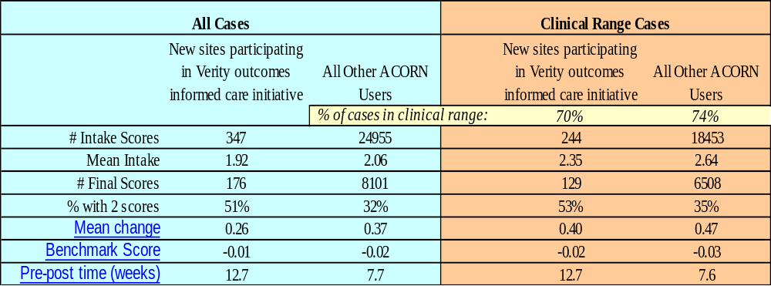

The client registration form is completed at the beginning of a treatment episode. It contains information about the client’s gender, age, insurance coverage and other demographic information. Many clients (47%) with outcome data did not have a registration form. Many clients (52%) with a registration form did not have outcome data. MHASD is addressing this discrepancy in the pilot agencies.

Data indicates that in the first 6 months of the pilot Verity members received effective treatment. Verity members averaged more improvement than the National Provider Sample. The “Effectiveness” score is based on the difference between expected improvement and observed improvement at most recent appointment. Data indicates that 60% of Verity clients improved since the pilot project began and 12% got significantly worse. These distributions are very similar to the national sample of clients with an ACORN assessment. Results are expected to improve as clients complete treatment episodes.

Cases classified as “significantly worse” are flagged as “off track” in the toolkit which is one of the purposes of the ACORN. Research shows that clinicians have a difficult time identifying at-risk cases without feedback from the test scores (see references 1-11). If the clinicians can keep these at-risk client engaged in treatment, the probability of improvement remains high

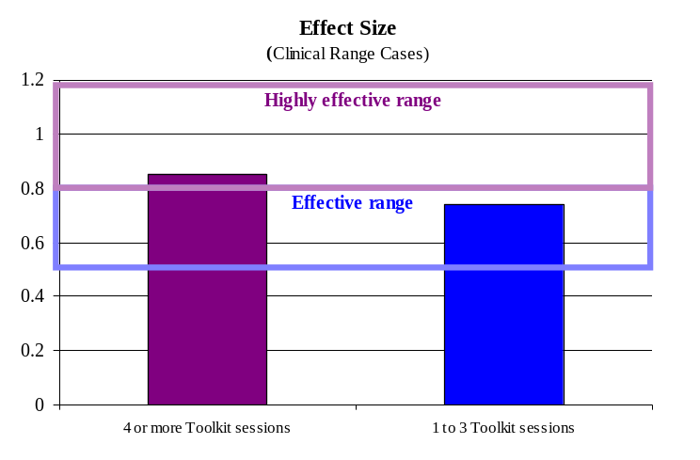

Use of theACORN tool is associated with better outcomes. Clients seen by clinicians who logged in more than three times in three months had 19% greater improvement. Difference in improvement is comparable to the difference between placebo and anti-depressants in a recent meta-analysis by the FDA data on top selling anti-depressants (see references 12-14). The data indicates that currently Verity clients are getting effective treatment which raises the question of how to improve the outcomes and how good is ‘good enough’?
Those who consistently provided “highly effective” treatment actively used the ACORN tool, had clinical leadership involved in monitoring outcomes, and integrated the tool into the treatment process.

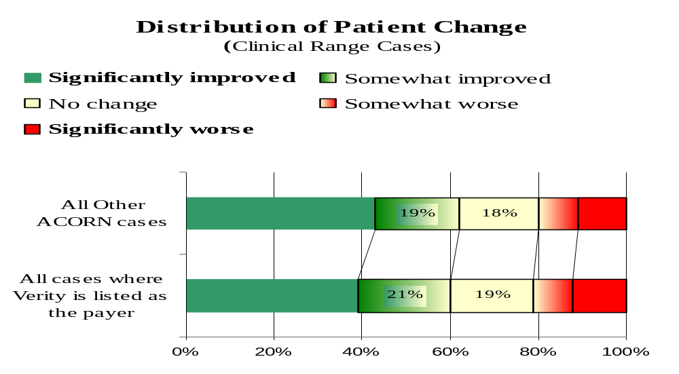

Domain: Prevention, Education, and Outreach
Program Area: All Outpatient Verity Clients

Plan: Suicide Prevention

Objectives
Implement suicide prevention activities for Verity clients.

Questions/Predictions
Access to crisis intervention resources and preventative education will reduce suicide rates.

Indicators
Number of suicide prevention activities reported by agencies and Verity
Percentage of referrals of school-age Verity clients who enter treatment

Performance Goal
One hundred percent of Verity clients will receive the suicide prevention handbook
Number of crisis calls received each month related to suicide will decrease
Establish a baseline measurement for referrals of school-age clients who successfully engage in mental health treatment

Measurement Method
Total count of handbooks sent to Verity members
Total count of prevention/education activities reported by Multnomah County Crisis Call and Verity Member Services
Number of school-age referrals that meet criteria for a mental illness
Percentage of school-age referrals that meet criteria for a mental illness and who enter treatment

Measurement Source
PEO report
School-age referral report

Do: Action Steps
Distribute Verity member handbooks to all new enrollees
Translate suicide handbook into top eight languages of Verity membership
Monitor school referrals to mental health services

Results
MHASD included a section for youth suicide prevention in the 2008 Verity member handbook. The information is based on “Recognizing Depression in Youth – A Key to Solving One of Oregon’s Most Serious Problems: Youth Suicide” by Kirk D. Wolfe, M.D. MHASD is updating the full English version of the Verity handbook including translating the suicide handbook in the top eight languages. Handbooks in Arabic, Hmong, Korean, Russian, Somali, Spanish, Simplified Chinese, and Vietnamese languages will be mailed in March 2010. As with all materials, other languages and formats are available upon request.

The Mental Health Call Center manages the 24/7 crisis services in Multnomah County. Crisis prevention is a part of those services and data about the number of prevention support services is captured in a report entitled Prevention, Education, and Outreach. Due a technical problem, MHASD was unable to capture prevention support activities for the 1st quarter of 2009. The following chart is the number of quarterly encounters that were captured.

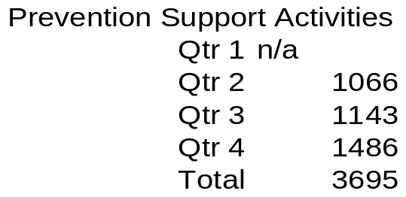

The school aged mental health consultants located throughout schools in Multnomah County have made 944 referrals for to providers for treatment. Of those who were referred, 821 engaged in treatment services. Those referred who did not engage in services either chose not to access treatment, left school, or moved out of the district.

Domain: Clinical Care

Program Area: Child and Adolescent Program Verity Clients

Plan: Increase Cultural Competency of Verity Network Providers

Objectives

To develop a cultural competency plan using consumer input and implement key interventions.

Questions/Predictions
Improving the cultural competency of direct service providers and increasing access to competent care for families of color will improve mental health outcomes for youth and families who have experienced inequities in the system as demonstrated by over or underutilization of services.

Indicators
Determine a standardized assessment tool to be used throughout the Verity provider network.

Performance Goal
Establish baseline

Measurement Method
Establish methods to be used

Measurement Source
Standardized tool and focus group results

Do: Action Steps
- Determine and implement a network-wide cultural competency survey of Verity providers
- Plan and facilitate focus groups
- Aggregate data from all sources of information into a single focused gap report that has agency and system recommendations

Results
MHASD hosted a series of focus groups, surveys, and community meetings occurred in 2009 that focused on cultural competency in the Verity provider network. We gathered information from consumers, stakeholders, community member, and providers. From this data we identified gaps in our system.

Verity providers helped MHASD identify service gaps and opportunities for technical assistance by participating in the cultural competency survey and the input meetings for the children’s system of care procurement. Consumers and other stakeholders gave input via surveys, focus groups and input meetings.
Nine culturally specific communities gave their feedback. These communities included African American, Native American, Hispanic, Russian, Burmese, Somali, Kurdish, Farsi-speaking, and Korean.

Gaps were identified in the following areas:

- Stigma/Feeling Judged
- Atmosphere
  - Customer Service
  - Environment
- Access
- Assessment/Treatment
- Language Barriers

MHASD is addressing the systemic need for increased community-based services, alternative hours of service for children, language competency, and access to child psychiatry in the Verity system of care requests for proposals in 2010 and 2011.

The affinity diagram on the following page contains focus group participants’ recommendations for improvement. Much of the work to lay the foundation for change has begun. All of the agencies have been or will be visited to share this information and to encourage customer service training, cultural competency training, and centralized scheduling. We are recommending that cultural competencies be added to all staff list of competencies, that providers increase minority staffing, increase minority consumer input in clinic design, and increase their collaboration with culturally specific agencies.

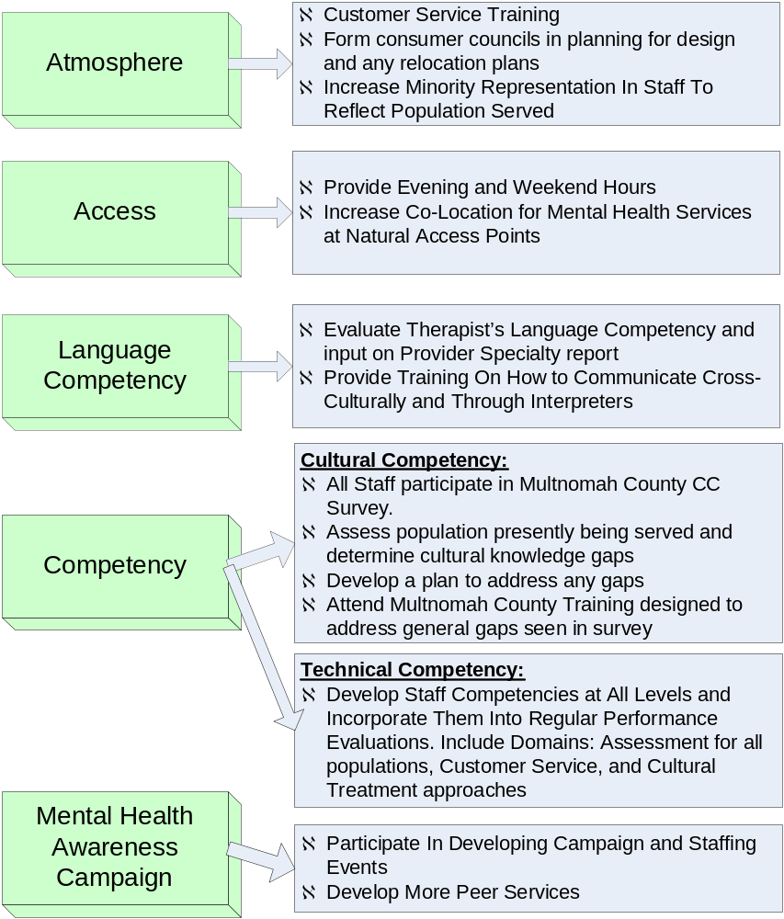

Domain: Quality

Program Area: All Verity Clients

Plan: improve documentation for billable services

Objectives
Decrease documentation errors through use of internal agency audits

Questions/Predictions
By assuring chart audits are regularly taking place at the agency level documentation errors will decrease.

Indicators
Participating Verity provider agencies will submit a chart audit tool to MHASD for approval. At minimum they must contain the following indicators:
- Current consent for treatment
- Current mental health assessment completed and signed by a qualified mental health professional (QMHP) with yearly updates signed by a licensed medical practitioner (LMP).
- Treatment plan completed within the last 12 months
- At least one goal addressing the mental health diagnosis on the assessment
- Treatment plan interventions have frequency and duration for specific intervention
- Treatment plan signed by a QMHP with yearly updates signed by an LMP
- Progress notes clearly define what treatment goal and intervention are being addressed in session

Performance Goal
- 75% of providers will participate quarterly (plan A)
- Participating providers will reduce error rates to less than 15%

Measurement Method
Agencies will complete a chart audit for a representative number of Verity members at least quarterly and submit aggregate data of results. (Plan A)

DENOMINATOR: Charts audited for each indicator above
NUMERATOR: Number of missing or incomplete data for each indicator above

Measurement Source
Chart Audit reports by agency

Do: Action Steps
Review indicators and revise if appropriate
Develop chart audit tool
Develop Pay for Performance Parameters

Results
MHASD gathered data from two Verity provider agencies in 2009. The providers used different formats so the data cannot be combined. The performance measure was approved by the 2009 QM committee but provider agency executives felt that the measure exposed them to undue risk. As a result, MHASD agreed to report Verity aggregate data rather than agency level data. Due to the low level of participation by Verity providers in 2009, MHASD is adjusting the 2010 plan to conduct sample chart audits at agencies that do not participate in the first quarter of 2010 (please see 2010 QM work plan.) Verity will refine the measure and develop more effective guidelines and tools in 2010.

Both provider agencies submitting data scored some areas below 85% in at least one review. Processes were different in each review. Agency A reviewed all Verity client charts and in the second review followed up and noted the date that items were corrected. By the second review the error rate was above 85%.

Agency B pulled sample Verity charts quarterly and developed a corrective action plan for the one indicator that scored below 85%. They changed their procedure to address the area with the majority of errors.

 | Agency A 1st Review | Agency A: 2nd Review | Agency B: 1st Review | Agency B: 2nd Review
Current consent for treatment | Unknown | Unknown | 100% | 100%
Current mental health assessment completed and signed QMHP/LMP | 82.64% | 95.04% | 97% | 100%
Treatment plan completed in the last 12 months | 90.91% | 99.17% | 100% | 100%
At least one goal addressing mental health diagnosis on the assessment | Unknown | Unknown | 97% | 98%
Treatment plan interventions have frequency and duration for specific intervention | Unknown | Unknown | 100% | 100%
Treatment plan signed by a QMHP/LMP | 79.34% | 97.52% | 100% | 75%
Progress notes clearly define what treatment goal and intervention are being addressed in session | Unknown | Unknown | 97% | 94%
(Data not submitted=unknown)

Domain: Quality

Program Area: All Verity Clients

Plan: Consumer Representation

Objectives
Increase the number of consumers attending MHASD advisory meetings including CMHSAC, AMHSAAC, and the Verity Quality Management Committee.

Questions/Predictions
Involving consumers in system of care planning will improve the quality and responsiveness of the services delivered.

Indicators
Increased participation of consumers on an ongoing basis

Performance Goal
Add three consumers to each advisory committee to increase consistent representation.

Measurement Method
Number of consumers attending meetings

Measurement Source
Meeting minutes

Do: Action Steps
- Hire or procure a contract for three family and child system navigators
- Promote adult participation through agency consumer groups

Results
MHASD has three main advisory committees with consumer as members. They include the Children’s Mental Health System Advisory Council, (CMHSAC), Adult Mental Health Substance Abuse Advisory Committee (AMHSAAC), and the Verity Quality Management (QM) Committee. Maintaining consistent consumer participation on these committees is an ongoing effort.

MHASD contracted for family and child system navigators in 2009 to help Verity members get to the appropriate place in the system of care. They had the additional task of increasing consumer and family participation at CMHSAC and the Verity QM committee meeting. There was a successful recruitment drive for both committees. Although CMHSAC lost three family members in 2009, six new family members recruited. Most of the departing families were long-standing members who moved on as new members were recruited. In addition, three new youth were recruited to participate as youth representatives to the committee.
Two family members joined the Verity QM meeting in 2009 and helped fill the gap left by a previous family member who left the committee.
A variety of recruitment methods were used to reach adult consumers. Attendees were recruited at each focus group in 2008 and 2009. Committee members of AMHSAAC actively recruited for consumer representatives. All consumer positions on AMHSAAC were successfully filled and three new consumer representatives were added to the QM committee. The QM committee now has three family advocates, four adult consumers, and one adult family advocate on its roster.

State and National data for 2006 Surveys obtained from http://mentalhealth.samhsa.gov/cmhs/MentalHealthStatistics/URS2006.asp
National data for 2006 Surveys obtained from http://mentalhealth.samhsa.gov/cmhs/MentalHealthStatistics/URS2006.asp

