Report Description
The Jail Longevity report presents a list of people who have been in pretrial custody for 80 or more days. The data is sourced from SWIS and OJIN to return attorney information associated with persons in pretrial custody.
This report is distributed monthly to the judges, DAs, Public Defenders, Sheriff and DCJ representatives.
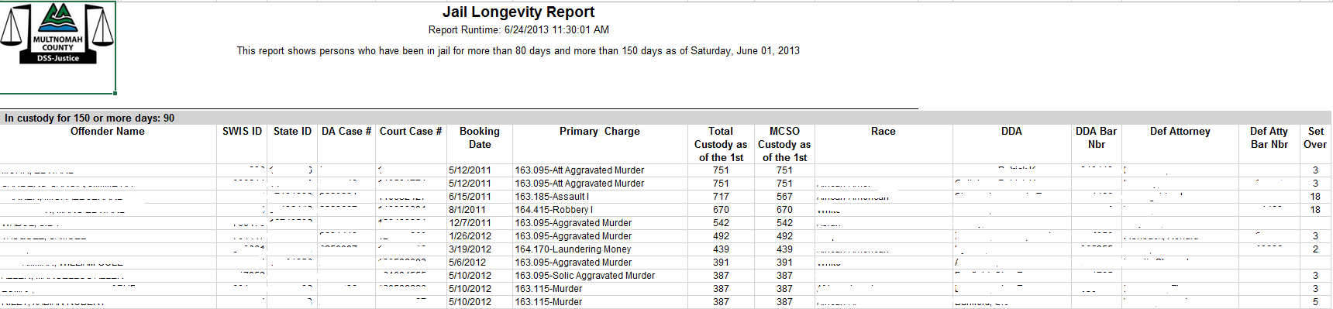
NOTE: Most of the report content is hidden due to the CJIS compliance.

This is a pretrial report that shows the primary unsentenced case on which a person is being held. As cases are processed and charges are disposed they will no longer show up on this report. If some cases are sentenced they will drop off. If the person has remaining unsentenced cases, they will continue to show up on this list, but the Primary Case ID, DA_Case and Court Case numbers may change.

Note: There is a known issue where some people who have been sentenced are on this list because they have holds that are categorized as unsentenced.

Data Model Details
Custody Snapshot provides the location of people who are in custody as of the first day of the month. Data is gathered from the DSSJ Names table, Prosecution Case and Court Case tables to fill in DA, Court Case Numbers, Attorney Names, Bar Number, and Set Over counts.

Report Parameter and Schedule
Custody Snapshot Date - by default, the first date of the current month is selected when report is ran.
This report will be scheduled to run on the 5th of each month to make sure the last day of the previous month has been loaded.

Data Dictionary
Report Field | Example | Definition | Source | Logic/Formula | Comments
Offender Name | SMITH, John (name is not real) | Combination of Last, First and Middle Name | DSSJ Names Table |  | Identified as the primary name for the person. In DSSJ combined from all the agencies by matching process.
SWIS ID | 11111 | Sheriff's Unique Person Identifier | SWIS System  DSSJ: Custody Snapshot Table
State ID | 01111110 | Unique State Identifier | In DSSJ it is coming from Person ID Numbers; Comes to DSSJ from all sources. In DSSJ - combined from all the agencies by matching process.
DA Case # | 1111110 | DA's Unique Case Identifier | SWIS System: SWIS Case Table  DSSJ: Booking Count Table | These columns exist in SWIS, which allows us to join to DA data (CRIMES). | A person can be in jail on many cases with multiple charges. DA Case numbers are stored in the SWIS Case table (DSSJ Booking_Count table).  This report is driven by the Jail Snapshot table which changes over time as cases are tried and charges are disposed.  A note about null DA Case Numbers: Sometimes the join between the Jail Snapshot and Booking Count table turns up a null in the DA Case Number column.
Court Case # | 111111111 | Court's Unique Case Number | SWIS: SWIS Case Table  DSSJ: Booking Count Table | These columns exist in SWIS, which allows us to join to OJIN. | Court Case number is also found on the DSSJ Booking Count table with the same issue with null values as the DA Case number.  A note about null Court Case Numbers: Sometimes the join between the Jail Snapshot and Booking Count table turns up a null in the Court Case Number column.
Booking Date | 12/16/2008 | The Date the Person was booked. | SWIS: Booking Table  DSSJ: Custody Snapshot Table
Primary Charge | 163.095-Aggravated Murder | Primary Charge is identified by the most severe charge for a Person that is unsentenced or currently serving their sentence. | SWIS: Case Count Table  DSSJ: Custody Snapshot Table
Total Custody as of the 1st | 1477 | Number of days between Booking Date and the Date the Report was ran for people who are still in Custody. | SWIS: Booking Table and Release Table  DSSJ: Custody Snapshot (Booking Date) | The Latest Date the report was ran - Booking Date
MCSO Custody as of the 1st | 1477 | Number of days a Person was in Multnomah County Sheriff. | SWIS: Location Table  In DSSJ: Admission Release Table and Incarceration Movement Table | All the segments of Custody between Admit and Temporary Release. | Accounts for temporary transfers out of County Custody into State or other agency Custody (i.e. temporary transfer to a State Hospital)
Race |  |  | DSSJ: Person Table |  | In DSSJ - combined from all the agencies by matching process.
DDA | Johnes, John (name is not real) | Prosecution Deputy District Attorney Name | DA (CRIMES) and DSSJ: Prosecution Case Table | Joins SWIS Case Table to the Prosecution Case Table on Court Case Number. The Attorney Name comes from the Attorney Lookup Table.
DDA Bar Nbr | 011111 | Prosecution Deputy District Attorney Bar Number | DA (CRIMES) and DSSJ: Prosecution Case Table | Joining SWIS Case Table to the Prosecution Case Table by Court Case Nbr
Def Attorney | Davis, David (name is not real) | Defence Attorney Name | OJIN and DSSJ: Court Party Case Table | Joins SWIS Case Table to the Court Case Party Table on DA Case Number. The Name comes from the Attorney Lookup Table. A condition on the Court Case Party table looks for PARTY_ROLE = CTA or PTA and the status of ‘ACTV’ or Null | This report specifically looks for attorney rows in the Court Case Party table where the party_role type = CTA or PTA.  Note: There are several nulls in the defense attorney column where attorneys have a party_role = PRV.
Def Atty Bar Nbr | 11111 | Defense Attorney Bar Number | OJIN and DSSJ: Court Party Case Table | Joining SWIS Case Table to the Court Case Party Table.
Set Over | 20 | Count of all Court Events that had to be rescheduled - Set Over. | OJIN: Case Event Table  DSSJ: Case Event Table where Event Status = SODF, SOCT, ORSU. |  | Set Over By Defense, Set Over By Court, Order Substitute Attorney

