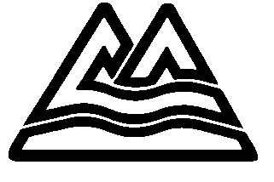

Multnomah County

Community Development Program

Department of County Human Services

DATE: February 6, 2014
TO: Community Development Block Grant Applicants
RE: PUBLIC SERVICE Projects Renewal-only Application FY 2014-2015

We are pleased to provide you with the FY 2014-15 Public Services Application package. Renewal-only public services projects will be accepted this year.

Application Due Date and Submission Requirements
Multnomah County’s Community Development Program will accept NEW and Renewal applications through February 28, 2013, 4:30 p.m. Please submit an original and one unbound copy to Regena Warren-Multnomah County, Community Development Program, 421 SW Oak Street, Suite 200, Portland, OR 97204. If you choose to drop your application, please leave at the Reception Desk on the 1st Floor. Eligible applicants include non-profit organizations, public agencies and county departments.

Funding Available
It is estimated that approximately $34,447 (between 10 and 15% of the total grant) in Community Development Block Grant (CDBG) funds may be available for renewed public services projects.

Eligible Public Services Activities

All public services must primarily benefit low and moderate-income persons.

Application Available In Electronic Format
An electronic copy of this application in WORD format is attached. Please e-mail Regena Warren at regena.s.warren@multco.us or you may call 503-988-4777 with any questions.

And Finally…
The schedule for the entire application process is included in this package. Remember that all applications must meet threshold criteria before being considered for funding.

Please do call for assistance during the application process if you have any questions. Staff would prefer to consult with you during the process to help you develop a fundable application. Either telephone consultations or meetings are fine. We look forward to working with you to make a difference in the lives of Multnomah County residents for whom your programs are essential.

