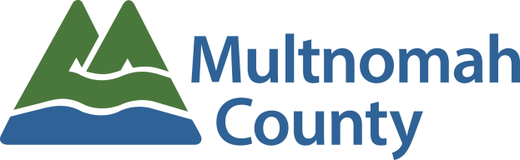
Employee Awards Nomination Form
Outstanding Team Achievement Award

To promote and recognize members of work teams who add significant value to the organization.

Team Being Nominated:
Your Name:
Your Email Address:
Your Phone #:

The following criteria will be used to select the Outstanding Team Achievement Award recipient: The accomplishments and contributions of the team shall reflect efforts made above and beyond normal work duties or performance expectations of a team. The work should have been done (or the major project completed) between March 1, 2017 and the time the nomination is written.

Please give examples of how this team completed a major project or a one-time effort, and did so either under budget, ahead of schedule, or with significant benefit to the division or community. (5 points)

Please give examples of any positive feedback that was received by internal/external customers regarding this team. (5 points)

Please give examples of how the team improved processes to save time or money. (5 points)

Please provide additional information regarding this employee or team and how you feel they inspired pride in the work of Multnomah County. (5 points)

Please be as detailed and specific as possible about the nominee. The information provided will be the sole factor determining the committee’s ranking of nominees.

PLEASE READ BEFORE YOU SUBMIT YOUR NOMINATION:

Every description field above is scored on a 0-5 point system and scored as indicated below. Any field left blank or incomplete will be scored with a 0 or a 1. All scores are then totaled and nominees are ranked based on those totals.

0 = Not Covered
1 = Unclear: Not clearly defined; not explicit.
2 = Noteworthy: worthy of notice or attention
3 = Significant: having or expressing a meaning; important; of consequence.
4 = Distinguished: made conspicuous by excellence;
5 = Extraordinary: exceptional in character, amount, extent, degree, etc…; remarkable; uncommon, rare, phenomenal, special

Submission instructions:
- Save file to your network folder
- Attach completed saved form in to an email to Employee.recognition@multco.us

