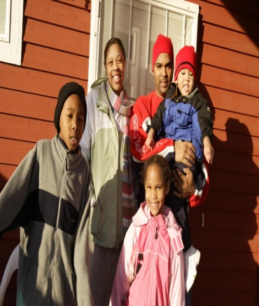
Consortium of City of Portland, City of Gresham and Multnomah County (the Consortium) will invest millions over the next fiscal year FY 2015-2016 to help address the community’s need for affordable housing and community economic development.
How are rising rents and home prices affecting your household?
You are invited to participate in the annual Need Hearing as one of several ways to offer input to this spending plan for federal dollars invested in housing and community economic development.
COMMUNITY NEED HEARING
Thursday, December 11th  Free Dinner 6:00 pm  Program 6:30 pm to 8:00 pm  Gresham City Hall  1333 NW Eastman Parkway  Accessible by Max and Bus | Sponsored by  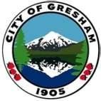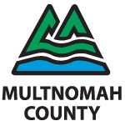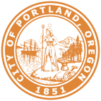
For more information visit, http://www.portlandoregon.gov/phb/
For RSVP’s, questions or requests call (503) 823-2375.
To help ensure equal access to City programs services and activities, the City of Portland will provide translation, reasonably modify policies/procedures, and provide auxiliary aids/services/alternative formats to persons with disabilities. Call three days in advance to request accommodations for ADA accessibility.
503.823.2375, TTY, 503.823.6868.
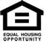
The City of Portland will provide translation services with at least 48 hours advance notice.
To request translation, please call 503.823.2375.
PHB Online | Become a Fan on Facebook | Follow us on Twitter

