This year, flu shots are coming to you! Oct. 5-16, 2015
There’s no need to find time to go to the doctor or pharmacy for your flu shot this year. Nurses will be coming to 30 County worksites, Oct. 5-16, to provide flu shots to employees. Click here for the schedule and locations.
Together with Kaiser and Moda, the County Benefits & Wellness Office is providing flu shot clinics to employees… because Your Health Matters!
The flu shot clinics are an easy, convenient way for you to get vaccinated before the flu season starts.
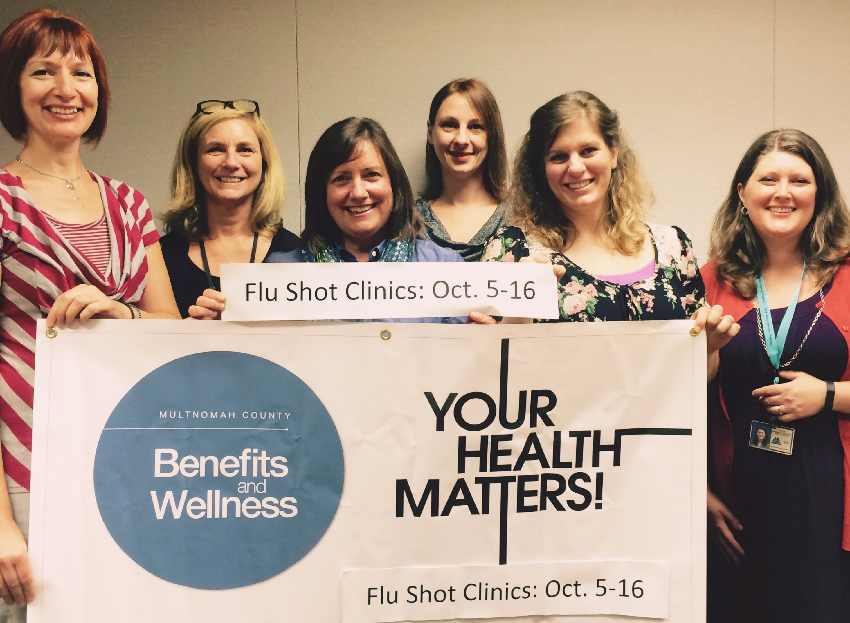
What You Need to Know
- There is no cost to employees who are members of a County health plan (Kaiser or Moda).
- IMPORTANT: Bring your Kaiser or Moda insurance ID card or use the mobile app. This will reduce wait times and ensure you are not charged.
- Clinics are open to all employees: full-time, part-time, permanent, temporary, on-call, and from any bargaining unit.
- For employees not enrolled in a County health plan, the cost is $26 paid by cash or check. You will receive a receipt that you can use to request reimbursement from your health plan or healthcare reimbursement account, as applicable.
- You can use paid time to attend—but must make coverage arrangements with your supervisor.
- Click here for Frequently Asked Questions or go to this URL multco.us/benefits/flu-shot-clinic-faqs.
- Click here for the Flu Shot Clinic Schedule (Oct. 5-16) or go to this URL multco.us/benefits/flu-shot-clinic-2015-schedule.
- The Health Department ordered its own supply of vaccine and is providing free flu shots to Health Department employees. Any Health Department employees who attend a County Flu Shot Clinic will have to fill out a Declination Form and turn it in to your supervisor.
For any questions or comments, please see the Frequently Asked Questions or contact the Employee Wellness Program at wellness.program@multco.us.

