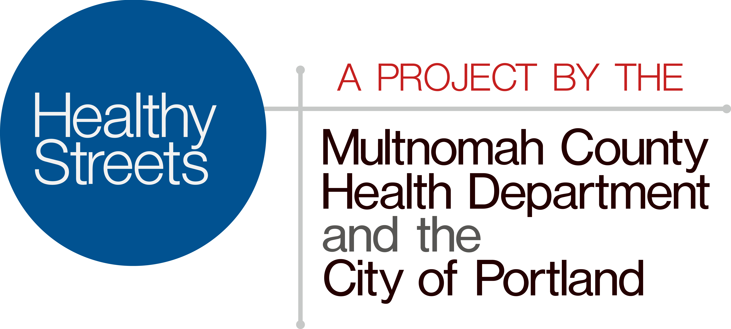

Safe and legal disposal of syringes and other sharps

Syringes and other needles can carry hepatitis, HIV and other disease. Putting them in the trash or recycling, or tossing them into the river or on the ground, puts other people at risk. You cannot dispose of syringes and other medical sharps in the garbage because it is illegal in Oregon.

How can I dispose of sharps used in my business?
Residential care facilities, group homes and other commercial generators of sharps should contact their regular solid waste collection company or call the Metro Recycling Information at 503-234-3000 or visit www.oregonmetro.gov/recycling.

How can I dispose of syringes used for personal reasons?
- Drop off at a Metro collection facility — Metro's Sharps Disposal and Container Exchange Program allows area residents to bring used sharps stored in approved sharps containers to Metro's hazardous waste facilities. Participants can dispose of used sharps and receive a new container ($5 for the first and get a new container at no cost) plus a disposal fee of $5.There is a $5 disposal fee for each visit up to 35 gallons. Locations are at Metro Central in NW Portland and Metro South in Oregon City, Monday-Saturday 9 a.m. to 4 pm.
If you have a non-approved container, such as a soda bottle, you can transfer this container to an approved sharps container at the facility for a $5 per sharps container fee plus $5 for disposal.
- Join a pharmacy container or medical supply store exchange program — Many area pharmacies and medical supply programs offer sharps disposal and container exchange programs that provide containers for a small fee.
Drop off at a Metro hazardous waste neighborhood collection event — Residents can bring used sharps and other household hazardous waste to nearby Metro household hazardous waste collection event for safe collection.
What about needle exchange?
Needle exchange programs are for people who inject illegal drugs. It provides new sterile syringes for used ones at no charge and safely disposes of them. You can find out more about syringe exchange here.

Will my doctor or pharmacy take used syringes?
Some will -- for a fee- and if they are safely stored in an approved manufactured sharps container. Ask your healthcare provider or pharmacist.
Can I use the new Healthy Streets container?
No. These secure outdoor containers are to reduce the harm of illegal drug use.

What should I do if I find a syringe?
- Do not pick up any syringe with your bare hands.
- Leave the syringe where it is until you can return with household cleaning gloves, tongs or pliers or a shovel or dustpan to pick it up.
- With the gloves on, carefully use the tongs to place in a puncture-proof container.
- Do not hold the container while you put the syringe inside to avoid accidentally sticking yourself.
- Tape the container shut and write: Sharps Container DO NOT Recycle.
- Wash any tool used in a solution of one part household bleach, nine parts water.
- Wash hands thoroughly with soap and water.
- Call 503-988-3030 Monday - Friday, 8:00 AM - 4:30 PM for safe disposal assistance.





