ATTENTION VISITORS!

We currently have a number of residents ill with respiratory symptoms.

In order to protect our residents’ health and the health of others,

VISITOR ACCESS IS LIMITED THROUGHOUT THE FACILITY.

Please check in at the front desk.

Wash your hands as you enter and exit the facility.

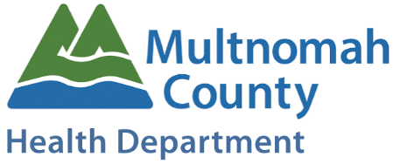

NOTICE!

We are currently experiencing a respiratory outbreak among our staff and residents.

We are working with the Multnomah County Health Department to contain and control this highly communicable disease.

For the safety of our residents and their visiting friends and family, we please ask that you limit visits to your loved ones as much as possible to avoid further spread of illness. Please do not visit if you are ill with flu-like symptoms.

Please also refrain from bringing young children and elderly to visit. They are most susceptible to complications from influenza like illness.

If you do decide to visit, please wash your hands often, and wear a mask upon entry to the facility.

