September 30, 2020

Hello, my name is Irma Jimenez; I am the Interim Division Director for Multnomah County Aging, Disability & Veterans Services. I would like to inform you that Felicia Nelson is currently out on Medical Leave through at least December 31, 2020.

My plan is to find a temporary replacement while Felicia is out. We will provide you with the name and contact information once that person is identified. In the meantime, feel free to contact Annie Neal with any urgent needs at 503-988-8316.

Thank you.

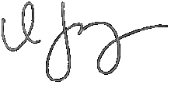

​Irma Jimenez
Interim Director
Multnomah County Aging, Disability & Veterans Services Division

